DEPARTMENT OF
ELECTRONICS & COMMUNICATION

ACTIVITY REPORT
JULY 2022- JUNE 2023

VISION
“Emerge as a center for quality education and research, to grow in pace with the rapidly changing technologies and create Electronics and Communication Engineers capable of accepting new challenges for the service of mankind.”

MISSION
- Impart quality education based on the curriculum, contemporary technologies, value based education that helps students groom into a highly competent Electronics and Communication Engineer.
- Constantly motivate students and faculty members to generate ideas and accept the challenges to provide solution for social needs and to endow competent professionals to undertake research and developmental activities.
- Promote academic growth for students by encouraging post-graduate and research programs.

PREAMBLE
At its inception in 2001 itself, Marian Engineering College offered the undergraduate programme (B.Tech) in Electronics & Communication Engineering (ECE) with an intake of 60. In 2014, the intake of Electronics & Communication Engineering was increased to 120. Later in 2018 the seats were reduced to 60.

STAFF DETAILS
DESIGNATION | NUMBER
HoD | 1
Prof. | 1
Asso. Prof. | 2
Asst. Prof. | 11
Technical staff | 6

LIST OF TEACHING FACULTY
ASSOCIATE PROFESSOR & HEAD
- Ms. Vinitha B.Elza | M.Tech
PROFESSOR
- Dr. M.Manoj | M.E ,PhD
ASSOCIATE PROFESSORS
- Ms. Ramola Joy P | M.E
- Ms. Subha P.S | M.E
ASSISTANT PROFESSORS
- Ms. Nurul Hidaya | M.E
- Ms. Minnu Jayan C. | M.E
- Mr. Evankumar G. | M.E
- Ms. Mary Sunitha | M.E
- Ms. Simi M.S | M.E
- Ms. Preetha S.L | M.E
- Ms. Sreena V.G | M.Tech (Transferred to CSE)
- Ms. Dhanya Mathew | M.E (Transferred to CSE)
- Ms. Ann Mathew | M.Tech (Transferred to CSE)
- Ms. Hema S. Mahesh | M.Tech (Transferred to CSE)
- Mr. Glastin Y.V | M.E
LIST OF TECHNICAL STAFF
- Mr. VIPIN ANTONY | - DIPLOMA, B.TECH
- Mr. TONY VARGHESE | - DIPLOMA
- Ms. DIVYA R.S | - DIPLOMA, B.TECH
- Ms. ANITHA R. | - DIPLOMA
- Ms. NOEL PEREIRA J | - DIPLOMA, B.TECH
- Ms. SUNITHAKUMARI V.S | - DIPLOMA

ACADEMIC RESULTS
ACADEMICS RESULT*
Batch | University | S1 | S2 | S3 | S4 | S5 | S6 | S7 | S8
2022 - ‘26 | KTU | 40.68% | *
2021 - ‘25 | KTU | 33.33% | 20% | 31.9% | *
2020 - ‘24 | KTU | 76.92% | 46.15% | 53.85% | 23.07% | 10% | *
2019 - ‘23 | KTU | 48.48% | 57.58% | 42.42% | 30.3% | 25% | 30.3% | 42.42% | 59.38%
*Current Status, - Appearing for Exam
ADMISSION @ ECE
YEAR | ADMITTED STUDENTS
2019-2023 | 55%
2020-2024 | 65%
2021-2025 | 78%
2022-2026 | 98%
PLACEMENTS 19-23 ECE

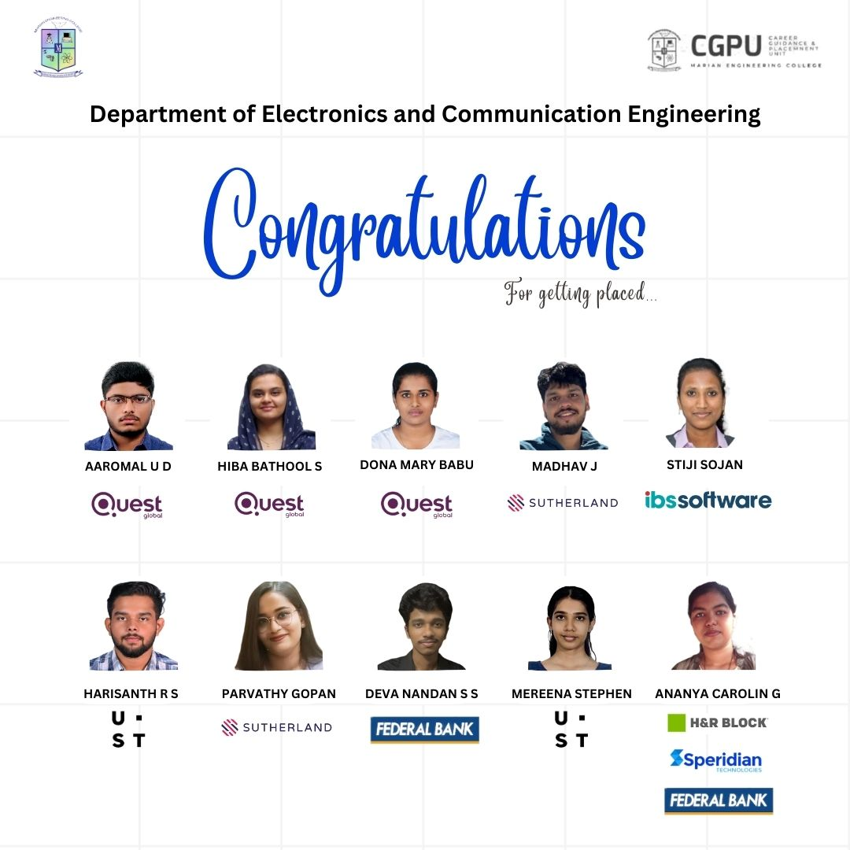

MARIAN CENTER OF EXCELLENCE IN AI & ML
Marian Center of Excellence (CoE) in AI & ML was established by Dept. of ECE, in the year 21-22 for scaling up the skill set of students through out of the syllabus learning, industry and live project exposure. CoE collaborates with UST, a leading multinational company for attaining its vision. Two batches of students were trained by UST in the fundamental of AI & ML, The sessions happened at Marian Engineering College Campus during the academic year 2022-23. 83 students were trained in the sector.
INDUSTRIAL VISITS
A campus visit to UST was conducted. CoE students visited UST and interacted with the resource persons from the company and got an insight on company functioning & project execution
.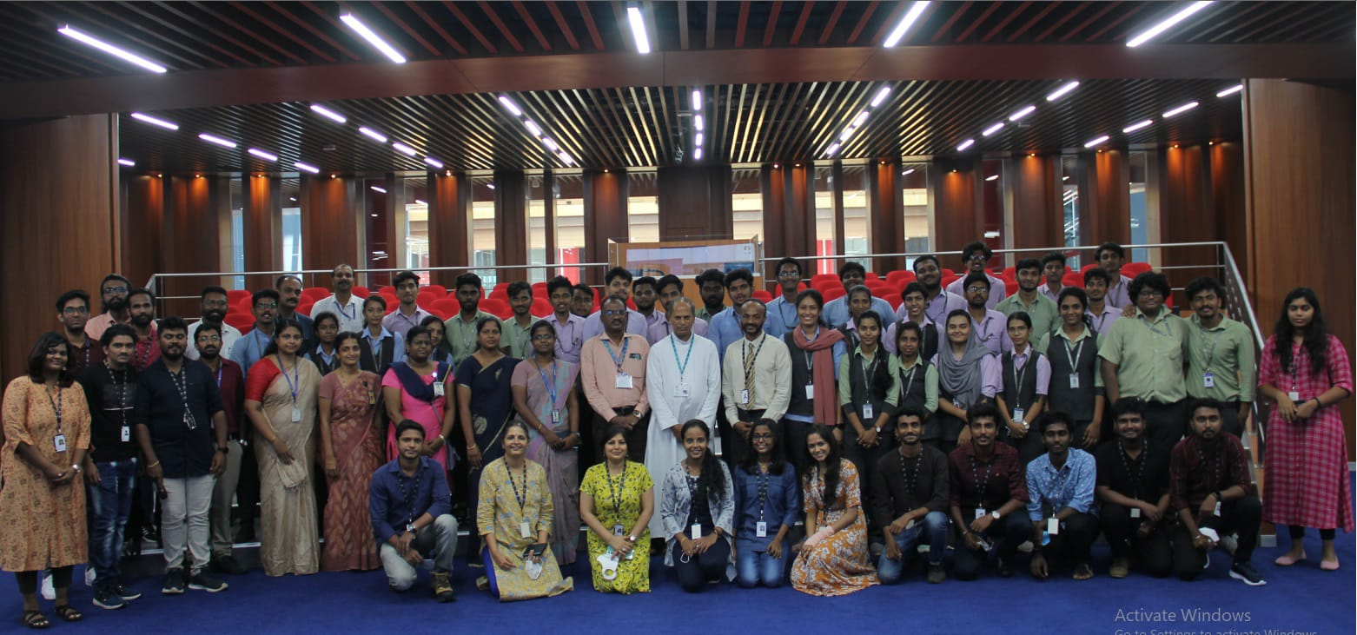
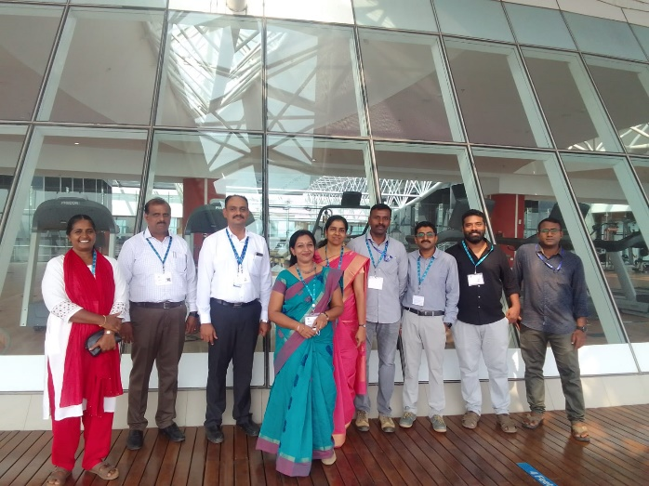
UST visit on 14th March, 2023
Placements through CoE
As a result of enhanced skill sets, students enrolled in CoE are easily getting placed in various organization, 29 students were placed in various companies. UST hired 16 students from the second batch itself.
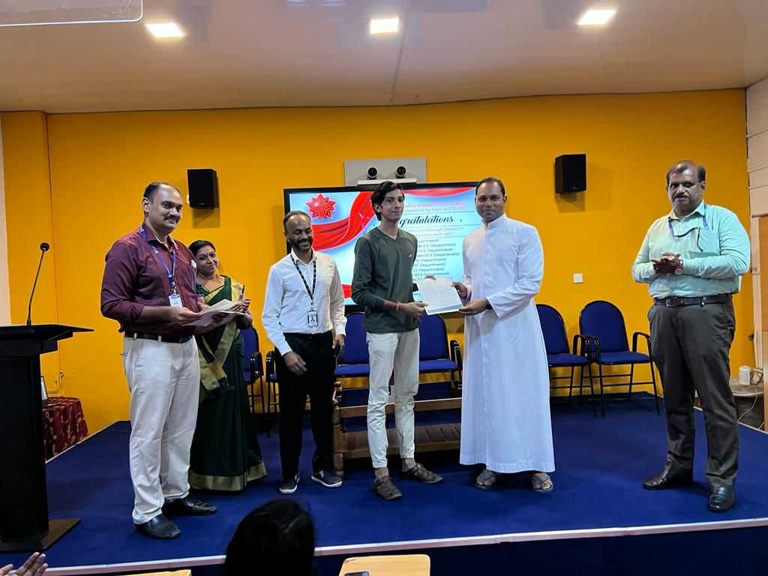 | 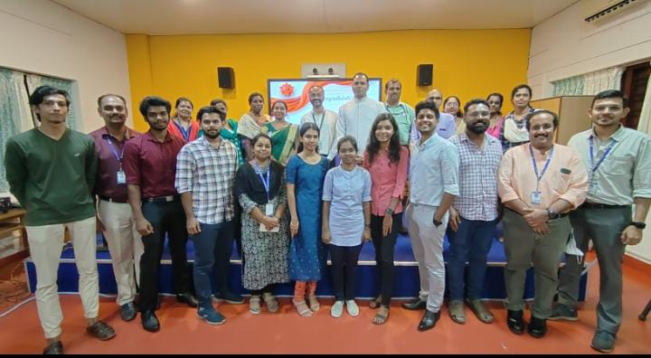
Offer letter distribution ceremony held on 13th July, 2023.

DEPARTMENT ACHIEVEMENTS
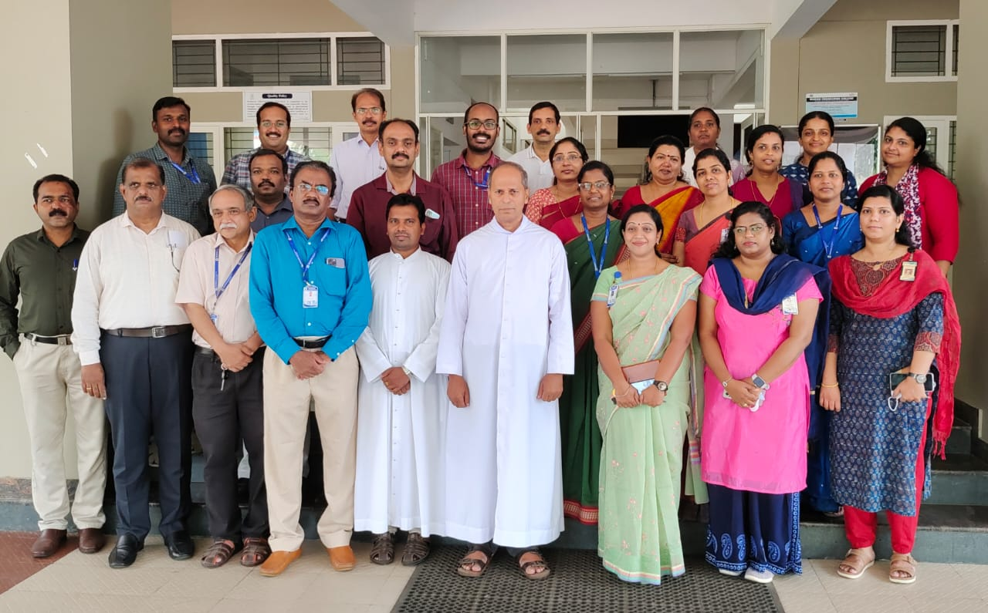
The NBA team visited the Dept. of ECE from 2nd to 4th December, 2022 and was declared as Accredited by January 2023.
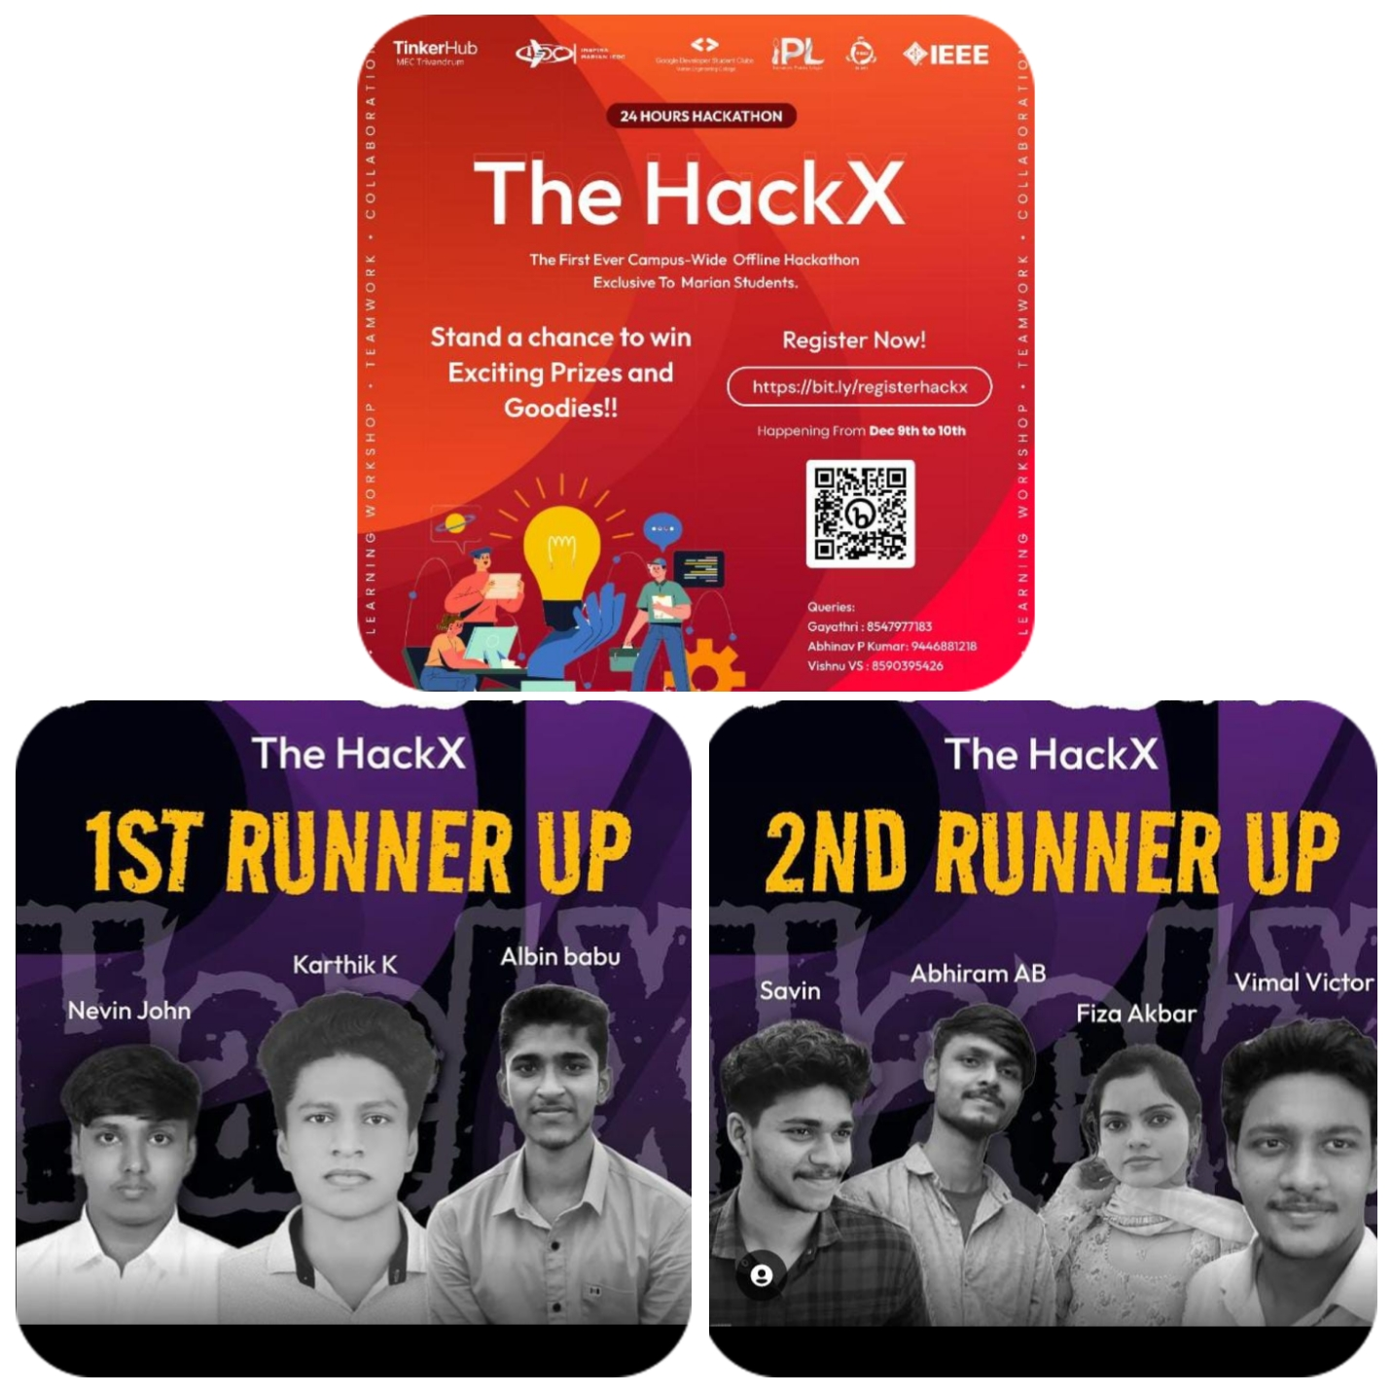
An Institution level Campus–wide Offline Hackathon ‘HackX’ was organized by IEDC, MEC for the Marian students as a platform for young innovators to showcase their talents. Team of First year, Second year and Third year students of ECE won the 1st and 2nd runner up.

FDP PARTICIPATED/ JOURNAL/ CONFERENCE

Faculty Name | FDP Attended | Name of the FDP
Ms. Preetha S l  Minnu Jayan C  Simi M.S | 6 days STTP organized by the Dept of CSE, Marian engineering Engineering college, Thiruvananthapuram from 29.8.22 to 3.9.22 | ARTIFICIAL INTELLIGENCE &  APPLICATIONS
Subha P S  Minnu Jayan C  Simi M S  Preetha S L  Ramola Joy P  Evankumar G  Mary Sunitha | 3 days FDP organized by the Dept of ECE, MBCCET,Peermade from 30.1.23 to 1.2.23 | Strategies for teaching -learning in the  context of NEP-2020
Minnu Jayan C | Online certfificate course organized by the Centre for Artificial Intelligence,TKM College of Engg from 26.8.22 to31.8.22 | DEEP LEARNING FOR BEGINNERS
Evan Kumar G | Two weeks fdp organized by the Dept of ECE, Amal Jyothy College of Engineering ,Kanjirapally from 27.2.23 to 10.3.23 | MATLAB & SDR Hands on for  communication engineering lab
Preetha S.L  Simi M.S | FDP organized by the Dept of ECE, CMR Institute of Technology,Bengaluru from 8.5.23 to 13.5.23 | Artificial Intelligence & Machine Learning for Image Analysis  -Matlab and Python perspective
CONFERENCE PUBLICATIONS

Minnu Jayan C (AP,ECE) ,presented and published, a paper entitled “A Survey on the Control Techniques used in Process Control”, in IEEE International Conference on Innovations in Engineering & Technology (ICIET-2023) at Ilahia college of engineering & Technology Muvattupuzha on 13th and 14th July, 2023.
Proceedings of 2023 IEEE International Conference on Innovations in Engineering & Technology
(ICIET-2023)
Minnu Jayan C (AP,ECE) , presented and published a paper entitled “A Review on Various Control echniques used in Industries”,in International Conference on Emerging Technologies in Engineering and Applied Sciences(ICETEAS 2023) , Noorul Islam Centre for Higher Education, Kumaracoil on 12th and 13th April 2023.
Proceedings of International Conference on Emerging Technologies in Engineering and Applied
Sciences (ICETEAS 2023).
Minnu Jayan C (AP,ECE) , presented a paper entitled RIPRESO: ELEPHANT PROTECTION SYSTEM AGAINST COLLISION WITH TRAINS, International Conference on Advanced Wireless Communication and Pervasive Technologies (ICAWCPT -23) ,MBCCET, Peermade on 25th and 26th May, 2023.
Ms. Vinitha B Elza (Asso.P,ECE), presented and published a paper entitled ‘Perspective on machine learning based investigated materials to realize Stable-Eficient-Toxin free(S-E-T) perovskite solar cells’ ,in International Conference on Materials and Sustainable Manufacturing(ICMISM -23), Vishnu Institute of Technology, Andra Pradesh on 16th and 17th Dec 2022.
DOI: 10.1016/ j.matpr.2023.04.640 Materials Today: proceedings

Ms. Vinitha B Elza (Asso.P,ECE), presented paper entitled ‘Numerical Analysis for Thermal Stability Evaluation of Perovskite Solar Cell using SCAPS-1D’, in 7th International onference on Nanoscience( and Nanotechnology (ICONN -2023) ,SRMIST DURING MARCH 27-29 ,2023
Ms. Ramola Joy P.(Asso.P, ECE), presented paper entitled “A Review on Retinal Disease Detection Methods using CNN from Fundus Image of the Retina”, in the International Conference On Emerging Technologies in Engineering and Applied Sciences ( ICETEAS 2023) on 12th and 13th April, 2023 organized by Dept. of ECE, NICHE, Kanyakumari.
Ms. Ramola Joy P.(Asso.P, ECE), presented paper entitled “A Comparative Study on Machine Learning Based Retinal Disease Detection Using Retinal Images”, in the International Conference On Advanced Research in Information and Communication Technologies ( ICARICT 2023) on 19th and 20th April, 2023 organized by Dept. of CSE and ECE, JP College of Engineering , Tenkasi.
Ms. Subha P.S (Asso.P, ECE), presented paper entitled “A Review on ECG Signal Denoising Techniques”, in the In the International Conference On Emerging Technologies in Engineering and Applied Sciences ( ICETEAS 2023) on 12th and 13th April,2023 organized by Dept. of ECE, NICHE, Kanyakumari.
Ms. Subha P.S (Asso.P, ECE), presented paper entitled “Analysis of ECG Signal Denoising Techniques”, in the International Conference On Advanced Research in Information and Communication Technologies ( ICARICT 2023) on 19th and 20th April, 2023 organized by Dept. of CSE and ECE, JP College of Engineering , Tenkasi.

FDP ORGANIZED
- 3 day FDP in AI and ROBOTICS was organized by the Department from August 31st to September 2nd, 2022.
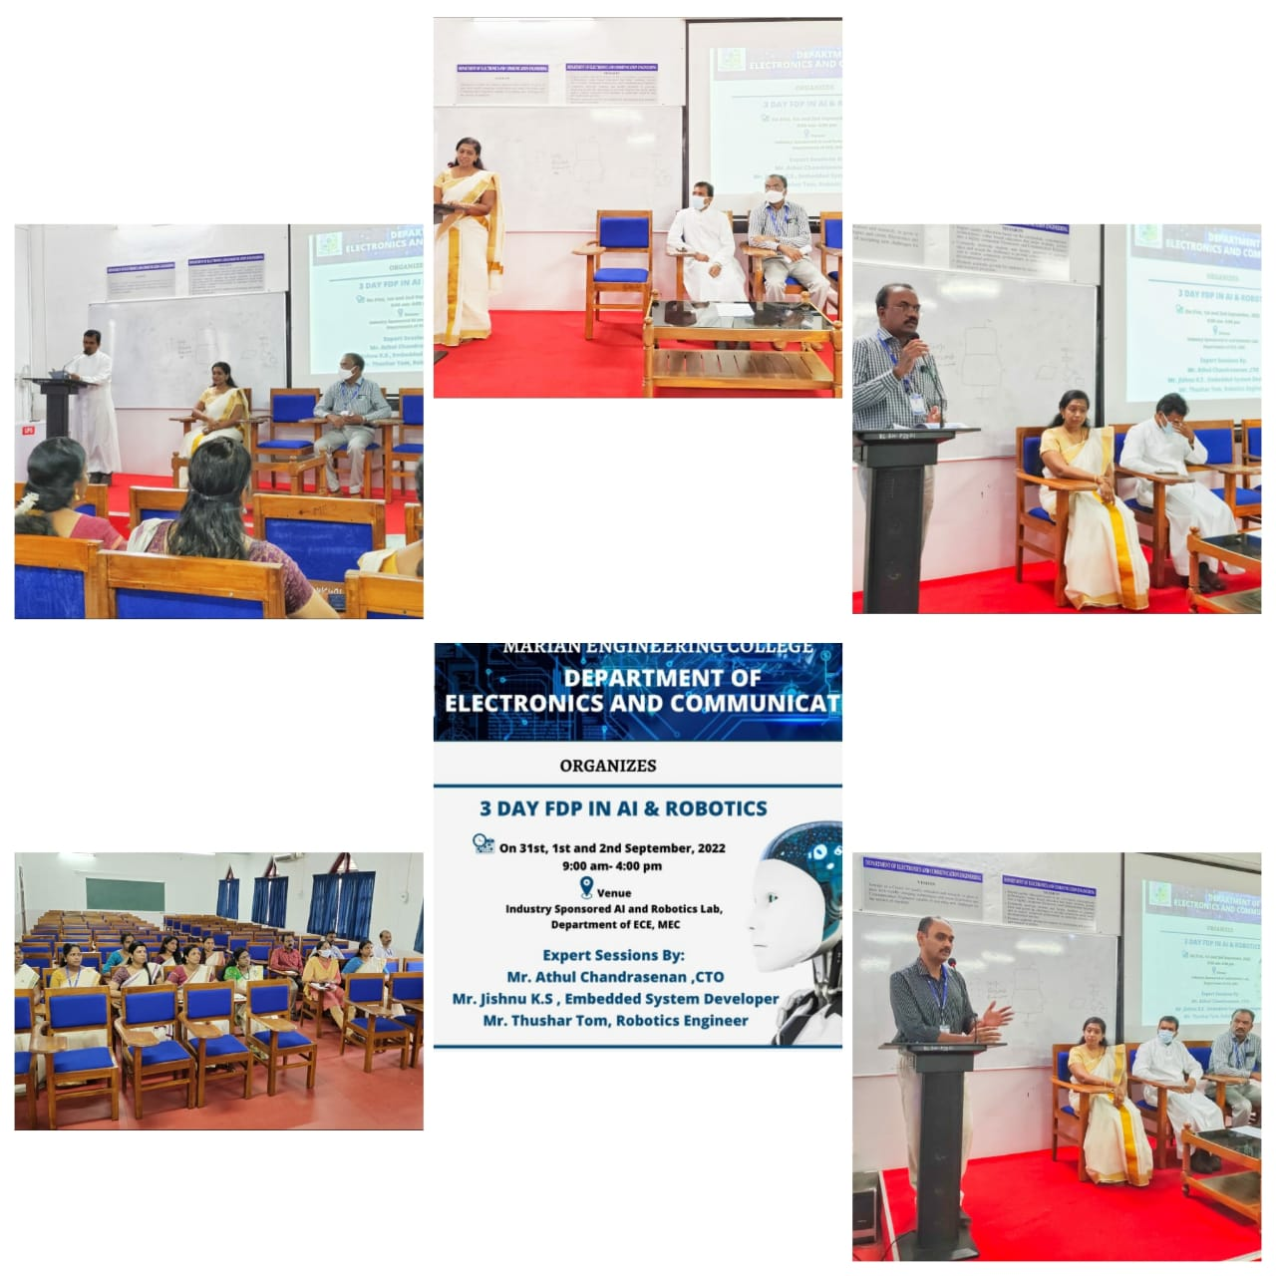

ELECTRONICS ASSOCIATION ACTIVITIES
- On 29/11/2022, the Electronics Association was inaugurated with the newly elected office bearers. The program began with prayer and welcome address by Nandana. S. Chandran (Student), presidential address by Manager, Fr. Wilfred. E followed by a keynote speech of the chief guests Anoop Mathew Uluvathu (Developer II Software Engineering at UST, Co-Founder and CTO at ZetGo, IEEEian) and Alan Mathew Uluvathu (ETL Developer at Guidehouse, Co-Founder of ZetGo, IEEEian). Later followed by a message from Principal, Dr. J. David and Dean, Dr. A. Samson. Felicitation was by Parvathy Gopan (Chairman, ECE association) and Jithin Thomas (Secretary, ECE association) and vote of thanks was given by Adithya A. S. (Joint Secretary, ECE association).

- On 07/12/2022, a talk on "Introduction to app development and entrepreneurship” was organized by the Electronics Association exclusively for S3 ECE students. The speaker was Dr. Abhishek. S, Managing Director, Deals Breezee Private Ltd.

- On 12/12/2022, a Drawing Competition on the theme of "Sustainable Development for Science and Technology" was conducted by the Electronics Association. The event aimed to encourage students to creatively express their ideas about sustainable development in the context of science and technology through their artwork. First prize: Nayana, Second prize: Krishna Dev. Winners were awarded with cash prize and certificates. Participation certificates were also provided.

- On 11/04/2023, a talk on "Career Building through Internship Programs” was organized by Electronics association. The speaker was Dr. Sreejith B. J, Assistant Professor, Dept. of Mechanical Engineering, SCT College of Engineering, Former assistant director of KTU.

- The event “2 - day hands on workshop of IoT, AI &ML”, by Electronics association in collaboration with Inspira Marian IEDC was held on 11th and 12th April, 2023. At the UST Sponsored Lab of ECE Department. The workshop mainly focused on creating modules in arduino and raspberry pi. Name of the event: 2-day hands on workshop of IoT, AI, & ML Date: 11-April-2023, 12-April- 2023, Venue: UST sponsored lab - ECE department.
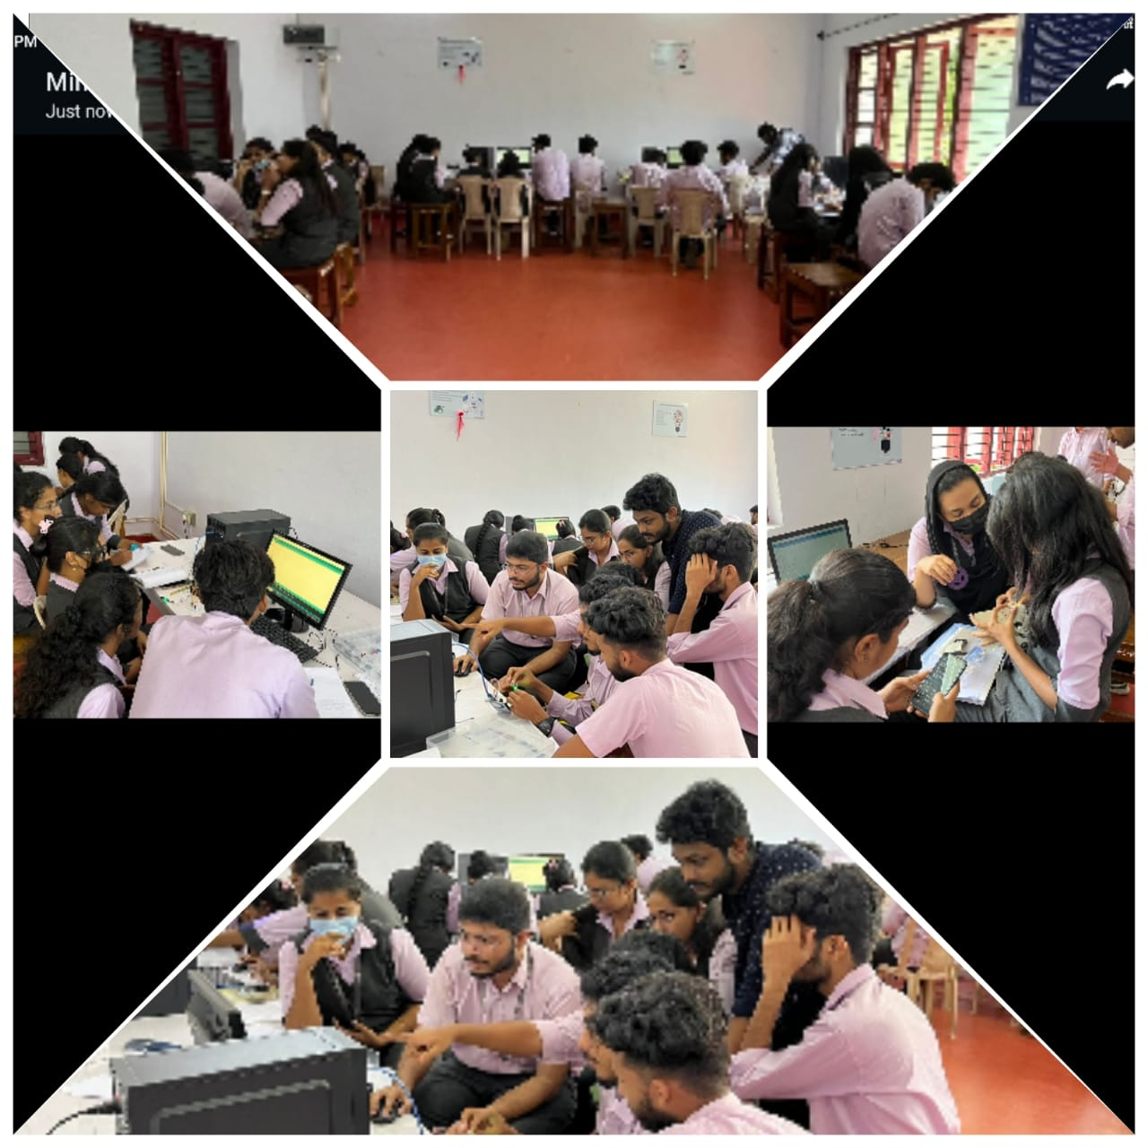
- On 27/04/2023, the Electronics Association organized a comprehensive and hands-on Web Development Workshop Class at AOC Lab. The workshop aimed to equip participants with the fundamental skills and knowledge required to design and develop functional websites. The class catered to individuals in enhancing their knowledge in web development.
‘Tech Expo’ 2023
On 26th June, Department of ECE organized an exciting and informative Project Exhibition ‘Tech Expo’ at Project Room of the department. The event aimed to showcase the talents and innovations of our students, foster interest in technology, and provide a platform for students to exhibit their projects and research in various technological fields.

STUDENT ACHIEVEMENTS

