AMETOS

CLUB MEMBERS
- Conveners:
Rani V (Associate Professors, MEC)

- Student coordinator (s)
Meera (S8C2), Secretary
Nora (S8C1), Joint Secretary
Arshad (S8C1), Programe Co-ordinator
Athul (S8C2), Programe Co-ordinator
Radhika (S8C1), Treasurer
Louna (S8C2), Treasurer

Executive Members:
Janaki (S6C)
Rency (S6C)
Vaishnav (S6C)
Mary Julie (S6C)
Ashna (S6C)
Bharath (S4C1)
Ariya P (S4C1)
Krishnapradhap (S4C2)
Aleena (S4C2)
Jithin (S4C2)
Afna (S4C2)

ACTIVITY REPORT MARCH-APRIL 2022

Inauguration of Civil Association (AMETOS) of Marian Engineering College for the academic year 2021-2022 was conducted on 29th April 2022 by Lakshmy A.S, Assistant Engineer at Irrigation Department and Parvathy A. S, Assistant Engineer at LSGD.
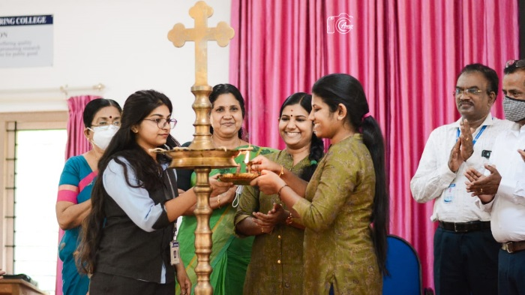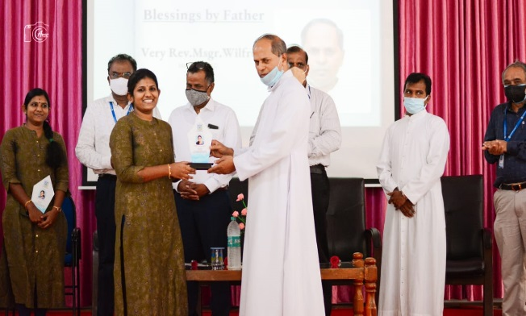
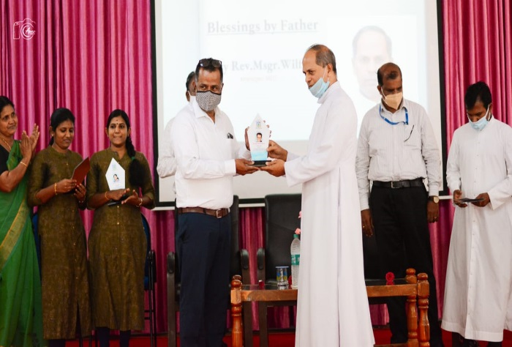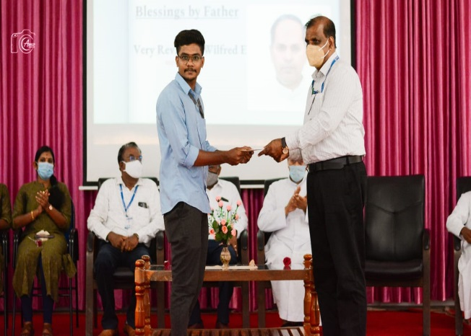

The Inaugural ceremony was followed by a talk on the topic Opportunities for civil Engineers in Australia by Er. Biju Balakrishnan , National Technical Engineering Manager at Intrax Consulting Engineers Pvt. Ltd .The session involved details on various Civil Engineering Fields and the opportunities and procedures to pursue engineering abroad.

