ACTIVITY REPORT 2020-21
- AMETOS, the Civil Engineering Association of MEC organized a technical talk on “Project Life Cycle” on 16th October, 2020. The session was handled by Dr. C.T. Ramanathan, Deputy Project Director, Pembinan Azam Jaya SDN, BHD, Malaysia. Dr. C.T. Ramanathan gave an in depth view of the four attributes, phases and various concepts regarding “Project Life Cycle”. The talk focussed about how a project is selected to fulfil the requirements of the society. He also explained on how the various phases make up a path to take the project from the beginning to the end. The online session was held through Google Meet and attended by around 100 participants. All participants were provided with e-certificates.
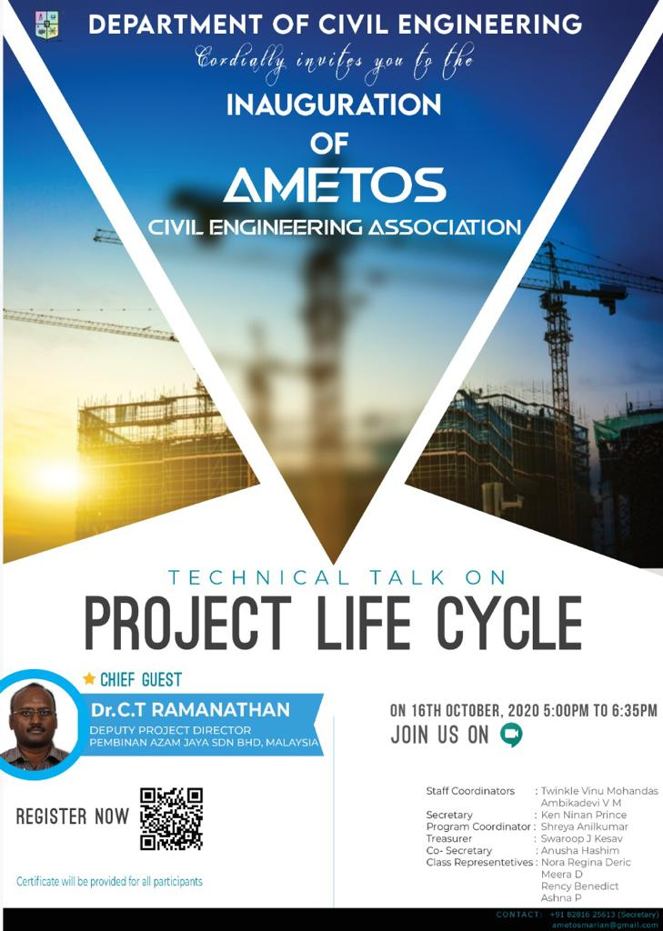
Technical talk on “Project Life Cycle”

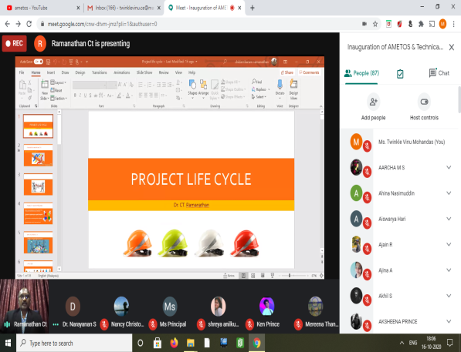
Screen shot taken during the Technical talk on “Project Life Cycle”

- AMETOS, the Civil Engineering Association of MEC organized a “Logo Designing Competition”. The main objective of this competition was to design an official logo for Ametos. The cash prize for the winner was Rs 500. The winner of the competition was Naveen S R of S8M1. The official logo was launched on 11th October, 2020. All the participants of the competition were provided with e-certificates.
Official logo of AMETOS
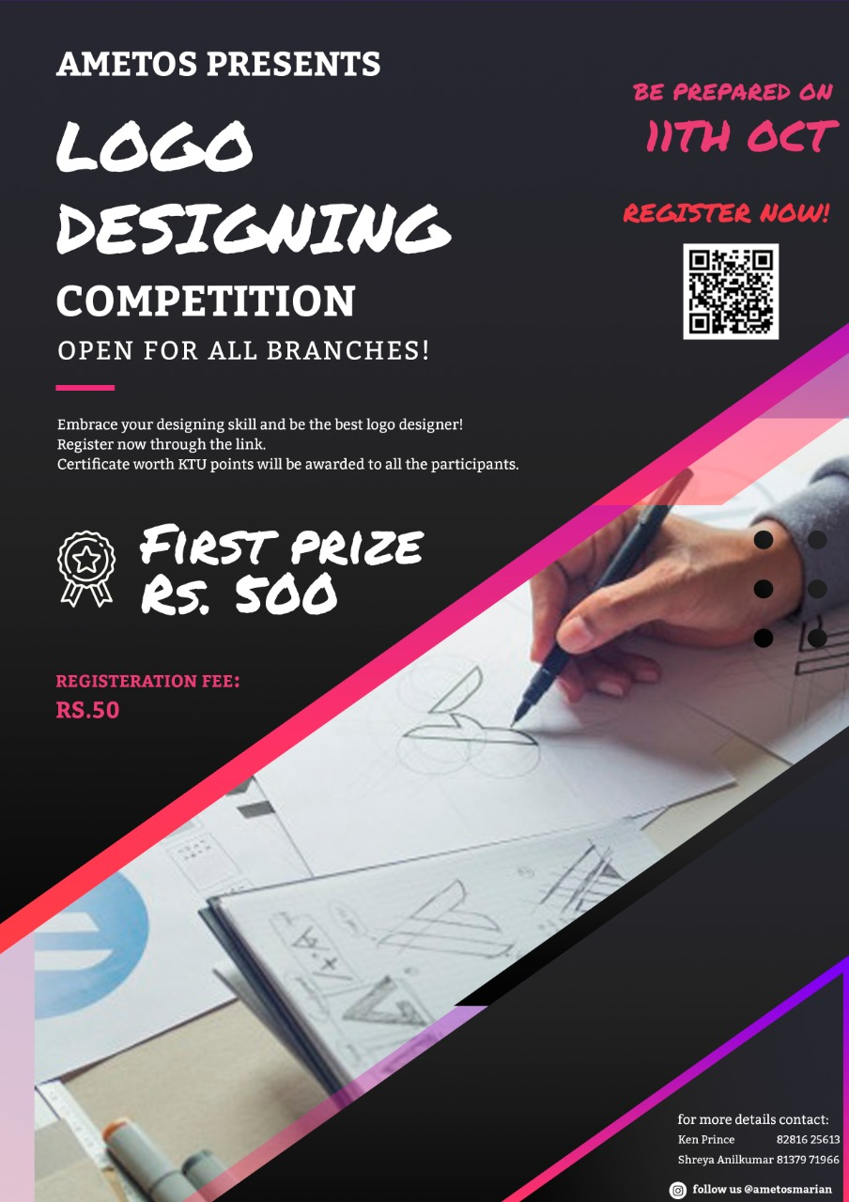
Poster of “Logo Designing Competition”

- AMETOS, the Civil Engineering Association of MEC organized a webinar on “Academic Projects with BIM” on 23rd October, 2020. The webinar was handled by Ms. SujishaV, Assistant Manager of BIMLABS. The talk focussed on the importance on analytical experiments than lab experiments during this period. The importance of BIM or Building Information Modelling was explained well by the speaker Ms. Sujisha V. The online session was held through Google Meet and attended by around 55 participants. All participants were provided with e-certificates.
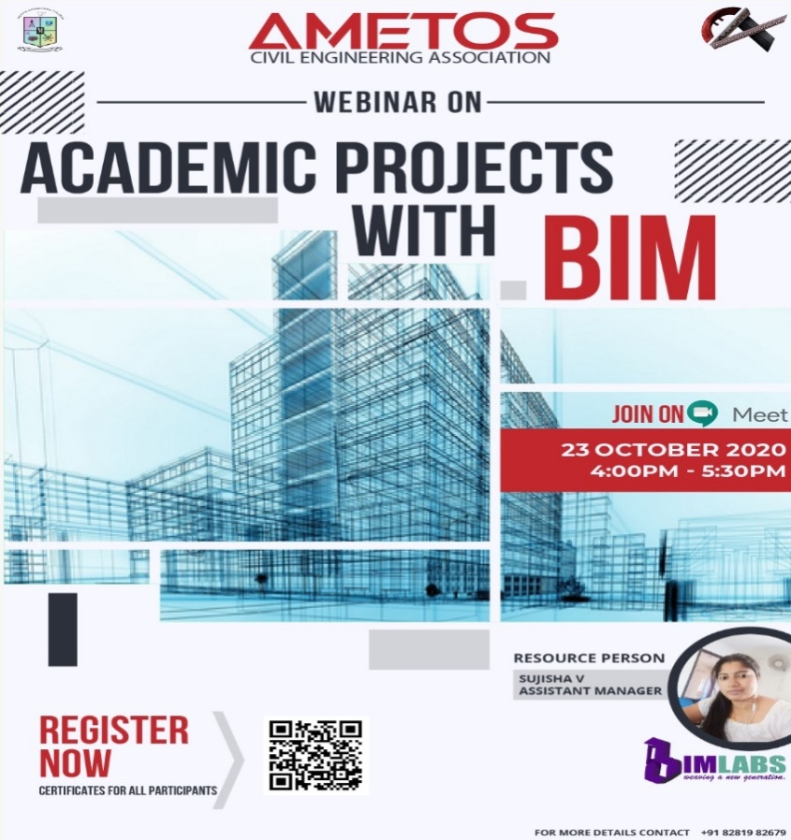
Poster for the Webinar on “Academic Projects with BIM”

- The Department of Civil Engineering in association with MEC IEI Civil Engineering Students Chapter organized a technical talk on “Modern Trends In Design And Construction Of Air Traffic Control Towers And Cabins” on 31st October, 2020. The session was handled by Mr. Unni Bhaskar, Managing Director, UNO Technology Pvt Ltd. Mr. Unni Bhaskar explained the basics of air traffic control towers and cabins. The webinar highlighted the design and construction challenges in air traffic control towers. The online session was held through Google Meet and attended by around 65 participants. All participants were provided with e-certificates.
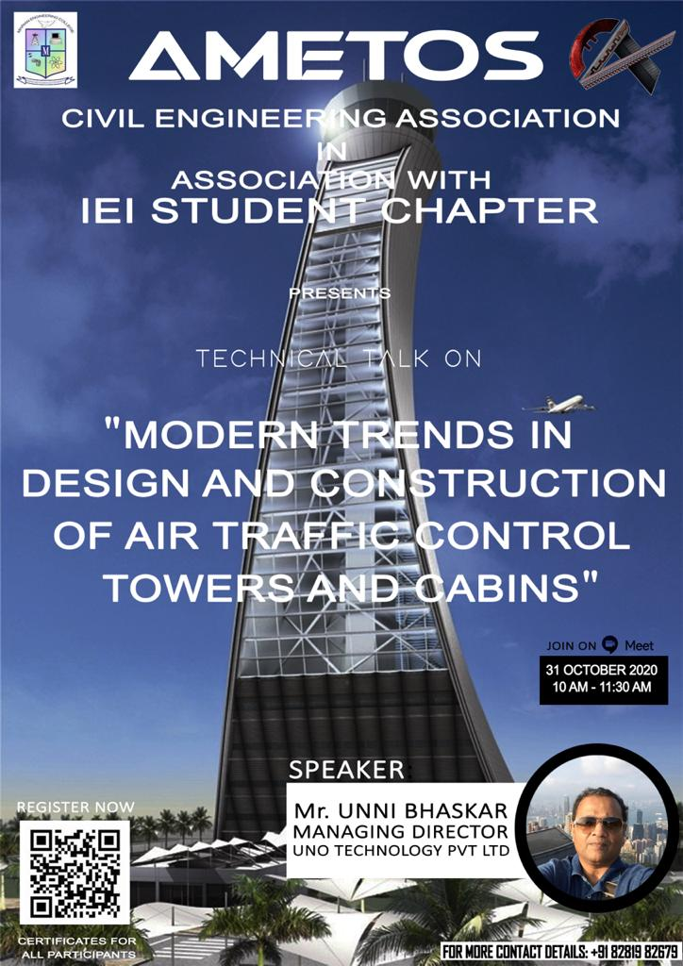
Brochure of the Technical talk on “Modern Trends In Design And Construction Of Air Traffic Control Towers And Cabins”

- AMETOS, the Civil Engineering Association of MEC in Association with Civilianz organized a webinar on “Career Openings for Civil Engineers in Public Sector” on 11th June, 2021. The webinar was handled by Ms.Pavithra V, Manager, Corporate Relations at Civilianz. Ms. Pavithra V, with profound knowledge in various dimensions of career opportunities in Civil Engineering and excellent communication skills, has been working as Manager in the Corporate Relations department of Civilanz since 2020. She explained the details regarding different entrance examinations, how to begin the process of preparation for these examinations and the different job opportunities civil engineers can make use of after graduation. She also explained the importance of writing the GATE exam for those students wishing to continue their studies in India and explained the details regarding preparation, applying etc. in a simple and concise manner. The online session was held through Google Meet and attended by around 56 participants.All participants were provided with E-certificates.
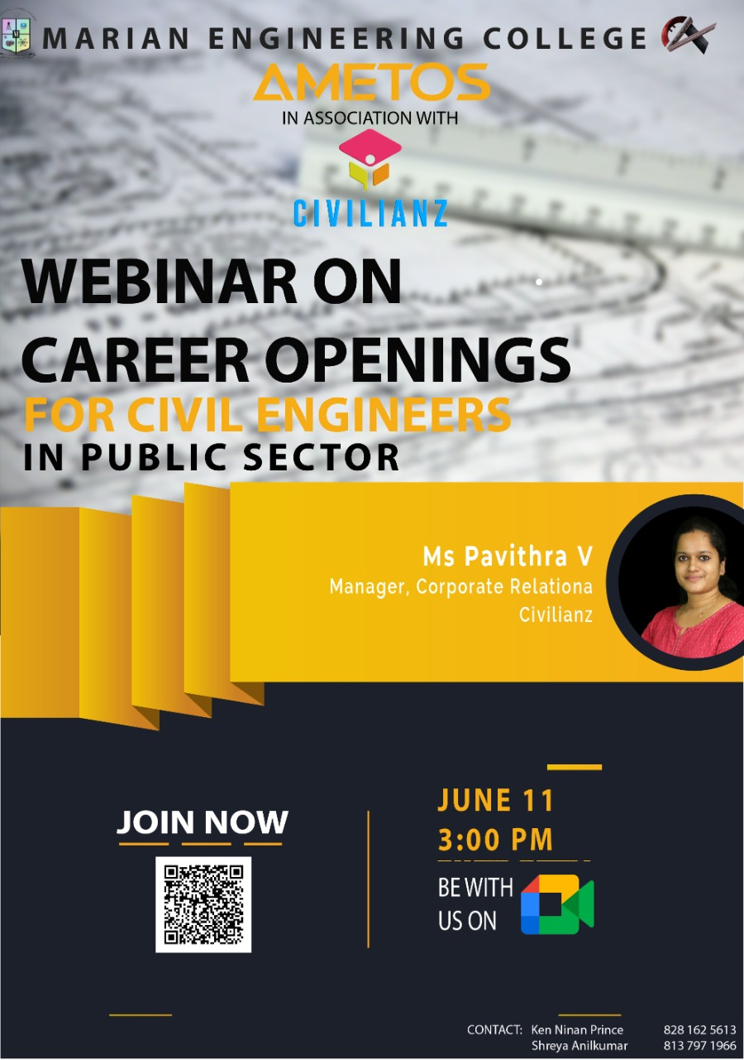
Brochure of the Webinar on “Career Openings For Civil Engineers in Public Sector”
- AMETOS, the Civil Engineering Association of MEC organized an Online Quiz Competition on Environmental Day on 4thJune 2021. The quiz was conducted on an online game based learning platform, Kahoot! It was coordinated by the members of AMETOS and the supervised by Prof. Ambikadevi VM, Asst Professor Civil Engineering department and faculty in charge. The quiz was conducted to commemorate the World Environment Day and it was aimed to create more awareness on the importance of the day within the student community. 11 students participated in the quiz. The first and second prizes of the competition were won by Magi N S, M4GT and the D Sabrish, S6EC respectively. The winners also won a cash prize of Rs. 300 for first place and Rs. 200 for runner up. All other participants were provided with E-certificates for their enthusiastic participation.

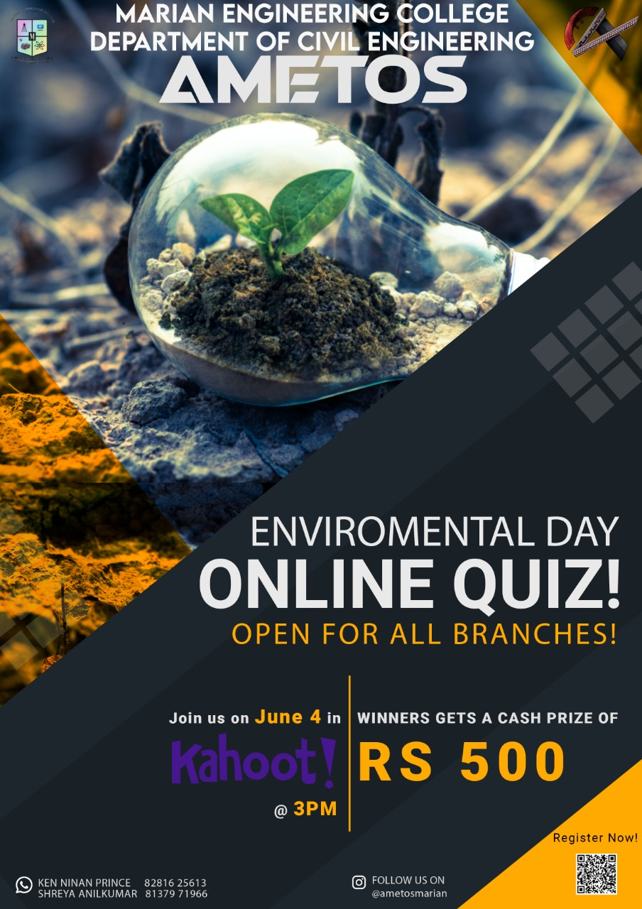
Poster of the Online quiz competition to commemorate World Environment Day

