IEEE EVENTS NOV-DEC
OPEN STREET MAPPIN TRAINING
IEEE SB MCE conducted a training session on OSM by an SB member, Abhyshek R on the 28th of November, 2020 at 8pm. It was a session on how to sign up and get started on mapping. The Execom members along with the volunteers took part.
UNSCRAMBLE IT
Date: 12th December
Venue: Online
IEEE SB MCE conducted the event 'UNSCRAMBLE IT' via Google meet on the 12th of December 2020.
Participants were given the chance to showcase their extensive technical vocabulary.
Participants were given a jumbled word and a clue based on which they were to unscramble the jumbled word.
The event was grand success and was recieved very well by the participants.
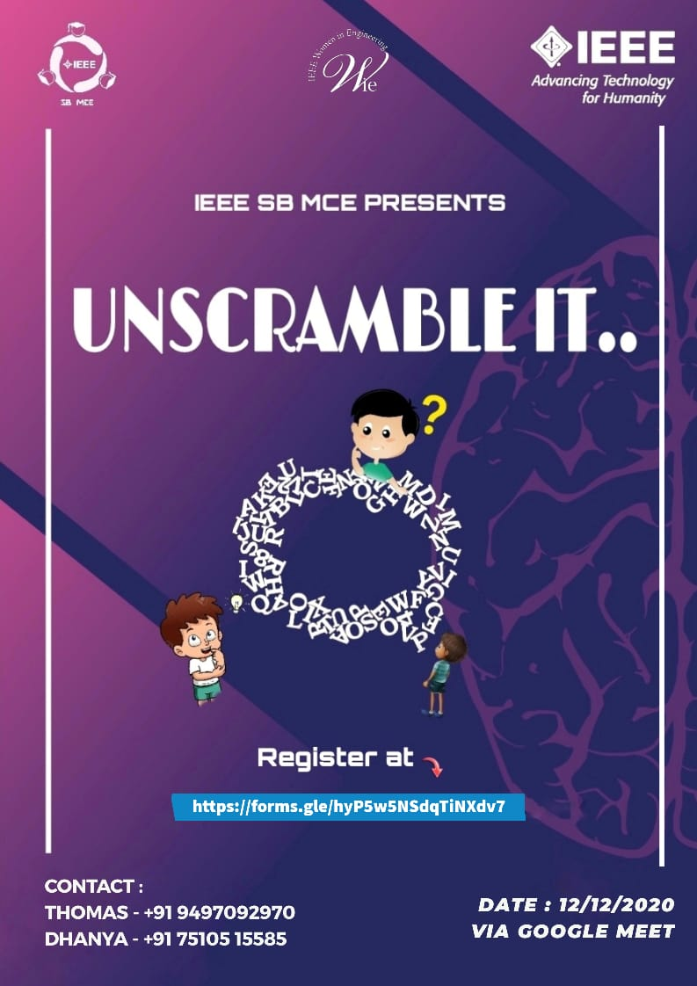
Winners
1. CS - Ryan Hubert(S5) & Ryan Cleetus(S5)
2. EEE- Arsha T J, Ritu Nanda S,Lija M S (S3E)
3. EC- Abhyshek R(S5T)
4. CIVIL- Fathima Parveen(S3C)
5.MECH- Akhil G(S3M1)

