TECHNICAL ARTICLE WRITING COMPETITION
Platform (Website): https://dare2compete.com/o/em7WzBK

Date & Time: 15 Oct'20 12:00 AM IST - 21 Oct'20 11:59 PM IST

No. Of Submissions: 20

Participants could select a topic on their own or choose one from the given topics:

1. 3D Printing Technology
2. Augmented Reality vs Virtual Reality
3. Tech's Role in Tracking, Testing, Treating COVID-19

Participants submitted their entries in pdf/docx format.

Judging Criteria:
• Content Clarity
• Technical Complexity
• Style
• Grammar and Mechanics

STICKER MAKER COMPETITION

Date of Event: 17/10/2020 (Saturday)

Time: 5-7Pm

No. Of Submissions: 23

Platform: WhatsApp

Topic: Sticker related to their department.

Participants were added to the WhatsApp group and they were given general guidance on the date of the competition. Topic was provided by 5 p.m. to the contestants. Participants then sent their sticker(s) to the event organisers in private. Based on the judgement criterion, stickers have been properly evaluated. The winners were announced on 19/10/2020.
Judging criteria:
• Uniqueness
• Closeness to the topic.
• Overall quality
• New concepts

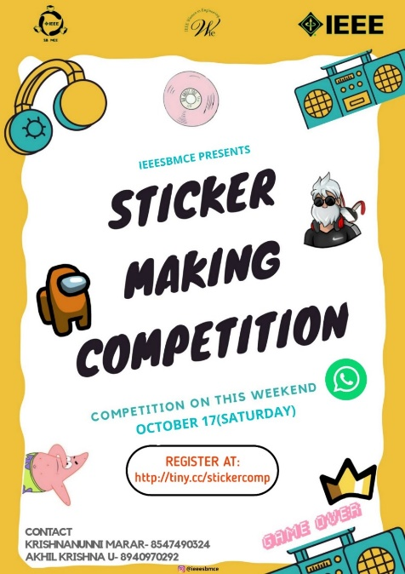

QUIZZICH
IEEE SB MCE held a quiz competition for 12th and 12th pass outs on the 2nd of October from 9am to 9pm. The quiz was technical with questions from Physics, Chemistry, Math and General knowledge. Prize money was also offered to first and second place winners.
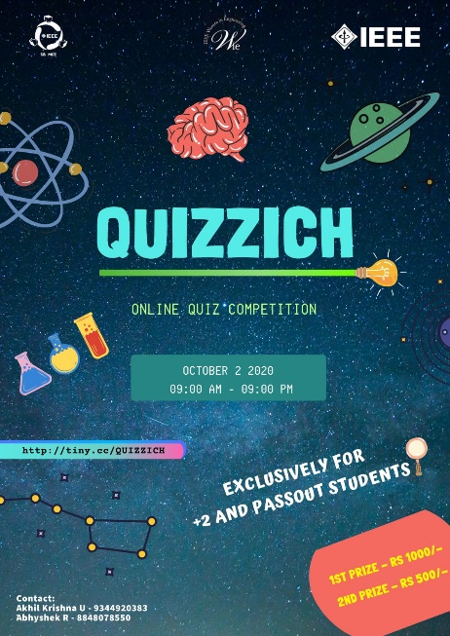
VOLUNTEER TRAINING
IEEE SB MCE collaborated with IEEE PES SBC MCE to conduct a training session for new volunteers over the month October. A total of 28 volunteers had joined the student branch.
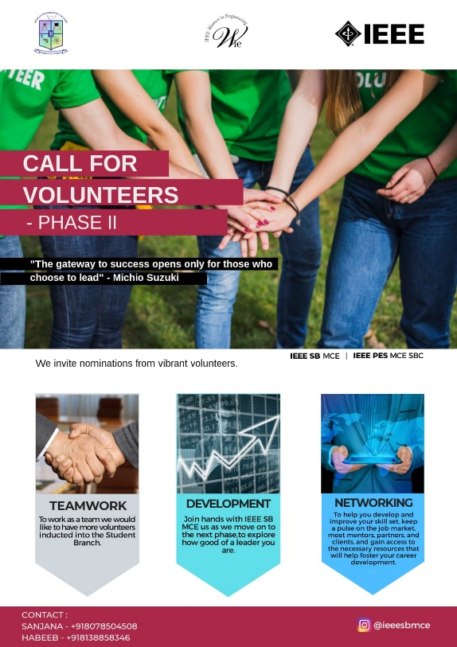
C++ TRAINING
IEEE SB MCE conducted a training session for C++ programing by an SB member, Sheni Nevil on 26th October, 2020. It was a session about the basics with logic of C++. The execom members took part.
OPEN STREET MAPPIN TRAINING
IEEE SB MCE conducted a training session on OSM by an SB member, Abhyshek R on the 28th of November, 2020 at 8pm. It was a session on how to sign up and get started on mapping. The Execom members along with the volunteers took part.

