Date : 15th October 2017
Venue : Marian Engineering College
Time : 9:30 am – 4:45 pm
No. of participants : 59
Web development workshop was conducted by IEEE SB MCE as a one day event in Marian Engineering college. A total of 59 students from different colleges participated in the event
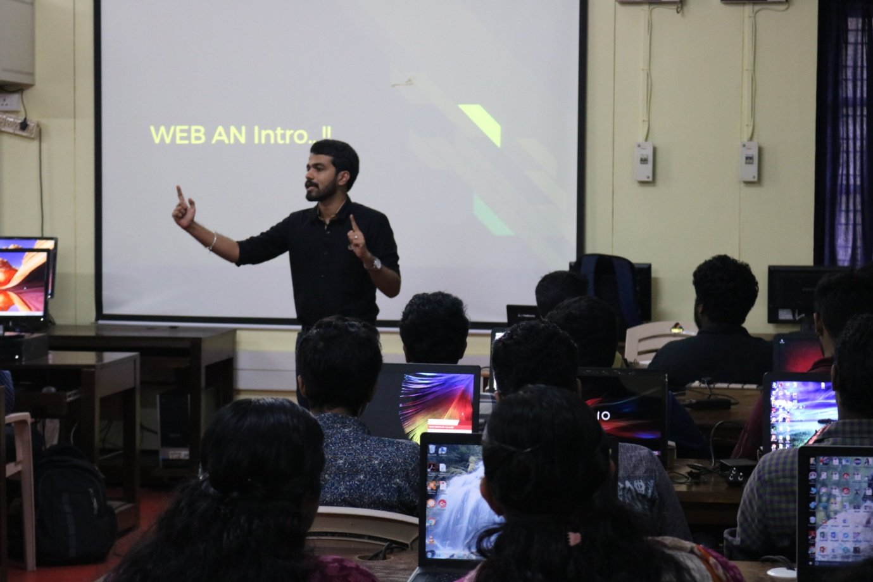

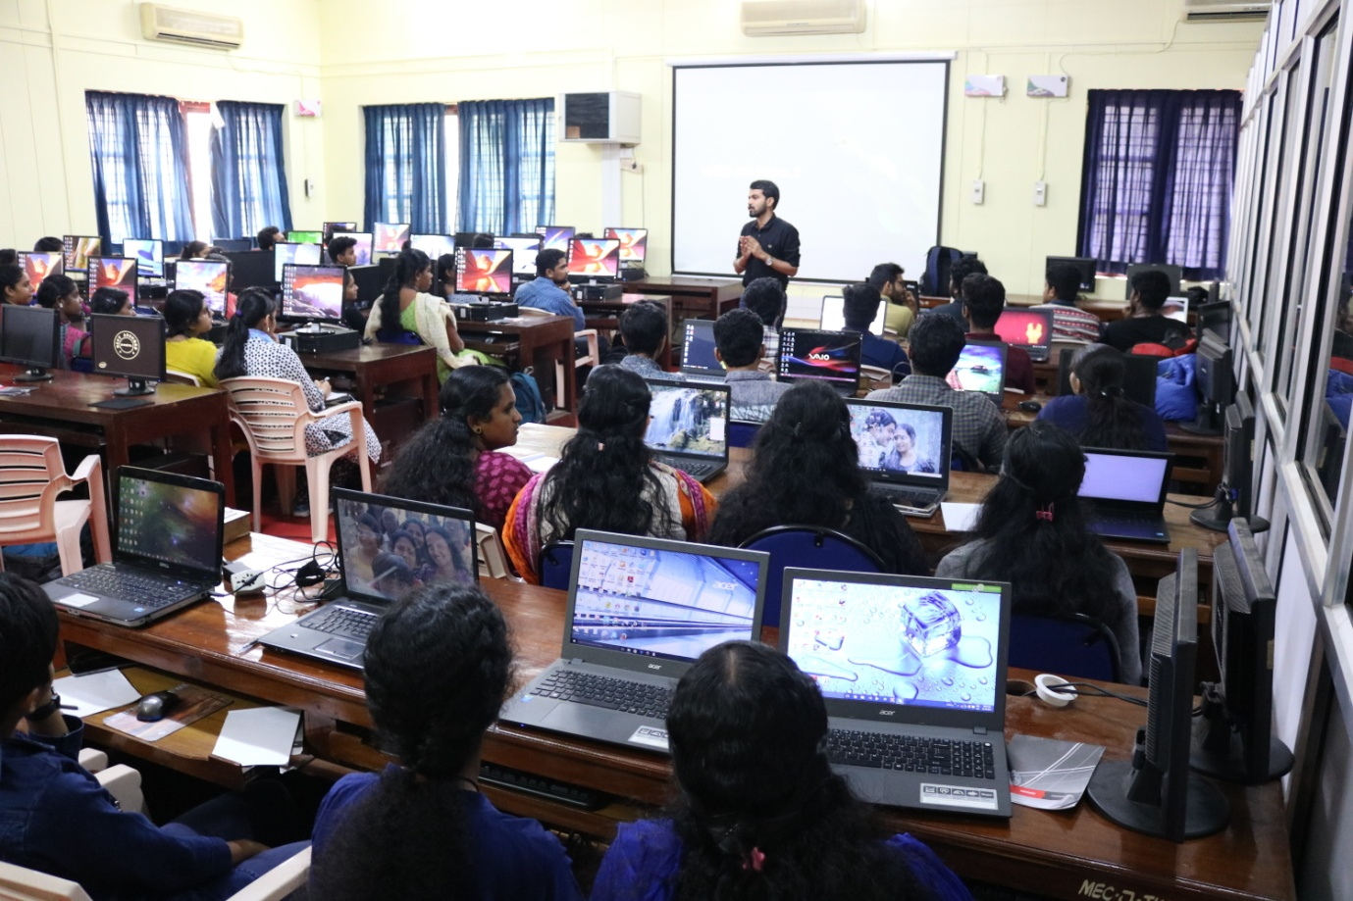

Date : 15th October 2017

Venue : Marian Engineering College

Time : 8:30 am - 5:00 pm

No. of participants : 60

Python workshop was conducted by IEEE SB MCE as a one day event in Marian Engineering College. A total of 60 students from different colleges participated in the event.

