IEEE SB MCE
WEBINAR ON INTERVIEW SKILSS
Venue: Online session(Google meet)
•IEEE SB MCE conducted a webinar on “Interview skills” on the 13th of June 2020. The session was very interesting and helped the participants to understand the various etiquettes that are to followed while attending an interview.
•The session was hosted by Ms. Aathira Marayil, software developer at Lulu Forex
•Ms Aathira Marayil is also an IEEE young professional.
•The participants were familiarized with the basic etiquettes that are to be followed in the professional world.
•Ms.Aathira Marayil also shared her own experiences attending interviews and acing them.
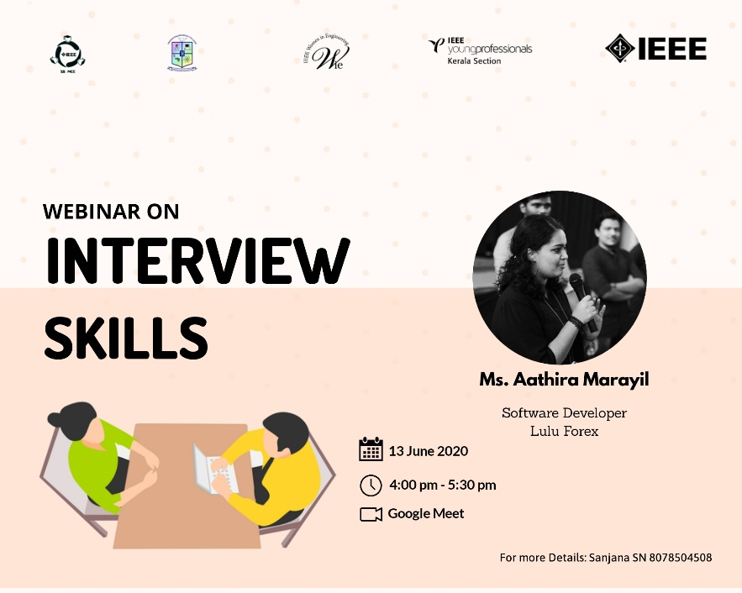
•The webinar was very informative.

