SIGNIFICANCE OF TECHNICAL COMMUNICATION
Technical communication is a broad field and includes any form of communication that exhibits one or more of the following characteristics: Communicating about technical or specialized topics, such as computer applications, medical procedures, or environmental regulations.
Technical communication is a task performed by specialized employees or consultants. For example, a professional writer may work with a company to produce a user manual. Some companies give considerable technical communication responsibility to other technical professionals—such as programmers, engineers, and scientists. Often, a professional technical writer edits such work to bring it up to modern technical communication standards.
To begin the documentation process, technical communicators identify the audience and their information needs. The technical communicator researches and structures the content into a framework that can guide detailed development. As the body of information comes together, the technical communicator ensures that the intended audience can understand the content and retrieve the information they need. This process, known as the writing process, has been a central focus of writing theory since the 1970s, and some contemporary textbook authors apply it to technical communication. Technical communication is important to most professions, as a way to contain and organize information and maintain accuracy.
The technical writing process is based on Cicero's 5 canons of rhetoric, and can be divided into six steps:
1. Determine purpose and audience
2. Collect information (Invention)
3. Organize and outline information (Arrangement)
4. Write the first draft (Style)
5. Revise and edit (Memory)
6. Publish output (Delivery)
Good technical communication is accurate, clear, concise, coherent, and appropriate. In the prose of science and technology, these qualities are sometimes difficult to achieve.
Purpose of Technical Communication
The purpose of technical communication is to make information clear and understandable in order to make business more productive and consumer goods more convenient. Technical communication helps to advance our economy by ensuring viable research and development, safeguarding design and manufacturing, and protecting consumers through accurate and informative documents. Good technical writing will:
Help employers understand and complete job tasks more successfully.
Prevent problems with the development and manufacturing of products.
Inform consumers how to assemble, fix or use a product.
Module 1. USE OF LANGUAGE IN COMMUNICATION

Communication

Communication skills are vital to a healthy, efficient workplace. Often categorized as a “soft skill” or interpersonal skill, communication is the act of sharing information from one person to another person or group of people. There are many different ways to communicate, each of which plays an important role in sharing information.
Importance of communication
We use communication every day in every environment, including in the workplace. Whether you give a slight head nod in agreement or present information to a large group, communication is absolutely necessary when building relationships, sharing ideas, delegating responsibilities, managing a team and much more.
Learning and developing good communication skills can help you succeed in your career, make you a competitive job candidate and build your network. While it takes time and practice, communication and interpersonal skills are certainly able to be both increased and refined.
There are four main types of communication we use on a daily basis: verbal, nonverbal, written and visual. With all of these communication styles, it’s most effective when you know how to actively listen, observe and empathize. Developing these soft skills can help you better understand a message and respond thoughtfully.
1. Verbal Communication
Verbal communication is the use of language to transfer information through speaking or sign language. It is one of the most common types, often used during presentations, video conferences and phone calls, meetings and one-on-one conversations. Verbal communication is important because it is efficient. It can be helpful to support verbal communication with both nonverbal and written communication.
Here are a few steps you can take to develop your verbal communication skills:
Use a strong, confident speaking voice. Be confident when speaking so that your ideas are clear and easy for others to understand.
Use active listening. The other side of using verbal communication is intently listening to and hearing others. Active listening skills are key when conducting a meeting, presentation or even when participating in a one-on-one conversation. Doing so will help you grow as a communicator.
Avoid filler words. It can be tempting, especially during a presentation, to use filler words such as “um,” “like,” “so” or “yeah.” While it might feel natural after completing a sentence or pausing to collect your thoughts, it can also be distracting for your audience. Try presenting to a trusted friend or colleague who can call attention to the times you use filler words. Try to replace them by taking a breath when you are tempted to use them.
2. Nonverbal Communication
Nonverbal communication is a way for people to express their thoughts or emotions without words or it is the method of communicating with others using actions rather than words. This can include communication using hand gestures, eye contact, body language, appearance, touch and tone of voice. Nonverbal communication can be one of the strongest forms of communication between employees and supervisors. It can take place in many workplace situations including during meetings, interviews or casual conversations. It can be used both intentionally and unintentionally. For example, you might smile unintentionally when you hear a pleasing or enjoyable idea or piece of information.
If they are displaying “closed” body language, such as crossed arms or hunched shoulders, they might be feeling anxious, angry or nervous. If they are displaying “open” body language with both feet on the floor and arms by their side or on the table, they are likely feeling positive and open to information. With nonverbal communication, people can express happiness, engagement, concern, gratitude and confidence throughout their workday.
Here are a few steps you can take to develop your nonverbal communication skills:

Notice how your emotions feel physically. Throughout the day, as you experience a range of emotions (anything from energized, bored, happy or frustrated), try to identify where you feel that emotion within your body. For example, if you’re feeling anxious, you might notice that your stomach feels tight. Developing self-awareness around how your emotions affect your body can give you greater mastery over your external presentation.
Be intentional about your nonverbal communications. Make an effort to display positive body language when you feel alert, open and positive about your surroundings. You can also use body language to support your verbal communication if you feel confused or anxious about information, like using a furrowed brow. Use body language alongside verbal communication such as asking follow up questions or pulling the presenter aside to give feedback.
Mimic nonverbal communications you find effective. If you find certain facial expressions or body language beneficial to a certain setting, use it as a guide when improving your own nonverbal communications. For example, if you see that when someone nods their head it communicates approval and positive feedback efficiently, use it in your next meeting when you have the same feelings.
Nonverbal communication examples in the workplace
1. Maintaining regular eye contact
2. Positive vocal tone
3. Strong presentation and appearance
4. Keeping an upright posture
5. Expressing kindness or professionalism through touch
6. Displaying engaging facial expressions
7. Providing enough space to maintain a conversation
8. Using hand gestures to express feeling
9. Showing feeling through body movement, etc.
3. Written Communication
Written communication is the act of writing, typing or printing symbols like letters and numbers to convey information. It is helpful because it provides a record of information for reference. Writing is commonly used to share information through books, pamphlets, blogs, letters, memos and more. Emails and chats are a common form of written communication in the workplace.
Here are a few steps you can take to develop your written communication skills:
Strive for simplicity. Written communications should be as simple and clear as possible. While it might be helpful to include lots of detail in instructional communications, for example, you should look for areas where you can write as clearly as possible for your audience to understand.
Don’t rely on tone. Because you do not have the nuance of verbal and nonverbal communications, be careful when you are trying to communicate a certain tone when writing. For example, attempting to communicate a joke, sarcasm or excitement might be translated differently depending on the audience. Instead, try to keep your writing as simple and plain as possible and follow up with verbal communications where you can add more personality.
Take time to review your written communications. Setting time aside to re-read your emails, letters or memos can help you identify mistakes or opportunities to say something differently. For important communications or those that will be sent to a large number of people, it might be helpful to have a trusted colleague review it as well.
Keep a file of writing you find effective or enjoyable. If you receive a certain pamphlet, email or memo that you find particularly helpful or interesting, save it for reference when writing your own communications. Incorporating methods or styles you like can help you to improve over time.

4. Visual Communication
Visual communication is the act of using photographs, art, drawings, sketches, charts and graphs to convey information. Visuals are often used as an aid during presentations to provide helpful context alongside written and/or verbal communication. Because people have different learning styles, visual communication might be more helpful for some to consume ideas and information.
Here are a few steps you can take to develop your visual communication skills:

Ask others before including visuals. If you are considering sharing a visual aid in your presentation or email, consider asking others for feedback. Adding visuals can sometimes make concepts confusing or muddled. Getting a third-party perspective can help you decide whether the visual adds value to your communications.
Consider your audience. Be sure to include visuals that are easily understood by your audience. For example, if you are displaying a chart with unfamiliar data, be sure to take time and explain what is happening in the visual and how it relates to what you are saying. You should never use sensitive, offensive, violent or graphic visuals in any form.
To make improvements to your communication skills, set personal goals to work through the things you want to accomplish step by step. It might be helpful to consult with trusted colleagues, managers or mentors to identify which areas would be best to focus on first.

SIGNIFICANCE OF TECHNICAL COMMUNICATION
Technical communication is a broad field and includes any form of communication that exhibits one or more of the following characteristics: Communicating about technical or specialized topics, such as computer applications, medical procedures, or environmental regulations.
Technical communication is a task performed by specialized employees or consultants. For example, a professional writer may work with a company to produce a user manual. Some companies give considerable technical communication responsibility to other technical professionals—such as programmers, engineers, and scientists. Often, a professional technical writer edits such work to bring it up to modern technical communication standards.
To begin the documentation process, technical communicators identify the audience and their information needs. The technical communicator researches and structures the content into a framework that can guide detailed development. As the body of information comes together, the technical communicator ensures that the intended audience can understand the content and retrieve the information they need. This process, known as the writing process, has been a central focus of writing theory since the 1970s, and some contemporary textbook authors apply it to technical communication. Technical communication is important to most professions, as a way to contain and organize information and maintain accuracy.
The technical writing process is based on Cicero's 5 canons of rhetoric, and can be divided into six steps:
1. Determine purpose and audience
2. Collect information (Invention)
3. Organize and outline information (Arrangement)
4. Write the first draft (Style)
5. Revise and edit (Memory)
6. Publish output (Delivery)
Good technical communication is accurate, clear, concise, coherent, and appropriate. In the prose of science and technology, these qualities are sometimes difficult to achieve.
Purpose of Technical Communication
The purpose of technical communication is to make information clear and understandable in order to make business more productive and consumer goods more convenient. Technical communication helps to advance our economy by ensuring viable research and development, safeguarding design and manufacturing, and protecting consumers through accurate and informative documents. Good technical writing will:
Help employers understand and complete job tasks more successfully.
Prevent problems with the development and manufacturing of products.
Inform consumers how to assemble, fix or use a product.

Vocabulary Development
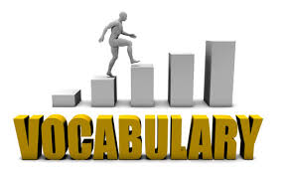
Vocabulary refers to the words we must understand to communicate effectively. Vocabulary development is a process by which people acquire new words. The size of a child's vocabulary between preschool and first grade is often a strong indicator of their reading comprehension in later grades. That's why it's so important to focus on building vocabulary skills throughout reading instruction. Infants build vocabulary slowly. By the age of 18 months, infants can produce a few words and begin to make word combinations. They also build vocabularies learning the meanings that words carry. The size of a child's vocabulary in kindergarten predicts the ability to learn to read.
Educators often consider four types of vocabulary: listening, speaking, reading, and writing. Listening vocabulary refers to the words we need to know to understand what we hear. Speaking vocabulary consists of the words we use when we speak. Reading vocabulary refers to the words we need to know to understand what we read. Writing vocabulary consists of the words we use in writing.
Ways to Improve Your Vocabulary
- Develop a reading habit. Vocabulary building is easiest when you encounter words in context. ... Read what ? stories/articles/newspaper/…..
- Use the dictionary and thesaurus/vocabulary/word list, etc
- Play word games. ...
- Use flashcards.
- Subscribe to “word of the day” feeds. ...
- Use mnemonics. ...
- Practice using new words in conversation.

Technical Vocabulary

Technical Vocabulary is the specialized vocabulary of any field which evolves due to the need for experts in a field to communicate with clarity, precision, relevance and brevity. Prior to developing your technical vocabulary, to improve your general vocabulary in English is very essential.

The thirst to learn new words, should be a continuous process; whenever we learn new words, try our best to use them while we communicate so that the words register in our mind. There are various ways in which we can learn new words. Learn by knowing their origin is one of the ways. A dictionary is an important tool to build our vocabulary. Sometimes we infer the meaning of a word from the context; but the meaning may not be exact. Only the dictionary would provide with the exact meaning.

Technical vocabulary generally refers to words and phrases that are used and known mainly in a specific profession, trade and so on. Technical words used in civil engineering are bar anchorage, factored load, reinforcing bar, bar cut-off point, factored resistance, service load, beam-column joint, fan yield line, shear crack, etc. Technical words in Computer science are Bandwidth, Big data, Bit, Bug, Cloud storage, Code, Control panel, etc. Similarly, an electrician needs to know technical words such as capacitor, impedance, and surge capacity.

Technicians in every field use technical vocabulary. Technical words play a role in replacing the common words that are used to describe it. Without technical words, we can't describe or communicate the right information to others. To be specific in the core field, these technical words are used. Some technical words are the same across a range of different languages.
Many writers provide clues about whether a word is technical or not, for example, they may define the word in the text, write the word in bold, inverted commas or italics, or in a diagram. Technical use of a word can be better understood by looking up the full definition of the word, with all its uses, in a good English dictionary.
……………………………………………………………………………………………………….
Vocabulary used in Formal Letters

Vocabulary used to write formal letters / emails:

Starting
We are writing you with reference to (the above order).
With reference to your advertisement/letter of 10 March……
We are pleased to have your inquiry of 25 of July….
We acknowledge the receipt of your letter dated 12 April …..
With reference to your letter inquiring about…
With reference to our telephone conversation yesterday (about…),…
We wish to remind you that…..
I am writing this letter to request the cancellation of……..
I am writing this letter to complain in the strongest terms about the poor service that I have received from your company.

Action
Please advise us as soon as the…….
Please open a ………….in favour of (name of the company)……….
Payment can be made on any basis acceptable to you.
Could you please supply us with information about the company’s standing.
We have been informed (by one of our clients) that……….
We regret to inform you, (however,) that….
Please accept our apologies for the inconvenience caused.
We must insist on…
Please note that the closing date/deadline for the ……… is 30 September, so will you please complete the attached forms and return them as soon as possible.
Any information you supply will be treated confidentially.
May we remind you that your statement is still outstanding?
Will you kindly balance your account promptly?
We are puzzled to have had no remittance from you.
You already have an overdraft of….
Please give the matter your immediate attention.
We will be left with no alternative but to (take legal action)… unless payment is received within the next seven days.
Our circumstances do not allow us to wait/to go on waiting any longer.
Please look into the matter.
We were dissatisfied to find that….
We shall have to terminate the contract.
On examination we have found…
We greatly appreciated your patience in this matter.

Enclosures and attachment
We would be grateful if you could forward/send any further information (you may have) about…. (products and terms of payment/this case)
We will be pleased to supply any further information you require.
We are sending the herewith the……
We look forward to doing business to our mutual advantage.
We would like to make a decision on this as soon as possible.
In the meantime, we suggest that you call the ………
We hope to meet your requirements.
Please send us by return the terms and conditions on …………..
For purposes of quick contact a reply by telephone would be appreciated.
We look forward to the opportunity of being at your service.
Could you please let us know in your earliest convenience whether the above terms and conditions are acceptable for you.
We hope that the matter will be settled to our mutual satisfaction.
We very much hope that you will be able to…..
I would be grateful if you could spare me a few minutes.
As our demand/request/issue is very urgent, a quick answer would be appreciated.
Would you (also forward details of charges)………. at your earliest convenience?
I should/would be pleased if you could send me …….
We trust/hope you will find this condition acceptable.
If there is any other information you need, please do not hesitate to contact us at the above e-mail address.
Thanking you in advance.
I would be most grateful if you would reply as soon as possible so that this matter can be resolved to everyone’s satisfaction.
Please find enclosed….
I am enclosing…….
Please find attached….

Writing Letter about Employment

Here are a few Useful Phrases for letter about Employment.
Openings:
The standard opening for formal correspondence is
Dear Sir
Dear Madam
Dear Sir or Madam
Dear Sir/Madam
Dear Sirs
Dear Mr.
Dear Mrs.
Dear Ms.

Useful phrases:
I am writing in response to your advertisement in [publication]
I am writing to apply for the post of
Thank you for your letter of [date] offering me the post of
I am delighted to accept the position of [job title]
I look forward to starting work with you

Closures:
Thank you for considering this application
I should be pleased to attend an interview
Please do not hesitate to contact me on the above number if you should require further information
I look forward to hearing from you

Closing Formula
If you know the name of the person use: Yours sincerely
If you don’t know the name of the person use: Yours faithfully

Useful Phrases for Personal and Social Correspondence
Here are a few Useful Phrases for Personal and Social Correspondence.

Openings :
The standard opening for personal correspondence is Dear but variations include:
My dear …
My dearest …
Darling …

Useful phrases:
Thank you for your letter [inviting, offering, confirming]
I am very grateful to you for [letting me know, offering, writing]
It was so kind of you to [write, invite, send]
Many thanks for [sending, inviting, enclosing]
I am writing to tell you that
I am delighted to announce that
I was delighted to hear that
I am sorry to inform you that
I was so sorry to hear that

Closures: For acquaintances and formal situations
Best wishes.
With best wishes.
Kindest regards.

Closures: Affectionate variations for close friends and family
All my love
All the best
Love
Lots of love
Much love
With love
Love from us both
See you soon
Once again many thanks
I look forward to seeing you soon
With love and best wishes
With love to you all
Do give my kindest regards to …
If you know the name of the person use: Yours sincerely
If you don’t know the name of the person use: Yours faithfully

Vocabulary used in formal emails

How do you politely use words in an email?
Dear Sir /Madam,
Dear Dr Smith,
By adding these at the beginning of your emails you will sound more friendly and social.
I hope you had a good weekend.
I hope you had a great trip.
Hope you had a nice break.
I hope you are well.
Hope you're enjoying your holiday.
I hope this email finds you well.
I hope you enjoyed the event.
Reason for Writing/ Replying
I am writing to make a reservation ……….
I am writing to apply for the post of ……….
With reference to our telephone conversation, I would like to inform you that ………..
Making a Request/ Asking for information
Could you please let me know if you can attend
I would appreciate it if you could please send me a brochure ……..
I would appreciate if you could please reply within this week.
Please let me know how much the tickets would cost
Offering help / giving information
I am glad to inform you that our college celebrates its 20th anniversary on 10th May 2012.
We regret to inform you that the meeting has been cancelled due to corona pandemic.
We would be glad to send you another statement if necessary.
Complaining
I am writing to express my dissatisfaction with …….. / I am writing this to complain about ……..
I would like to receive compensation for the damages.
Apologizing
Please accept our apologies for the delay / We would like to apologize for any inconvenience caused.
Attaching Files
I am attaching my cv for your consideration / Please see the statement/ letter/cv attached
Ending
I look forward to hearing from you / I look forward to hearing when you are planning to visit us town.
Closing Formula :
Yours faithfully, Yours sincerely, Yours truly, ………..
Vocabulary used in writing reports

A report is a short, sharp, concise document which is written for a particular purpose and audience. It generally sets outs and analyses a situation or problem, often making recommendations for future action. It is a factual paper, and needs to be clear and well-structured. When you prepare a report you should keep sentences short and simple. You can use linking words, everyday English, avoid passive forms where possible and keep an eye on punctuation while writing a report.

USEFUL PHRASES [REPORT]
INTRODUCTION
• The aim / intention / purpose of this report is to outline / present / discuss / sum up …
• Further to my visit to …, I have prepared the following report.
• I have recently visited … and have prepared the following report for your consideration.
• This involved visiting / looking at / investigating … / The data was obtained by …
• In order to help make this report I asked / discussed / gave out a questionnaire …
• It is based on my observations / the feedback from participants …
• My findings are outlined / presented below. / I outline my findings below.
• The report contains the relevant details concerning the problem as you required.

INTRODUCING POINTS

• To begin with … / Let us start with …
• First(ly) … / In the first place … / First of all ... / The first aspect / thing to consider is …
• Second(ly) … / Third(ly) …
• Moreover … / Furthermore … / What is more …
• Another aspect to consider … / Yet another aspect / consideration is …
• Besides that … / Apart from that … / In addition to this … / On top of that …

INTRODUCING YOUR OPINION
• I think / believe that … / In my opinion … / I am of the opinion that / It seems to me that …
• Personally I believe that / In my view / If you ask me … / To my mind / As far as I am
concerned …
• I would like to suggest / recommend … / I therefore suggest / recommend …
• I (strongly) recommend … / My recommendation is to …

INTRODUCING SOMEONE ELSE’S OPINION

• A few / Many / The majority / minority of people said / reported / complained …
• According to … / As … said … / In the words of …
• It is said that … / It is often suggested that …
GIVING EXAMPLES
• For example / instance …
• This can be shown / illustrated / demonstrated / clarified by …
• Let me just give you an example, ...
• The picture / diagram shows / illustrates …

COMPARING

• One of the main / biggest / most significant / … differences between … and … is …
• Unlike …, … is … / While / Whereas / Although … is, … is …
• … is completely / entirely / totally different from …
• … is a little / slightly / somewhat / a great deal bigger / more elegant / … than …
• … is not quite / nearly as comfortable / expensive / convenient / … as …
• … is virtually / exactly the same as … when it comes to …

CONCLUSION

• It can be seen from the data / reactions / information above that …
• All things considered, I believe that … / Taking everyone’s comments into consideration …
• In general / On the whole I found that …
• In conclusion … / To conclude … / To sum up … / In summary …
• To put the matter in a nutshell … / In a nutshell …

Report Writing Format
Here are the main sections of the standard report writing format:
- Title Section – This includes the name of the author(s) and the date of report preparation.
- Summary – There needs to be a summary of the major points, conclusions, and recommendations. It needs to be short as it is a general overview of the report. Some people will read the summary and only skim the report, so make sure you include all the relevant information. It would be best to write this last so you will include everything, even the points that might be added at the last minute.
- Introduction – The first page of the report needs to have an introduction. You will explain the problem and show the reader why the report is being made. You need to give a definition of terms if you did not include these in the title section, and explain how the details of the report are arranged.
- Body – This is the main section of the report. There needs to be several sections, with each having a subtitle. Information is usually arranged in order of importance with the most important information coming first.
- Conclusion – This is where everything comes together. Keep this section free of jargon as most people will read the Summary and Conclusion.
- Recommendations – This is what needs to be done. In plain English, explain your recommendations, putting them in order of priority.
- Appendices – This includes information that the experts in the field will read. It has all the technical details that support your conclusions.
Write an outline of a Report
The next step is to construct your report's outline. This typically looks like a bulleted or numbered list of all the different sections in the document. Your report's outline might look similar to this:
- Title page
- Table of contents
- Introduction
- Terms of reference
- Summary of procedure
- Findings
- Analysis
- Conclusion
- References or bibliography
___________________________________________________________________________
SEQUENCE WORDS
Sequence words are words that help us understand the order of events that are happening in the story. They tell us things like what happened first, what happened next, and what happened that was unexpected. Think of them as signal words that help us identify the next event in a story and the end of a story.
When we hear the phrase 'once upon a time,' we know a story is about to start. ~'Once upon a time~' is a great example of sequence words. ‘‘First’ and 'today' are great examples of sequence words found at the beginning of a story. These words are signals that tell you a story is starting. 'Then', 'later', 'after' and 'suddenly' are sequence words that might be found in the middle of a story. They signal that a new event is being described. The word 'Finally' is an example of a sequence word that marks the end of a story. 'Finally, I hopped into bed and turned out the lights.' Without sequence words, reading a story would be confusing because we wouldn’t be able to picture what is happening in our heads in the right order.
Examples of sequence words
- In the beginning, there are only heliotrope flowers on the tree tops.
- Once upon a time, there lived a king.
- After that news, I got angry.
- Firstly, it’s very expensive and secondly, it’s too slow.
- In the end, we all decided to organize a meeting.
- All of a sudden I heard a strange noise from the garden.
Sequence Words look like this-- depending on where they appear in a story:
Beginning | Middle/Continuing | Interruption  (something unexpected) | Ending
Once upon a time,  One day,  First,  Today,  Yesterday, | Then,  The next day,  After that,  Later,  Later that day,  Later that night, | Suddenly,  All of a sudden,  But then, | Finally,  In the end,

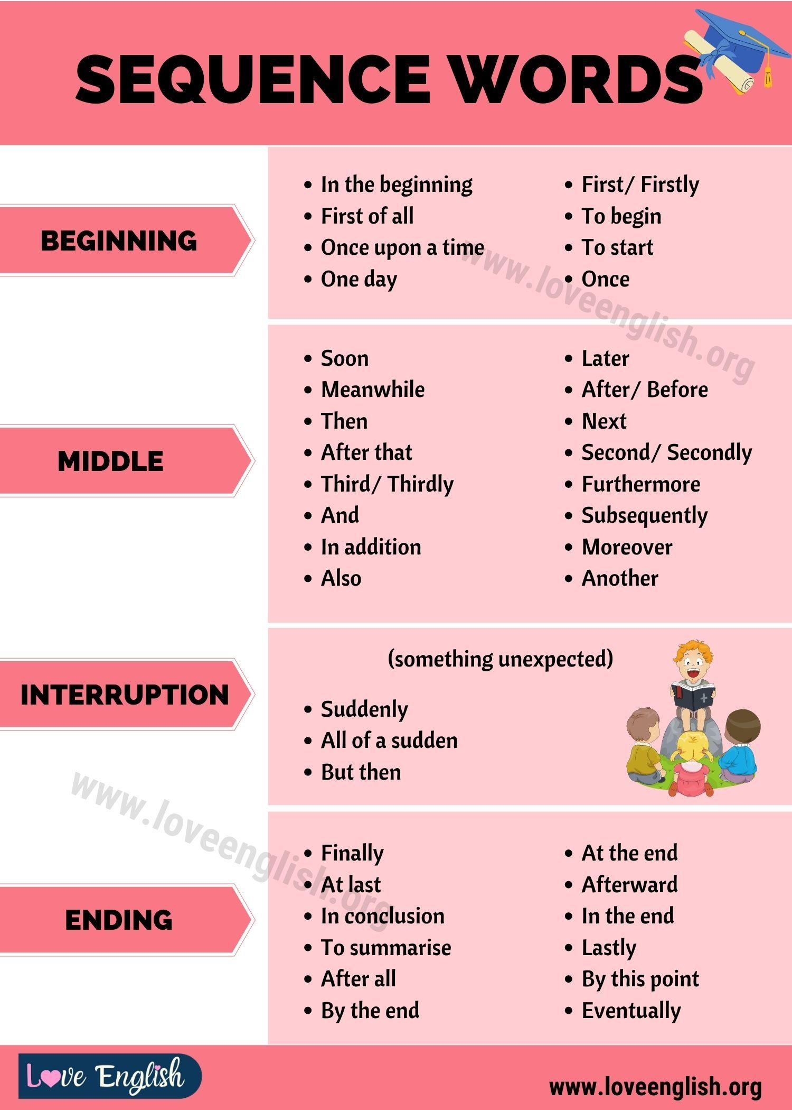
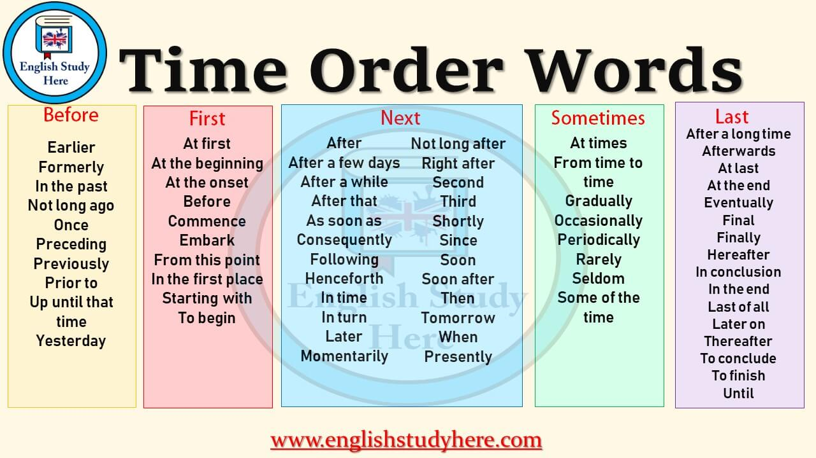

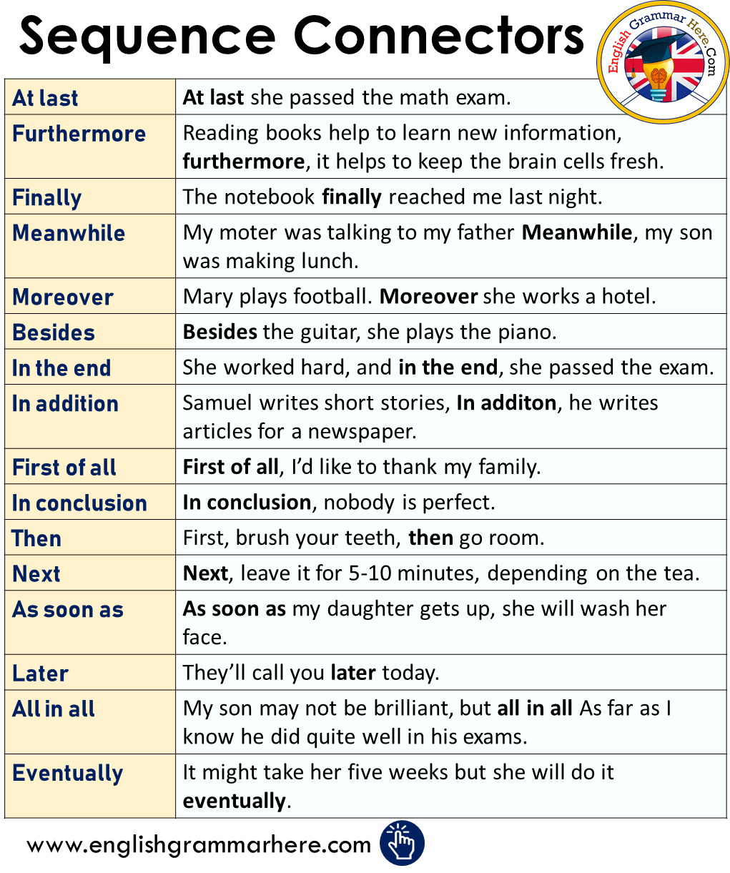
Misspelled Words
What makes some English words difficult to spell?
One source of difficulty is inconsistent pronunciation. In some cases it is an unexpected combination of letters containing few phonetic clues – bureaucracy and manoeuvre are examples here. In both these cases the spelling pattern is literally foreign; French, to be precise.
Bureaucracy /ˌbjʊ(ə)ˈrɒkrəsi/ noun

a system of government in which most of the important decisions are taken by state officials rather than by elected representatives.
Manoeuvre /məˈnuːvə/
- Noun
a movement or series of moves requiring skill and care.
"snowboarders performed daring manoeuvres on precipitous slopes"
Similar: operation, exercise, activity, move, movement, action
2. verb
move skilfully or carefully.
"the lorry was unable to manoeuvre comfortably in the narrow street"
Similar: steer, guide, drive, negotiate, navigate, pilot, direct

COMMON MISSPELLED WORDS

A | B | C | D | E
absence  acceptable  accessible  accommodation  accomplish  achievement  acquire  address  advertisement  advice – (noun)  advise – (verb)  amateur  apartment  appearance  argument  athletic  attendance  acknowledgement  accidentally  accuracy | basically  beginning  belief  believe  beneficial  business | - calendar  - campaign  - category  - cemetery  - challenge  - characteristic  - cigarette  - clothes  - column  - committee  - commitment  - completely  - condemn  - conscience  - conscientious  - conscious  - controversy  - convenient  correspondence  - criticism | - deceive  - definitely  - definition  - department  - describe  - despair  - desperate  development  - difference  - difficult  disappointed  - discipline  - disease | easily  effect  eighth  either  embarrass  encouragement  enemy  entirely  environment  especially  exaggerate  excellent  existence  experience  experiment
F | G | H | I | J
- familiar  - February  - finally  - financial  - foreign  - foreigner  - formerly  - forty  - fourth  - forehead  - forward  - fulfillment | general  generally  genius  government  grammar  grateful  guarantee  guidance  glamorous  governor  guaranteed  grammatically | - happily  - height  - heroes  - humorous  - hypocrite  - happened  - harassment  - hypocrisy | - ideally  - imaginary  - immediate  - incredible  - independent  - influential  - insurance  - intelligent  - interference  - interrupt  - introduce  - island | • jealous  • jealousy
K | L | M | N | O
kneel  knowledge  knight | - later  - legitimate  - length  - library  - lightning  - likely  - loneliness  lose (verb)  loose (adjective)  lovely  luxurious  loneliness  license | - maintain  - maintenance  - manageable  - management  - manufacture  - marriage  - married  - millionaire  - misspell  - mischievous  - money  - mortgage  - muscle  - mysterious | - naturally  - necessary  - neighbor / neighbour  - ninety  - noticeable  - nowadays  - ninth  - nickel | - obedient  - obstacle  occasional  - occurred  - official  - opinion  opportunity  opposition  - ordinary  - originally  - omitted  - opponent  - occasion
P | Q | R | S | T
- peculiar  - perceive  performance  permanent  - pamphlet  - permissible  - physical  - physician  - piece  - pleasant  possession  - possible  - possibility  - potatoes  - practically  - prefer  - precede  - privilege  - professor  professional  pronounce / pronunciation  psychology  psychological  pumpkin | - quantity  - quality  questionnaire  - queue  - quizzes  - quite  - quiet | - realistic  - realize  - really  - receipt  - receive  - recognize  - recommend  - religion  - religious  - remember  representative  - resistance  - restaurant  - rhythm  - ridiculous  - roommate | - sacrifice  - safety  - scared  - scenery  - schedule  - secretary  - sentence  - separate  - similar  - sincerely  - strength  - surprise  - suspicious  - success  - successful  - summary  - succession  - sergeant  - skiing  - specimen  - sponsor  superintendent  surround  symbol  swimming | - technical  - technique  temperature  temporary  their (possessed by them)  there (not here)  they’re (contraction of “they are”)  themselves – not themself  thorough  till  tomorrow  tremendous  transferred  through
U | V | W | X | Y and Z
undoubtedly  unforgettable  - unique  - until  - unanimous  - unfortunately  unnecessary  - usually  unconscious  - unforeseen  - useful | - valuable  - village  - violence  - violent  - vision  - vegetable  - villain  - vengeance  - volume | - Wednesday  women – (plural)  - worthwhile  - width  - writing  - warrant  - weather  - whether |  | - yacht  - young  - yield

