 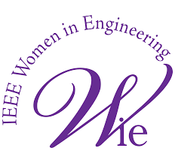 

Report of Mismatched

OVERVIEW

Mismatched was a crossword puzzle competition event and it was conducted by colleges under travancore cluster of IEEE as a part of ‘Wiemarge’, WIE week celebration of WIE IEEE.The colleges under travancore cluster collaborated to conduct this event.

The colleges which collaborated are Marian Engineering College, Perumon Engineering College, Sri Chithra Thirunal college of Engineering, Musaliar college of engineering. It was conducted through online mode(google form) on 4th April at 7:00pm. The duration of the competition was 10 minutes. The theme of the crossword puzzle was famous women in sports.

EXECUTION

Arranged a meet with the WIE IEEE chairs of Travancore cluster.

After discussion we came to a conclusion of dividing the works equally like deciding the date, time, preparation, poster etc.

IMPORTANT DATES

16th March- a group of WIE IEEE chairs were formed.

19th March- a meet was conducted to discuss the events.

31st March- event was planned and the date was fixed.

2nd April- poster was released.

4th April- event was conducted.

DEMOGRAPHIES

9 entries in total and 3 students were selected as winners.

ORGANIZERS

Bhavana- IEEE WIE chair of MEC.

Vishnupriya- IEEE WIE chair of Perumon engineering college

Badra- IEEE WIE vice chair of Sri Chithra Thirunal college of engineering

Hayfa- IEEE WIE chair of Musaliar college of engineering

POSTERS

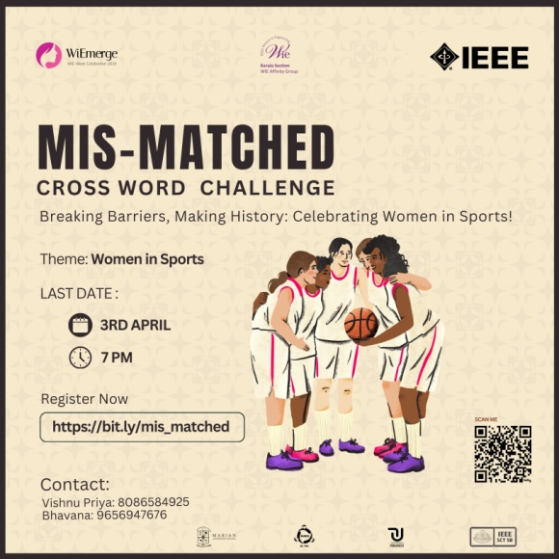

CONCLUSION

The event was successful with active participation.