 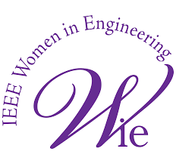 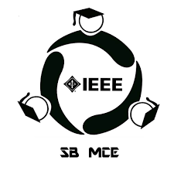

Report of SheRise

OVERVIEW

SheRise was a talk session in which it was discussed about transition from engineering background to community head and the speaker was Jyothika Nithin (community growth executive at Khyaal, Malabar hub coordinator, IEEE computer society Kerala chapter) who was also a former IEEE member of SCT SB and and it was conducted by colleges under travancore cluster of IEEE as a part of ‘Wiemarge’, WIE week celebration of WIE IEEE.

The colleges under travancore cluster collaborated to conduct this event. The colleges which collaborated are Marian Engineering College, Perumon Engineering College, Sri Chithra Thirunal college of Engineering, Musaliar college of engineering. It was conducted through online mode(google meet) on 2nd April at 7pm. The duration of the session was 1hr.

EXECUTION

Arranged a meet with the WIE IEEE chairs of Travancore cluster.

After discussion we came to a conclusion of dividing the works equally like deciding the date, time, preparation, poster etc.

IMPORTANT DATES

16th March- a group of WIE IEEE chairs were formed.

19th March- a meet was conducted to discuss the events.

24th March- event was planned and the date was fixed.

29th March- poster was released .

2nd April- event was conducted.

DETAILS

ORGANIZERS

Bhavana- IEEE WIE chair of MEC.

Vishnupriya- IEEE WIE chair of Perumon engineering college.

Badra- IEEE WIE vice chair of Sri Chithra Thirunal college of engineering

Hayfa- IEEE WIE chair of Musaliar college of engineering

EVENT OBJECTIVE

To learn about community engagement strategies and social media management.

To establish an online presence (e.g., LinkedIn, Twitter).

To Develop a deep understanding of the community's culture and dynamics.

To Identify opportunities for growth and improvement.

EVENT OUTCOME

Develop a deep understanding of the community's culture and dynamics.

Identify opportunities for growth and improvement.

Positive impact on community development and growth.

Inspiration to others considering a similar career transition.

DEMOGRAPHIES

Around 20 students participated in this event.

POSTERS

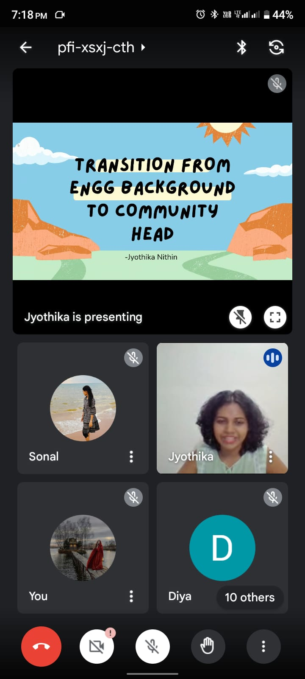 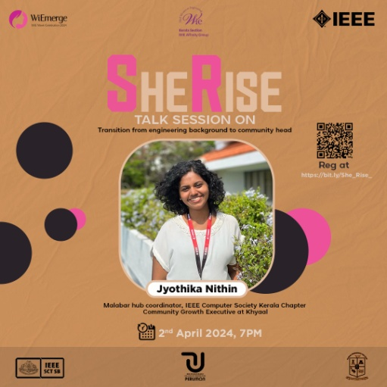

CONCLUSION

The event was successful with active participants.