UNSCRAMBLE IT
Date: 12th December
Venue: Online

IEEE SB MCE conducted the event 'UNSCRAMBLE IT' via Google meet on the 12th of December 2020.
Participants were given the chance to showcase their extensive technical vocabulary.
Students were given a jumbled word and a clue based on which they were to unscramble it.
The event was grand success and was recieved very well by the participants.
Winners
1. CS - Ryan Hubert(S5) & Ryan Cleetus(S5)
2. EEE- Arsha T J, Ritu Nanda S,Lija M S (S3E)
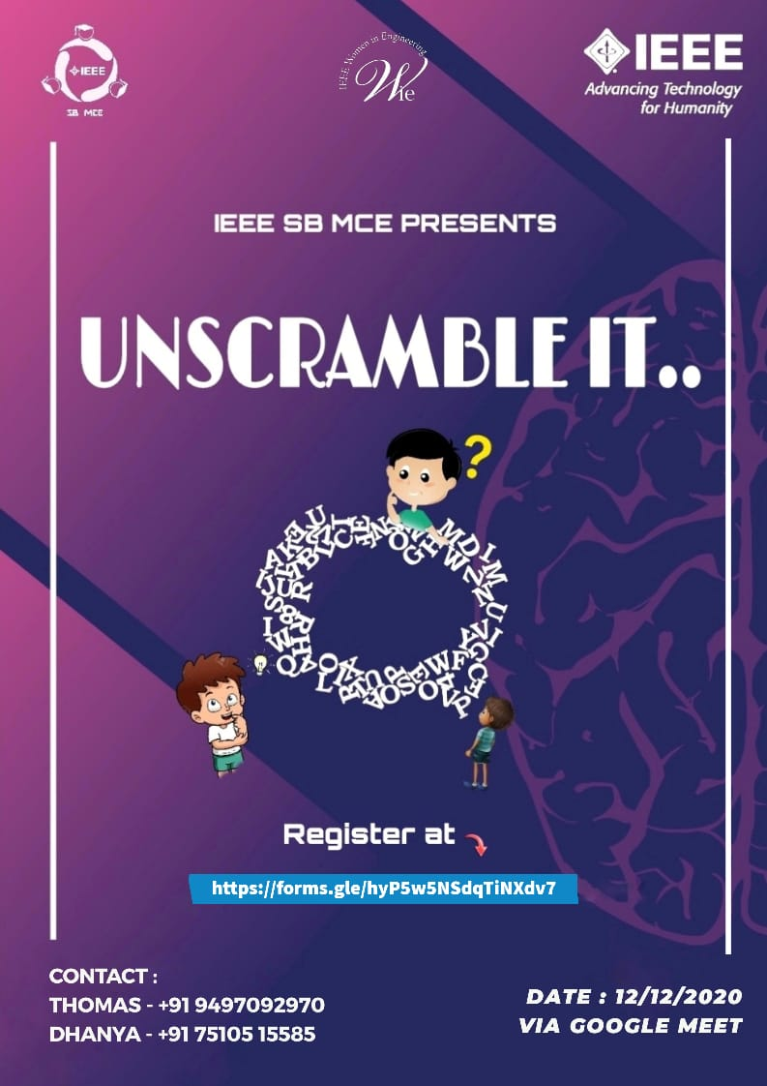
3. EC- Abhyshek R(S5T)
4. CIVIL- Fathima Parveen(S3C)
5.MECH- Akhil G(S3M1)

