ACTIVITY REPORT

- The Bhoomithrasena Club of Marian Engineering College organized a seminar on “MANAGING PLASTIC POLLUTION: TACKLING THE SINGLE-USE PLASTIC (SUP) CRISIS” on 1st April 2022. The session was handled by Er. Dileep Kumar M, Program Director, CED and Er. Vivek, Technical Expert, Marine Litter Project, GIZ. The session was held in the seminar hall of civil engineering department, MCE and was attended by S8 civil students.
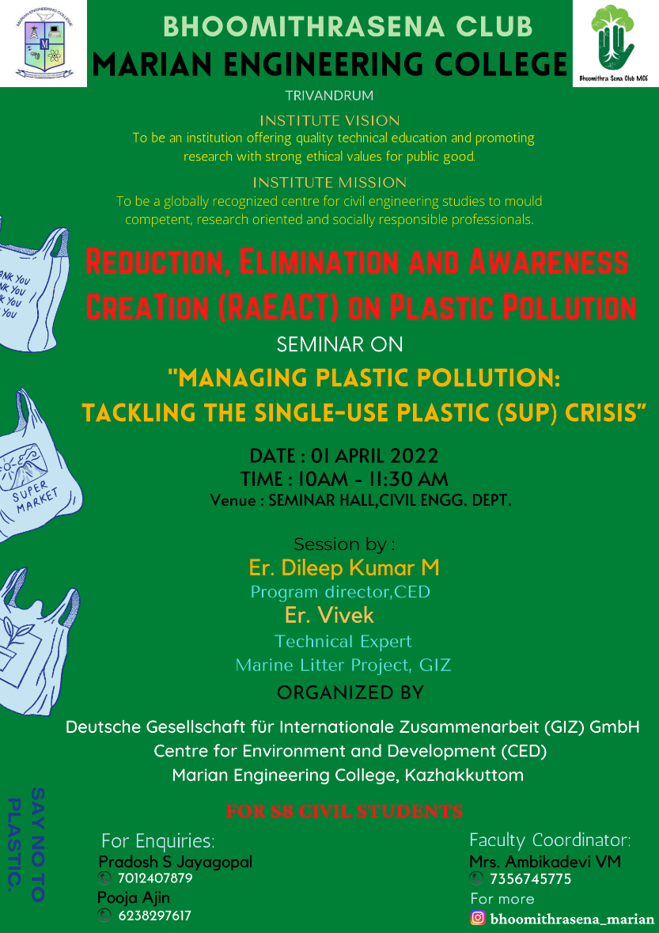
Seminar on “Managing plastic pollution: Tackling the single-use plastic (SUP) crisis”
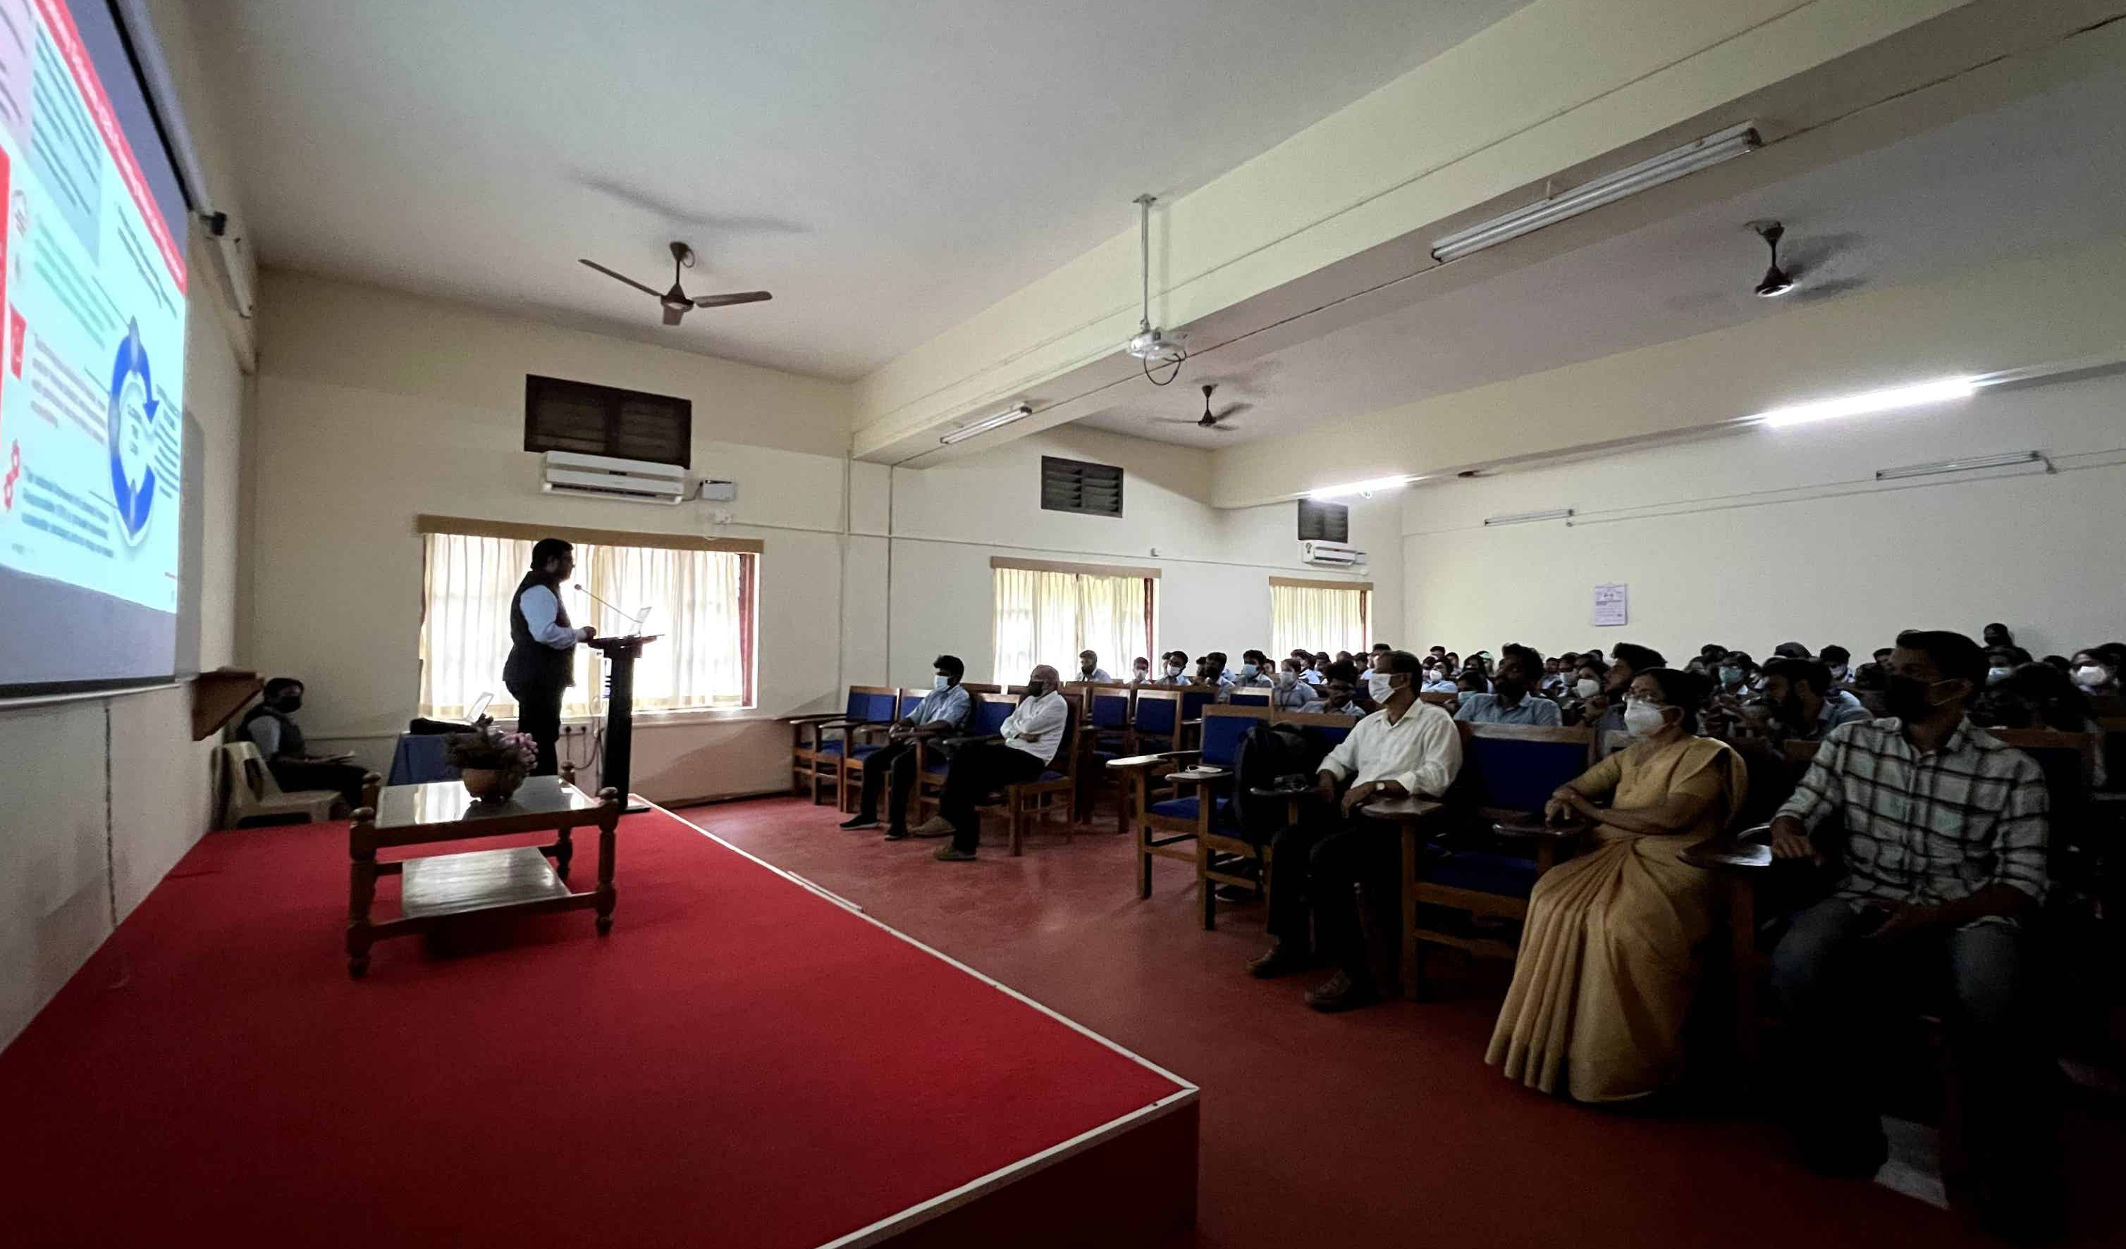

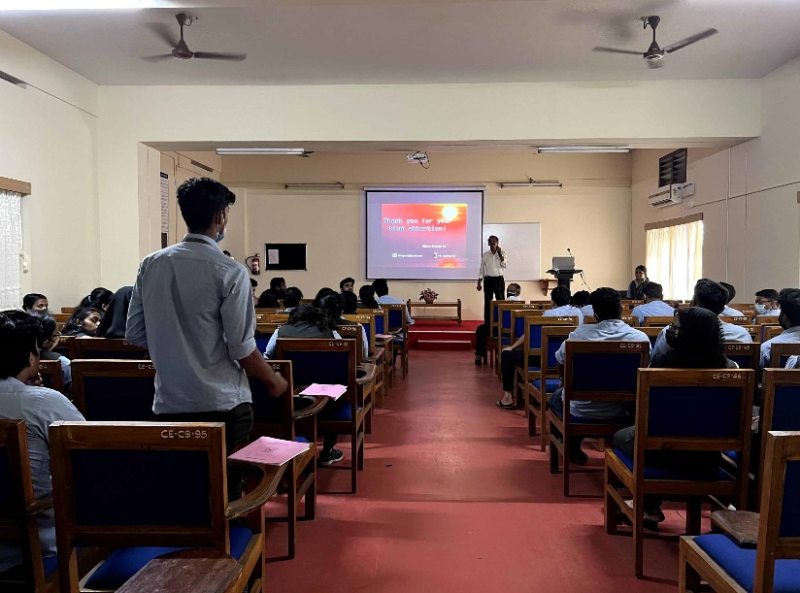

Seminar on “Managing Plastic Pollution”

- The Bhoomithrasena Club of Marian Engineering College organized a technical talk on “ROLE OF BIOFUELS TO CREATE A SUSTAINABLE ENVIRONMENT “on 14th January 2023. The session was handled by Dr. Jaganathan V M, Assistant Professor, National Institute of Technology, Thiruchirapally. Dr. Jaganathan V M had explained how biofuels create a sustainable environment and related topics. The session was held online through google meet and was attended by around 60+ participants. All participants were provided with e-certificates.

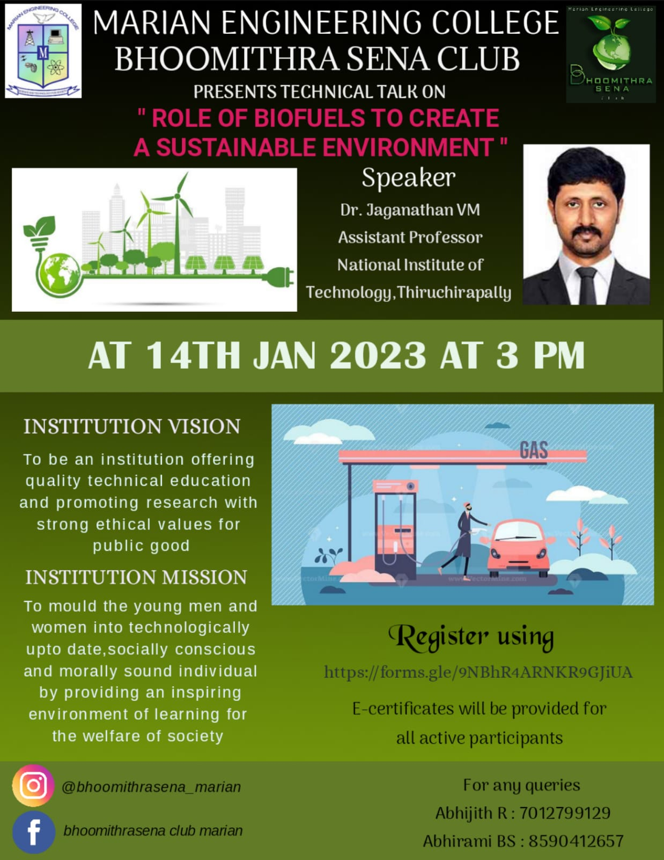

Technical talk on “Role of biofuels to create a sustainable environment”

