**ACTIVITY REPORT (AY 24-25)**

**BHOOMITRASENA CLUB**

For more details visit our page on Instagram

<https://www.instagram.com/bhoomithrasena_marian?igsh=bXM5azR3ZjkzYnFt>

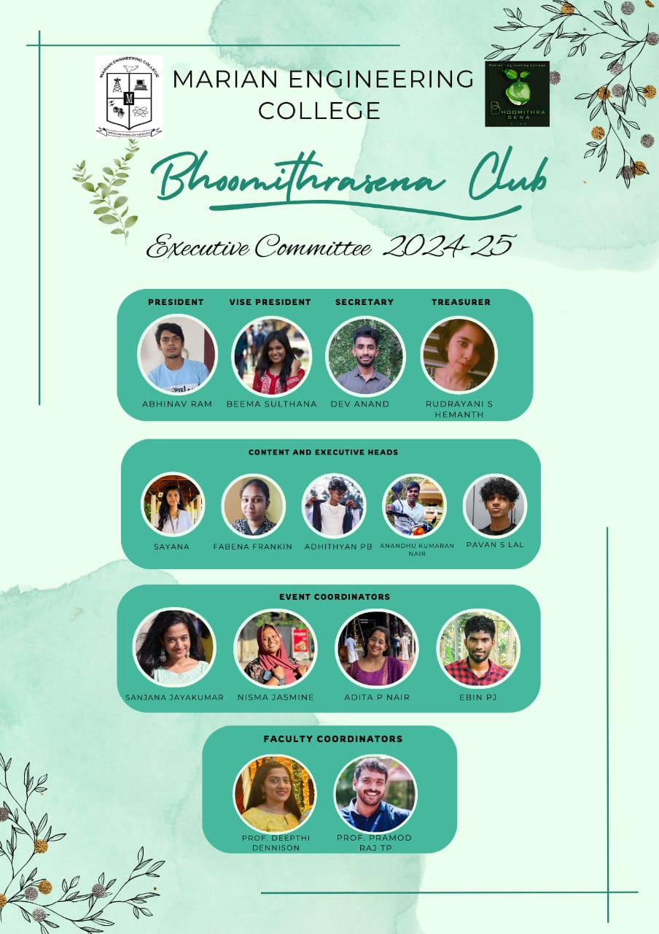

**Executive Members of BMS Club for the AY 2024-25**

1. Students of Bhoomitrasena in collaboration with SUSTERA, GLOBAL SHAPERS COMMUNITY, TVM and TREE TAG conducted Tree Sapling at MEC on 09/08/2024. 9 Executive members of BMS Club, Rev. Father Jim Carvin Roach, Prof. Deepthi Dennison (AP, CE), Prof. Pramod Raj T P (AP, ME) - Faculty Coordinators, Representatives from SUSTERA & GLOBAL SHAPERS COMMUNITY, TVM have attended the event.

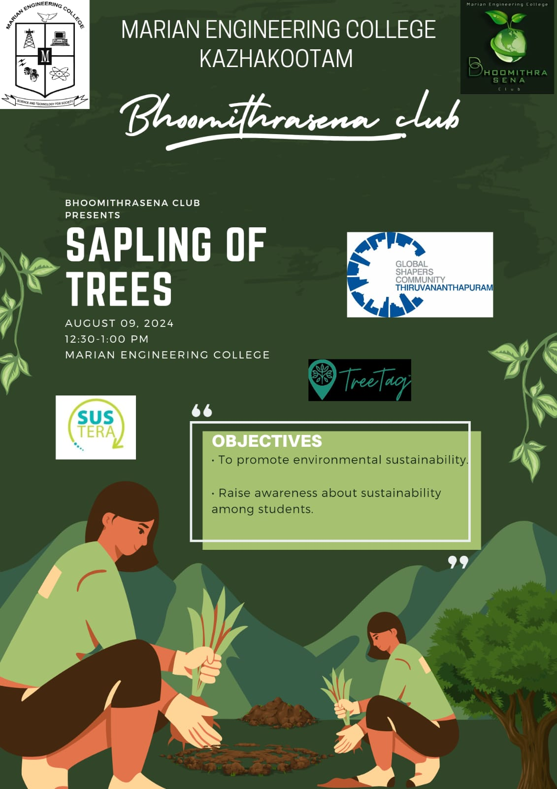

**Poster for Tree Sapling**

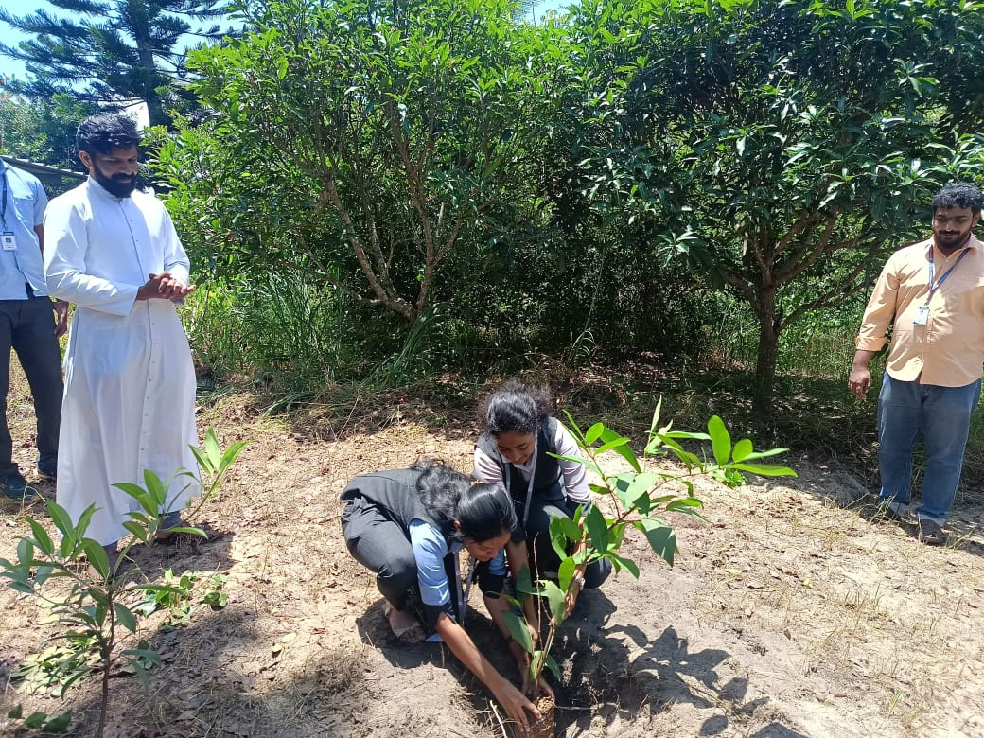

**Rev. Father Jim Carvin Roach and BMS Club Executive Members**

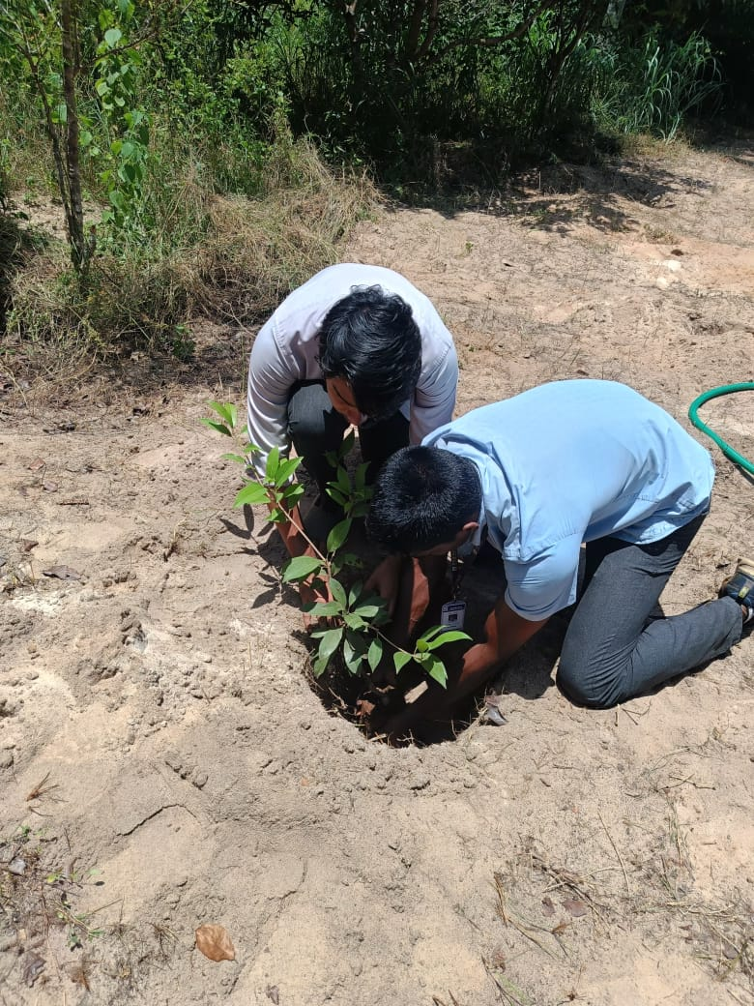 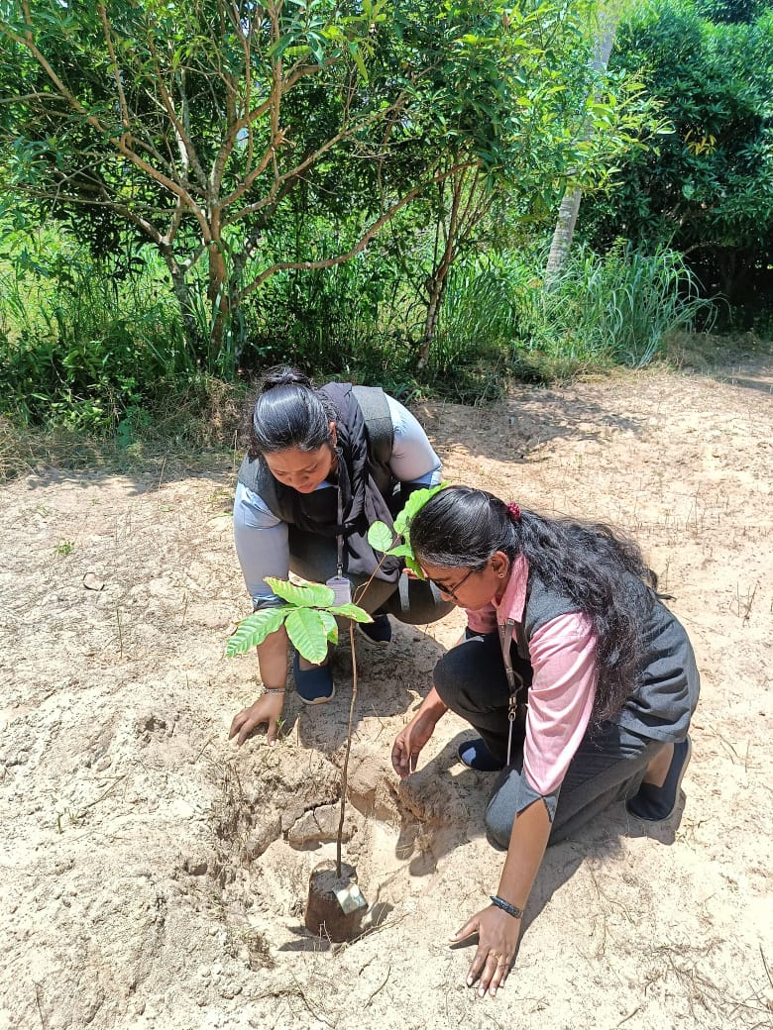

**Executive Members During Tree Sapling**

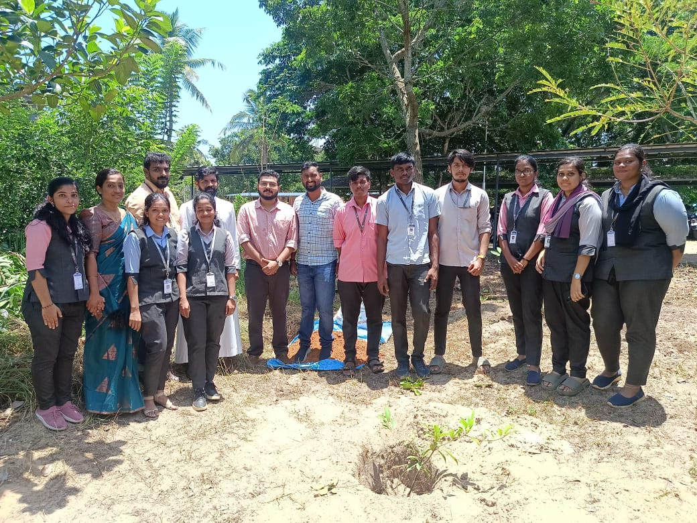

**Tree Sapling Team (Rev. Father Jim Carvin Roach, Prof. Pramod Raj T P, Prof. Deepthi Dennison, Reprersentatives from SUSTERA & GLOBAL COMMUNITY and Executive Members of BMS Club)**

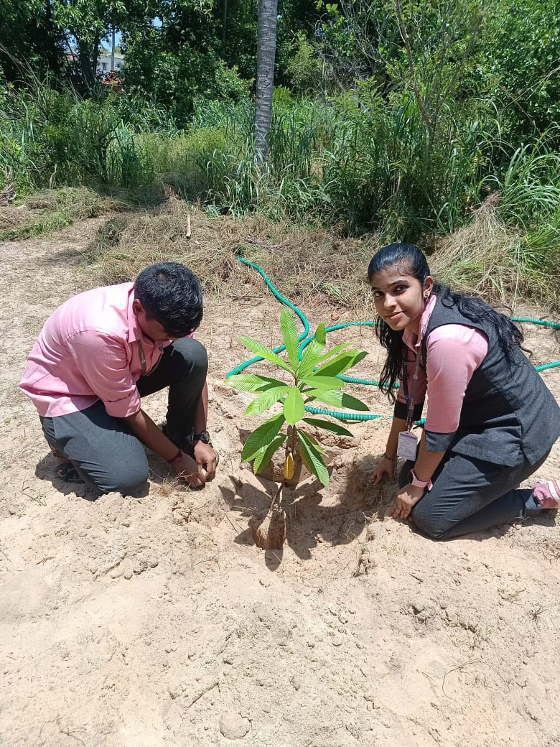 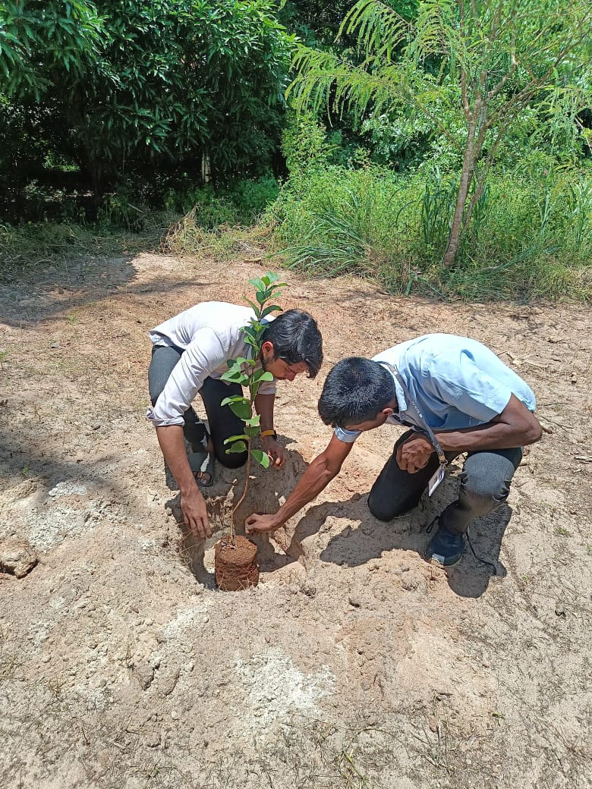

**Anandu Sukumaran Nair (S3R1, Sayana (S3ES), Abinav Ram (S7R1) and Seimon Vicor (S5M)**

1. Students of Bhoomitrasena Club organized bird watching and nature walk on “KUMARAKOM BIRD SANCTUARY PARK” on 12/10/24 as a part of World Bird Migratory Day. 101 students attended the event. Prof. Deepthi Dennison (AP, CE) and Mr. Sreekumar (Lab Technician of EEE) were the faculties accompanied.

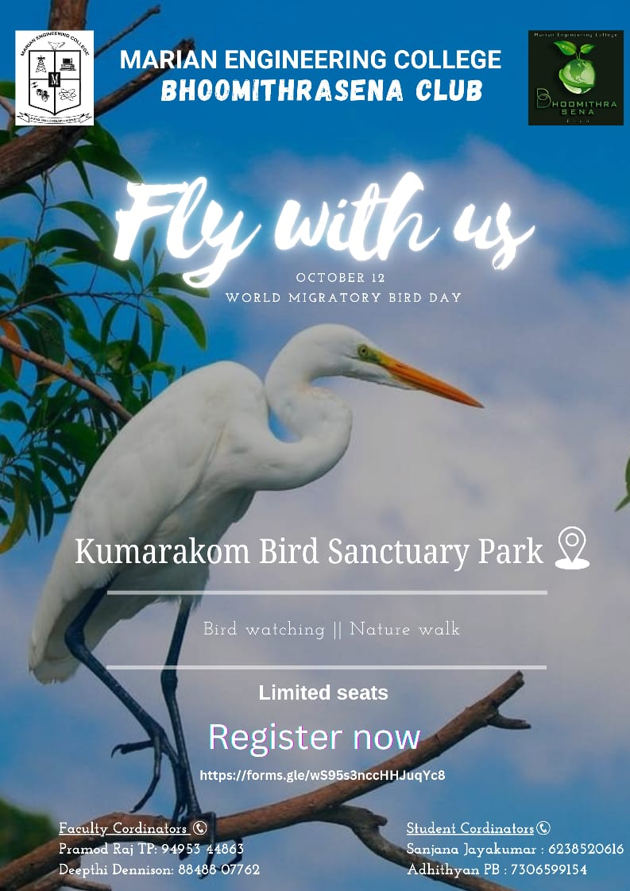

**Poster for Bird Watching**

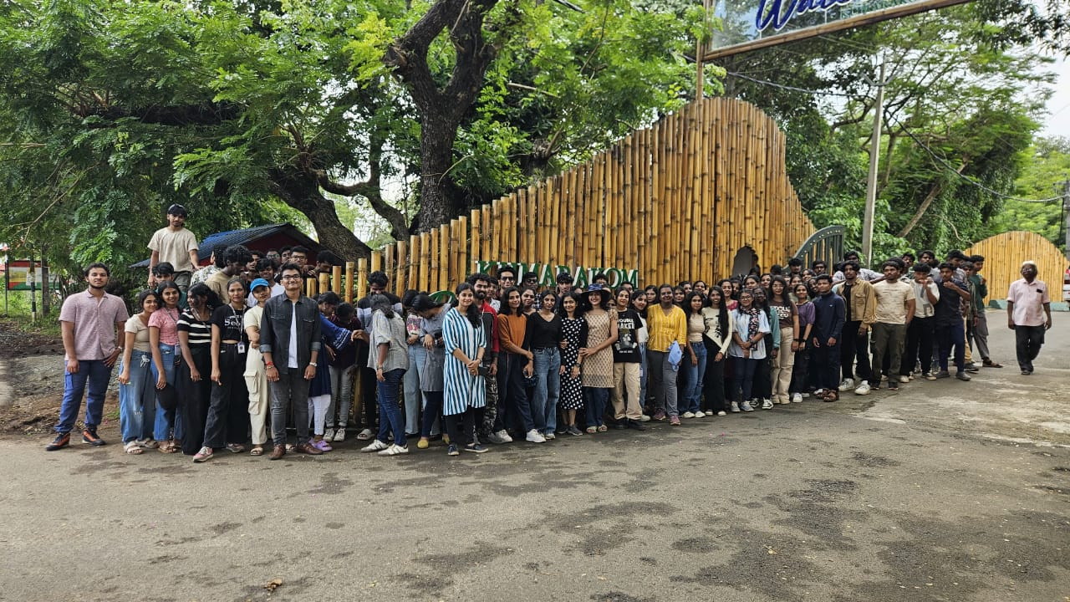

**BMS Club Students at Kumarakom Bird Sanctuary, Kottayam**

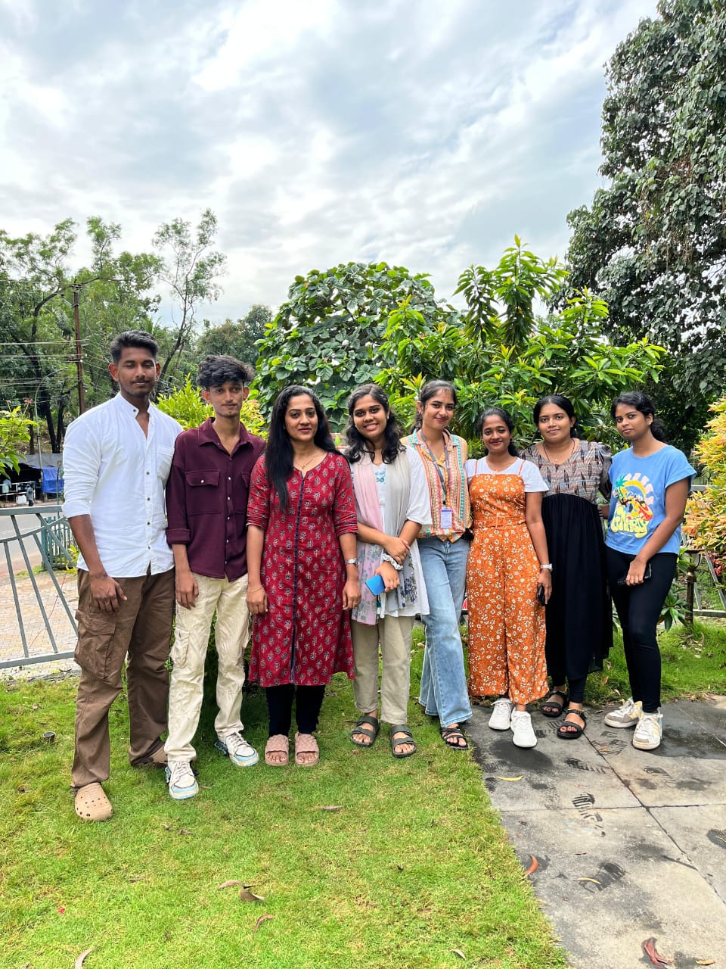

**Students of BMS Club and Faculty Coordinator during Nature Walk**

1. Students of Bhoomitrasena Club organized Ozone Day Quiz as a part of “WORLD OZONE DAY” on 10/10/24. Twelve students had attended the quiz at the Seminar Hall of Civil Department. Among them Ms. Nazia Banoo (S7C), Mr. Ayman Ali Noufal (S3C) and Ms. Noora Thasneem (S5C) scored first and second prizes respectively. First prize was Rs. 750/ and second prize was Rs. 500/ which was equally distributed. Abhinav Ram (S7R1) and Rudrayani S Hemanth (S3ES) were the quiz masters.

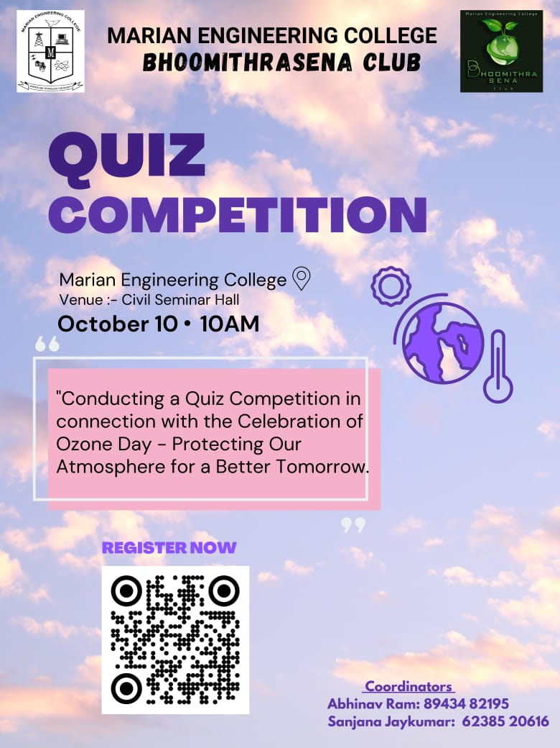

**Poster for Ozone Day Quiz Competition**

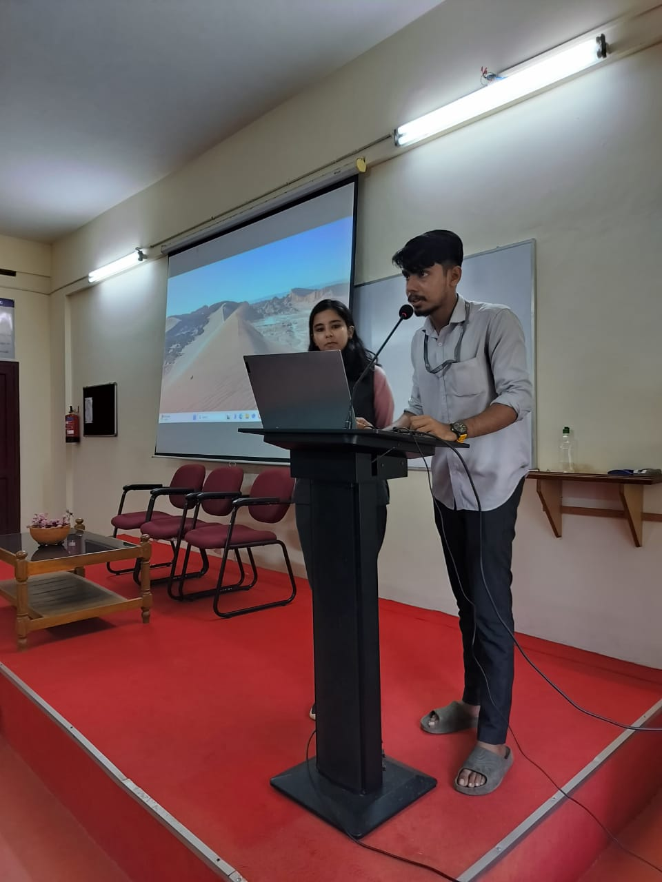

**Mr. Abhinav Ram (S7R1) and Rudrayani S Hemanth (S3ES) mastering the quiz**

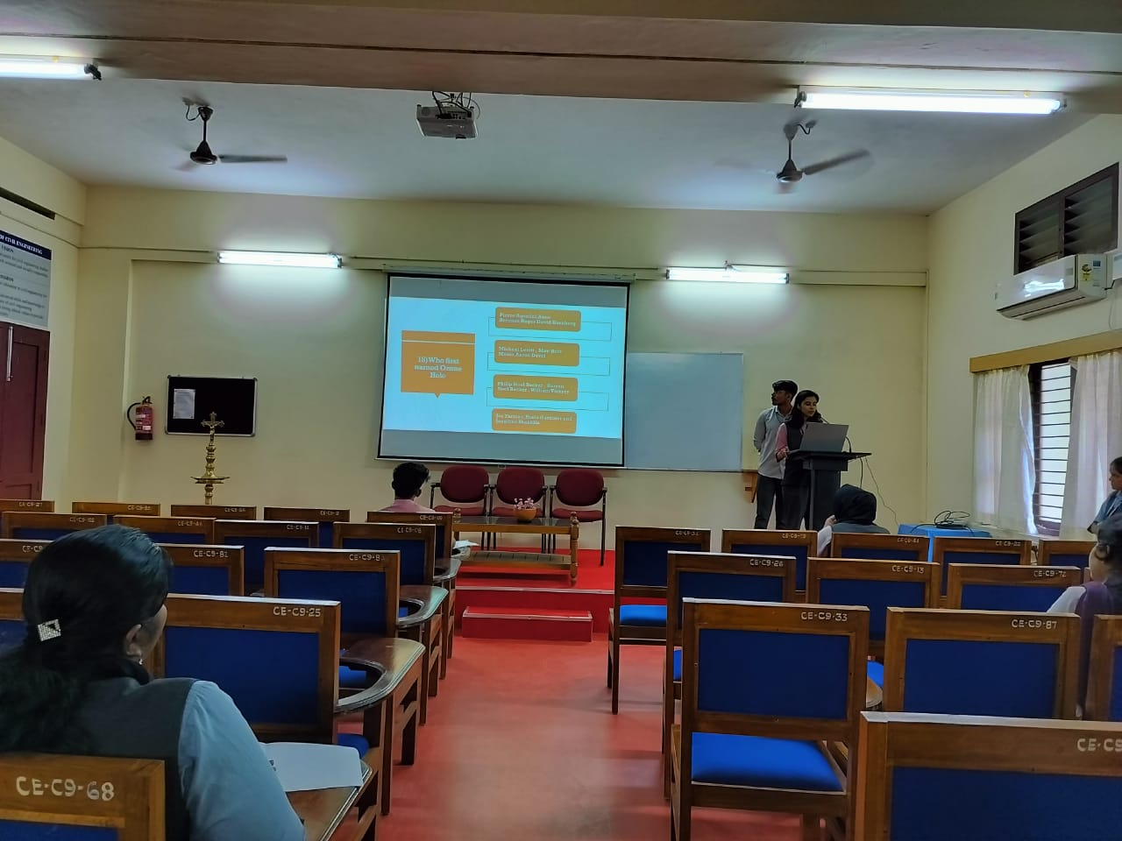

**Execution of the Quiz**

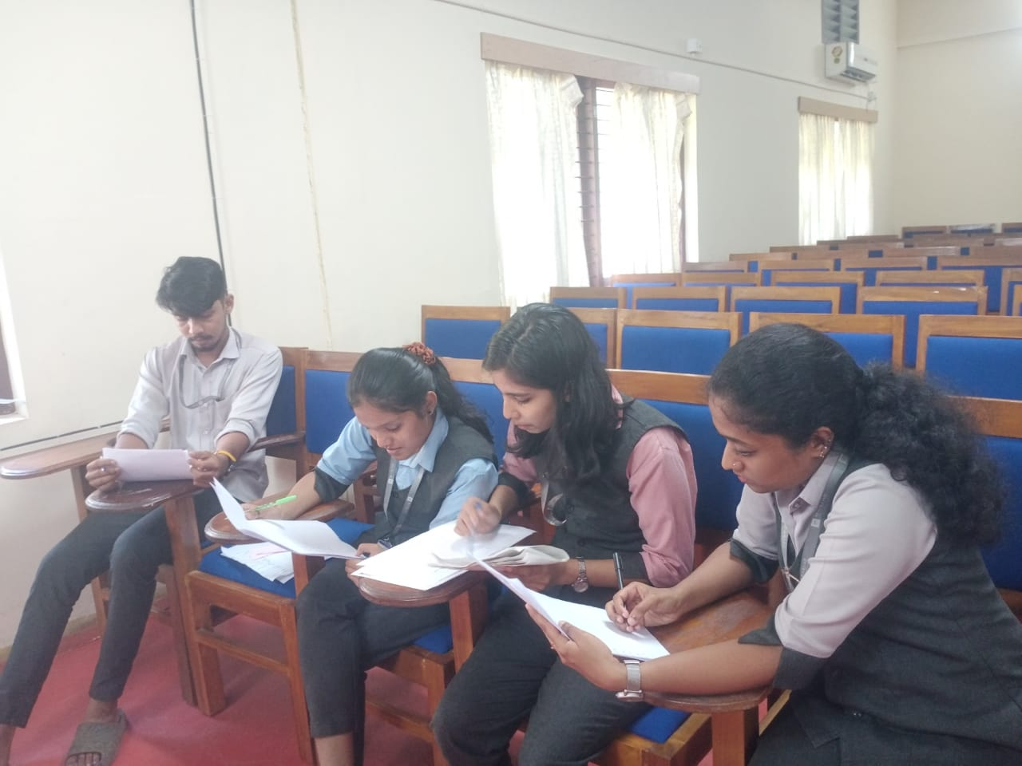

**BMS Club Executives on Evaluating the Responses**

1. BMS club organized an online meeting for conducting Digital Tree Tagging on MEC Campus. Mr. Wazeer (representative of TREE TAG), Prof. Deepthi Dennison (AP CE), Prof. Pramod Raj T P (AP, ME), Executive Members of BMS Club have attended the same.