**ACTIVITY REPORT (AY 23-24)**

**BHOOMITRASENA CLUB**

For more details visit our page on Instagram

<https://www.instagram.com/bhoomithrasena_marian?igsh=bXM5azR3ZjkzYnFt>

1. Students of Bhoomitrasena Club of Marian Engineering College along with Thiruvananthapuram Corporation, Green Worms and SUSTERA organized Mega Awareness Beach Clean up Campaign in association with on 4/11/23 at Shanghumugham Beach.

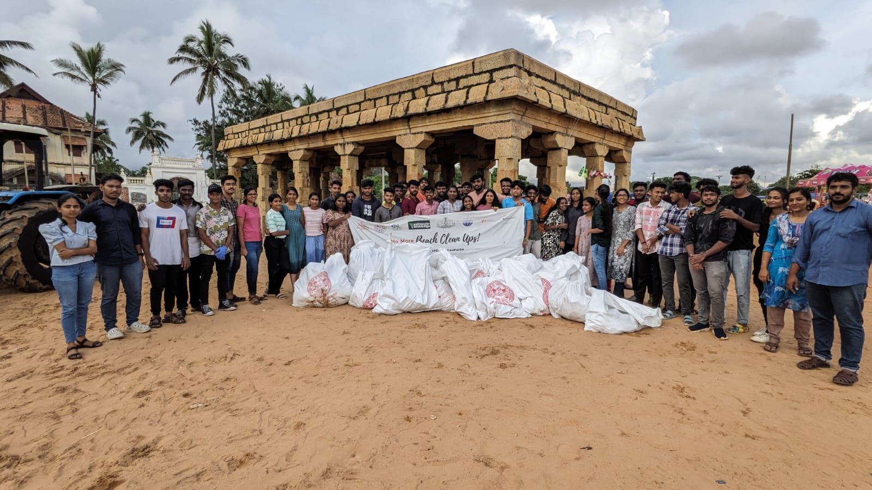

1. Students of Bhoomitrasena Club made a visit to Technopark Phase-III Green Building on 14/11/23.

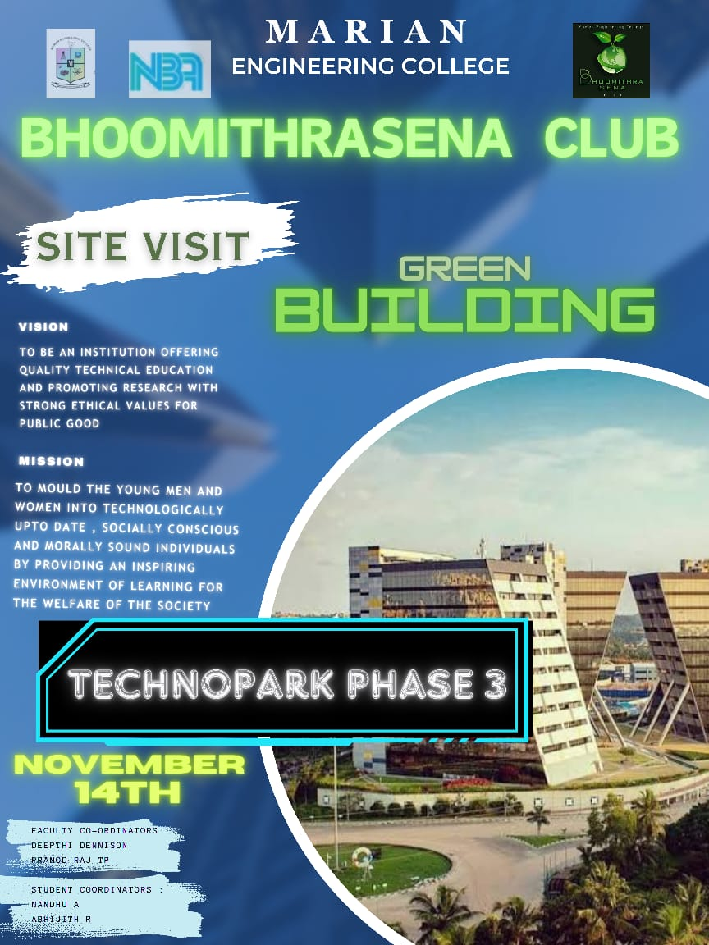

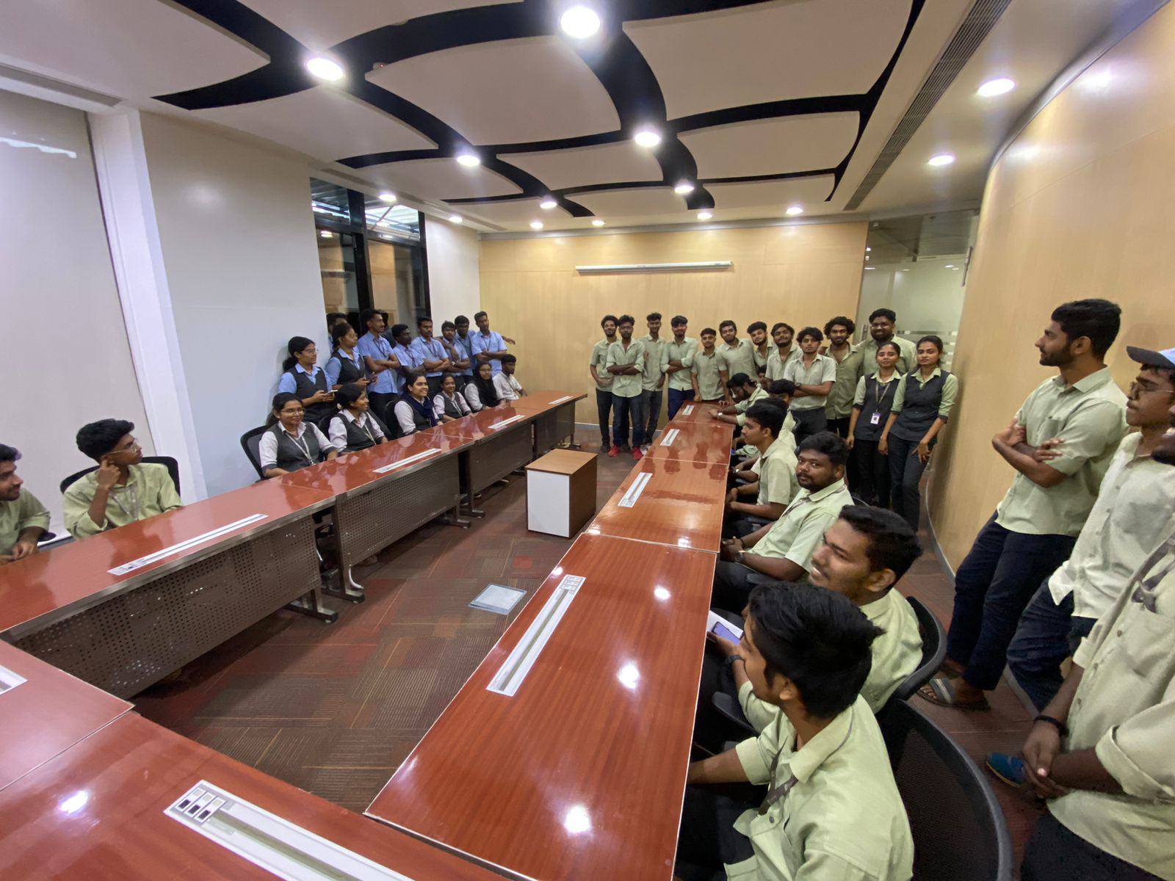

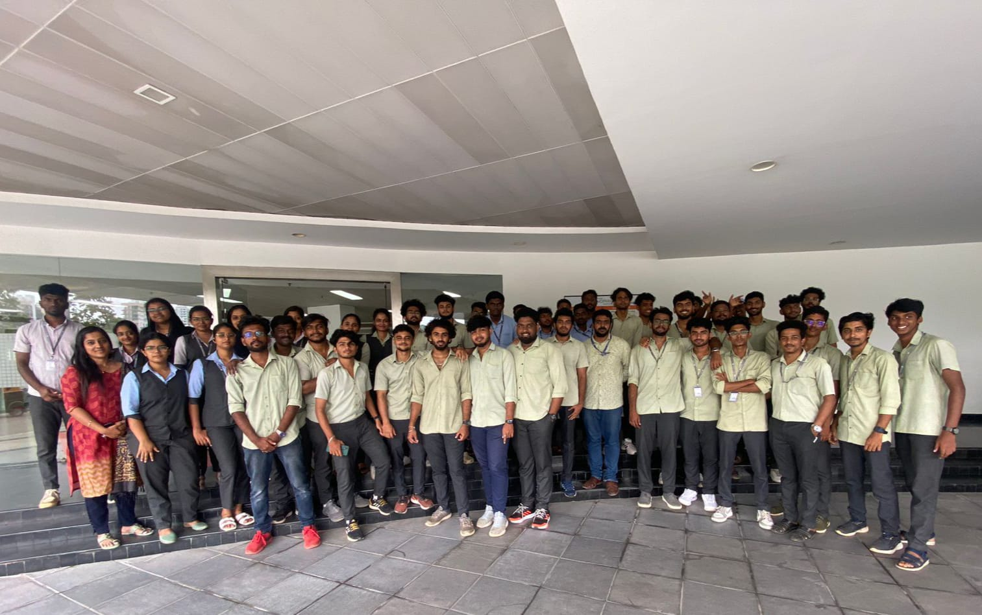

1. Documentary Making Competition on “Wetland Across Kerala” was conducted by Students of Bhoomitrasena Club as apart of World Wetland Day and the winners are Abhijith & Sandra S OF S5C and Febena of S2AH.

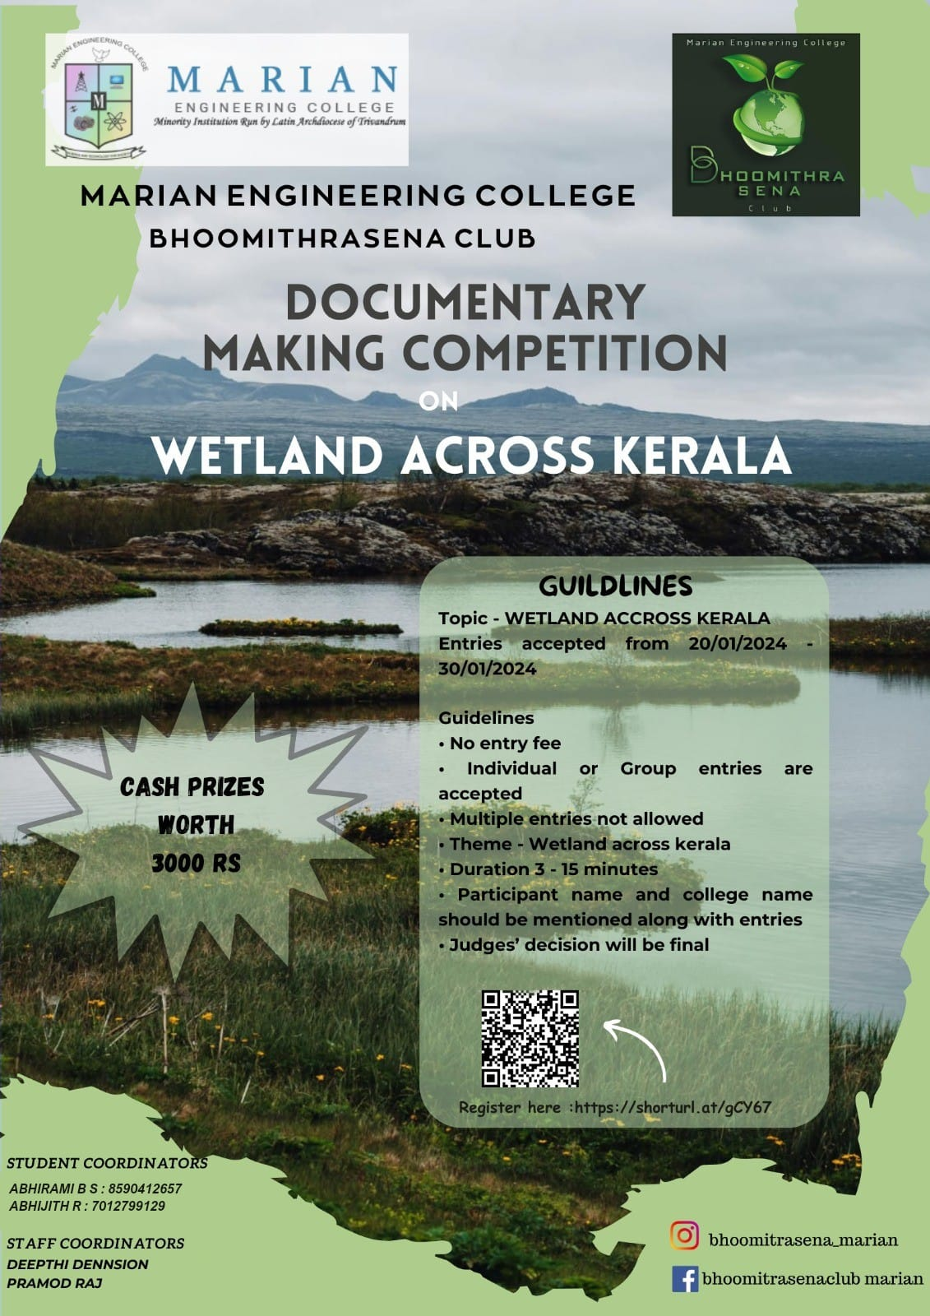

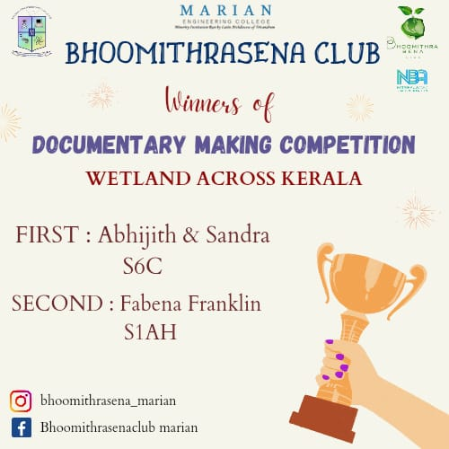

1. Students of Bhoomitrasena Club organized webinar on “Deep Water Horizon Oil Spill” on 8/2/24. The speaker of the event was Prof. Shimna Manoharan of BMS Institute of Technology & Management, Bengaluru.

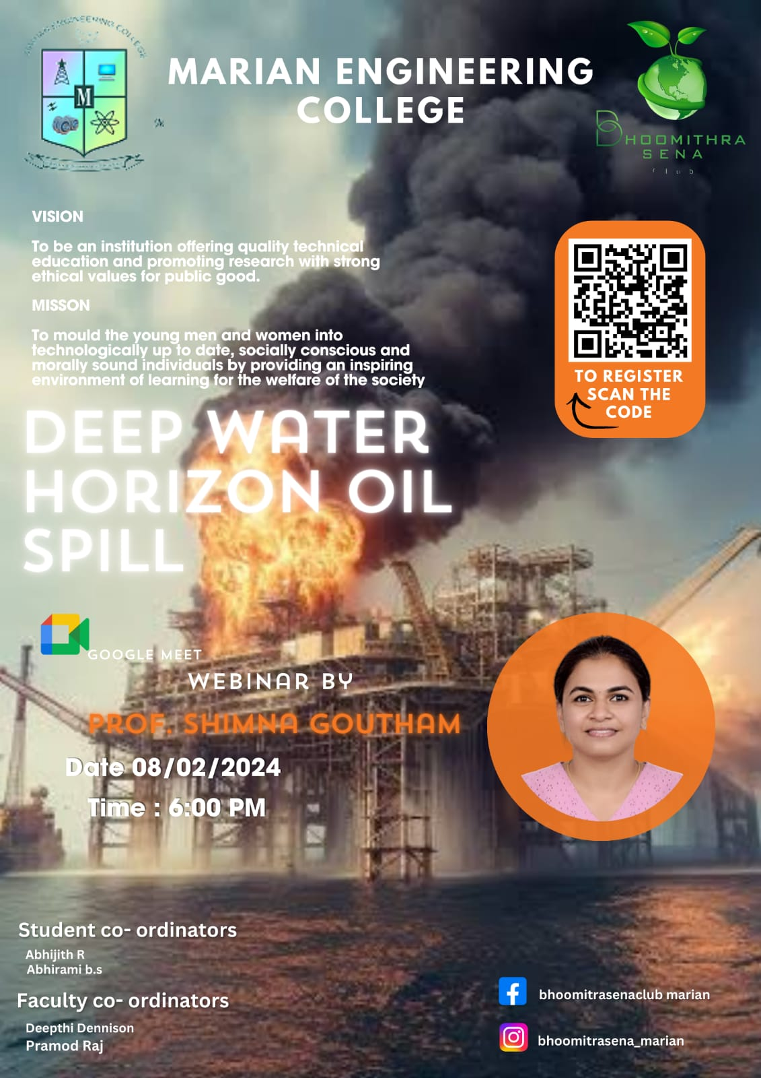

1. Students of Bhoomitrasena Club organized forest walk on “ARIPPA FOREST” on 24/2/24 as a part of World Forest Day.

