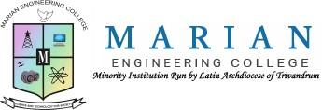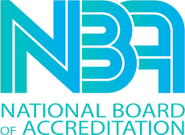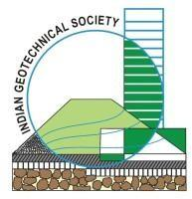

MARIAN ENGINEERING COLLEGE
DEPARTMENT OF CIVIL ENGINEERING

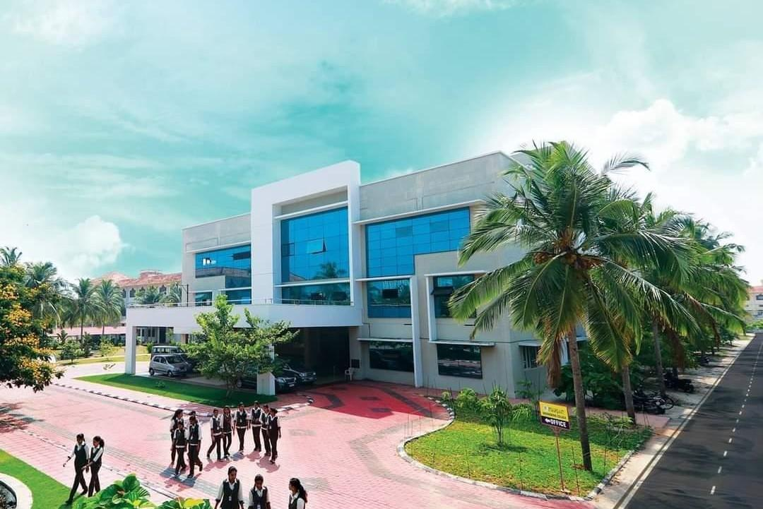
REPORT OF ACTIVITIES OF INDIAN GEOTECHNICAL SOCIETY STUDENT CHAPTER 2023-2024

OFFICE BEARERS

MENTORS | DR. RANI V, PROF. KANNAN K
PRESIDENT | GOKUL NATH G S
SECRETARY | KARTHIKA SATHEESH
TREASURER | VAISHNAVI CHANDRAN
VICE PRESIDENTS | ABHIRAMI B S, SHEFIN MOHAMED
JOINT SECRETARIES | GEOMEL GEORGE, PRARTHANA JAYAN
CO - TREASURES | AMRITHA A V, SABEER B S
ASSOCIATE PRESIDENT | GOKUL J S
ADDITIONAL SECRETARY | ADVITIY SRIVASTAVA
PROGRAM COORDINATORS | ATHUL RAJ, ARDRA A S, ANAND U S

MEETINGS

SL.NO | DATE | DISCUSSION
1 | 22/08/2023 | EXECOM 2023-24 were  selected and meeting with them
2 | 3/09/2023 | Planning of Teacher’s Day celebration
3 | 1/10/2023 | Planning for Inauguration of IGS student chapter and  Ametos civil association
4 | 7/10/2023 | Scheduled programs for inauguration and brochure preparation
5 | 15/10/2023 | Planning for activities and industrial visits
6 | 30/11/2023 | Planning for Soil Day

EVENTS

- TEACHERS DAY CELEBRATION
- INAUGURATION
- SESSION ON: COASTAL EROSION, CONTROL MEASURES AND GEOTECHNICAL ASPECTS
- FIELD VISIT - KERALA FIRST 3D PRINTED BUILDING, KERALA STATE NIRMITHI KENDRA TRIVANDRUM
- SITE VISIT - SPT TEST AND PILING
- FIELD VISIT - WATER TREATMENT PLANT ARUVIKKARA
- FIELD VISIT - SOIL MUSEUM TRIVANDRUM
- WORLD SOIL DAY - PHOTOGRAPHY CONTEST
- WORLD SOIL DAY - POSTER MAKING COMPETITION
- WOMEN’S DAY CELEBRATION

- WORKSHOP ON SPATIAL PREDICTION OF SOIL PARAMETERS USING GEOSPATIAL AI/ML

ABOUT THE EVENTS

- TEACHERS DAY CELEBRATION
Teachers’ Day is an annual celebration dedicated to recognizing and honoring the invaluable contributions of educators to society. Originating from historical roots, this day holds particular significance in many countries, including India, where it is observed on September 5th to commemorate the birthday of Dr. Sarvepalli Radhakrishnan. The day is marked by various customs, with students expressing gratitude through heartfelt gestures such as cards, flowers and messages. On 5th September 2023, Marian Engineering College celebrated TEACHERS’ DAY with great enthusiasm and excitement. The event was held at Seminar Hall of the Civil Department and was attended by students and faculty members.
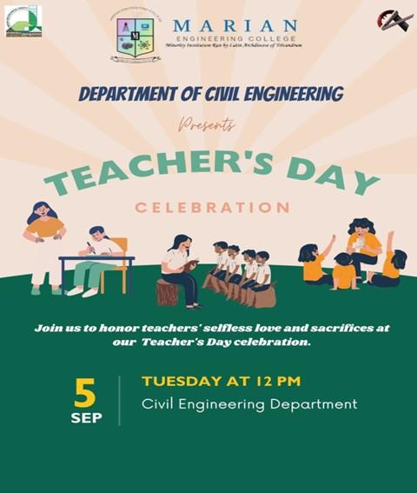

The event began with the blessings of almighty and a speech delivered by Anamy J B of S7C2, who shares inspirational stories of exceptional educators, emphasizing their dedication and positive impact. The ceremony proceeded with the inaugural address by the Head of Civil Engineering Department,

Dr. Narayanan S, who shared his experiences and insight from his career, which was then followed by the felicitation delivered by Assistant Professor, Mr. Abhijith R P. The event concluded with a vote of thanks by Krishna M S of S7C1, who expressed her gratitude to the faculty members and students for their support and participation in the event.
The highlight of the day was the distribution of personalized cards and flowers, with students taking the opportunity to convey their admiration for the hard work and dedication of our teaching staff. In addition to the heartfelt gestures, students organized a cake cutting ceremony for the teachers, creating a celebratory atmosphere that resonated with the significance of the occasion. The festivities commence with a special tribute video to the family, where students expressed through their heart-warming performances dedicated to our esteemed teachers.
The Teachers’ Day celebration was a well-coordinated and meaningful event that showcased the mutual respect and admiration between students and teachers. It not only recognized the hard work and commitment of educators but also emphasized the symbiotic relationship that exists. The event’s success echoed the sentiment that acknowledging and celebrating teachers is an integral part of fostering a conducive and appreciative educational environment.
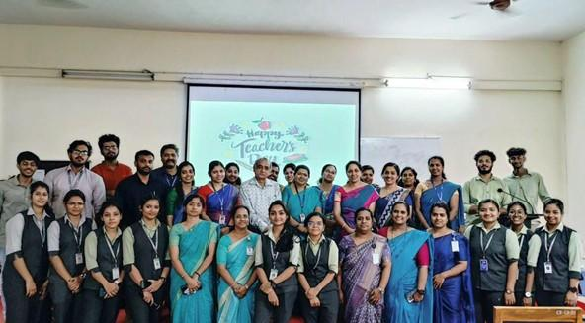

- INAUGURATION OF IGS STUDENT CHAPTER 2023-24

PRAYER

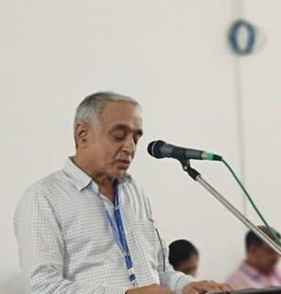
WELCOME ADDRESS

Dr. NARAYANAN S
Head Of Civil Engineering Department Marian Engineering College

PRESIDENTIAL ADDRESS

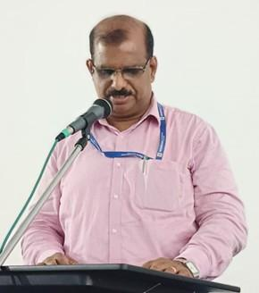
Dr.A. SAMSON

Dean

Marian Engineering College

LAMP LIGHTING CEREMONY
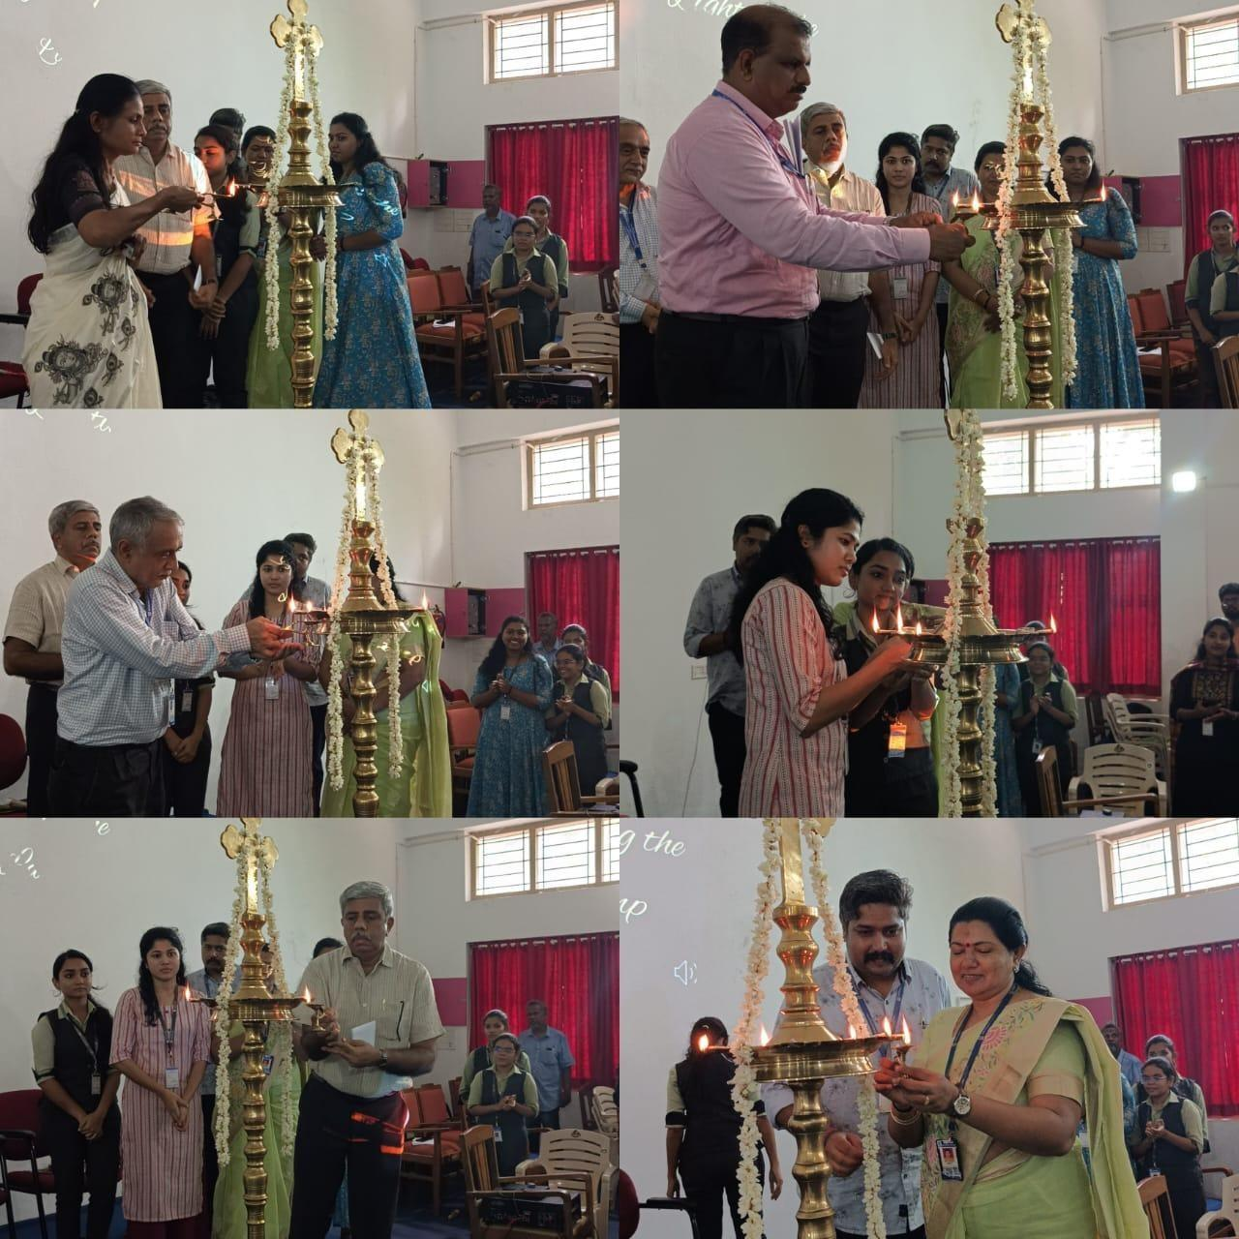

THE LIGHT WAS LAMPED BY SECRETARY OF IGS STUDENT CHAPTER ALONG WITH GUEST

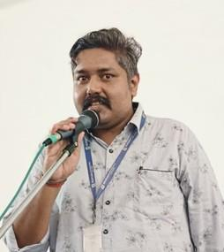
OVERVIEW OF CHAPTER ACTIVITY

Prof. KANNAN K
Department of Civil Engineering Marian Engineering College

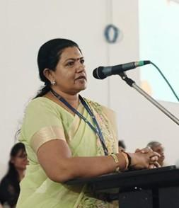
VOTE OF THANKS

Dr. RANI V
Department of Civil Engineering Marian Engineering College

MORE ABOUT THE EVENT
On 11th October 2023, Marian Engineering College celebrated the inaugural ceremony of Indian Geotechnical Society Student Chapter, which is aimed at promoting and developing the skills and knowledge of students pursuing civil engineering at the college. The event marked a significant milestone in fostering academic growth and industry interaction within the institution. The inauguration ceremony was held in the Gallery Hall at the admin block of MEC and was attended by students, faculty members, and distinguished guests from the civil engineering industry. The event began with a prayer and a welcome address delivered by the Head of Civil Engineering Department, Dr. Narayanan S, followed by the lighting of the lamp by the chief guest, Dr. Sheela Nair. The ceremony proceeded with a presidential address by, Dr. A. Samson, the Principal and Dean of our college who highlighted the importance of such associations in promoting innovation and creativity in students, and an overview about the chapter activities was delivered by Prof. Kannan K., mentor of civil engineering association, which was then followed by the felicitation delivered by the Dean, Dr. A. Samson.. The highlight of the event was the technical talk delivered by the guest Dr.Sheela Nair on the topic ‘COASTAL EROSION, CONTROL MEASURES AND GEOTECHNICAL ASPECTS’ the session served as an invaluable platform for understanding coastal erosion. The welcome speech for the guest was delivered by Aiswarya Sunil of S3C and vote of thanks for the session was delivered by Advitiy Srivastava of S5C and the event officially concluded with a vote of thanks by the Mentor of the Civil Association Mrs. Rani. V, who expressed her gratitude to the faculty members, students, and chief guest for their support and participation in the event.

MORE PHOTOS OF THE EVENT
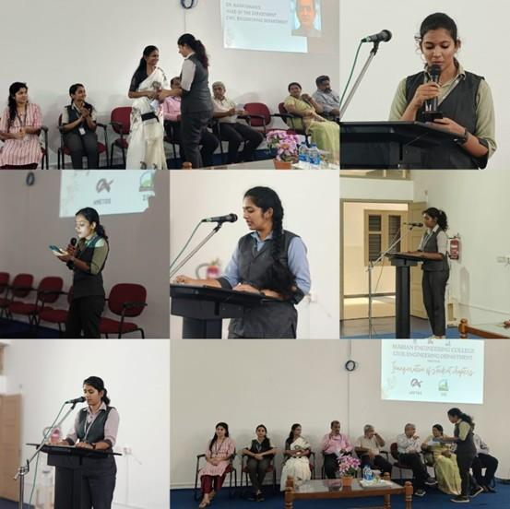
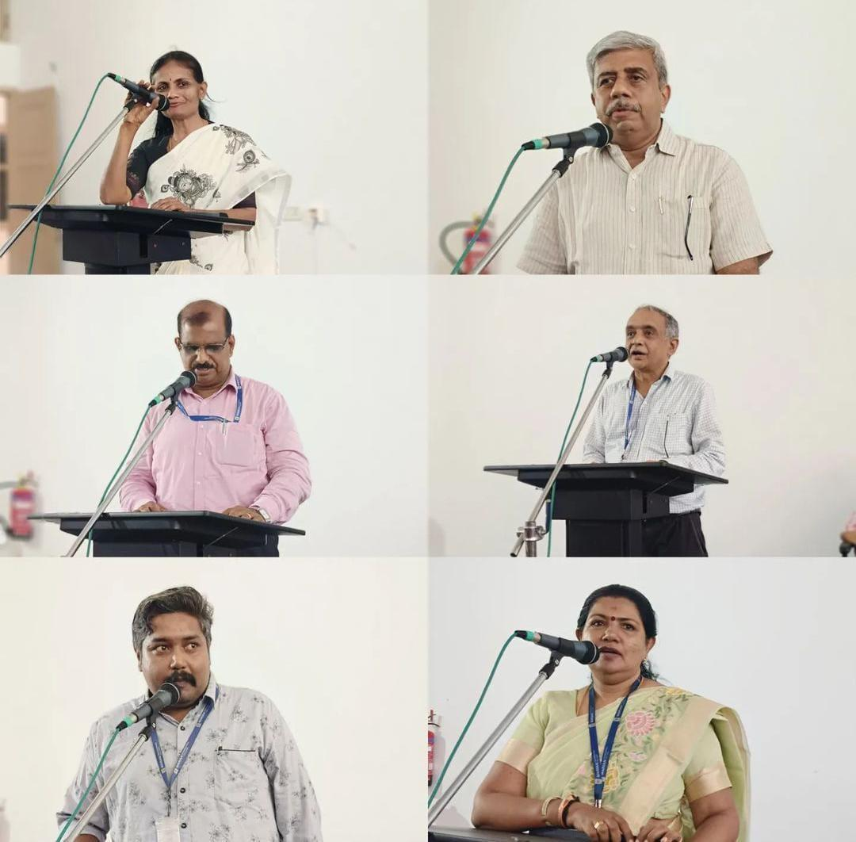
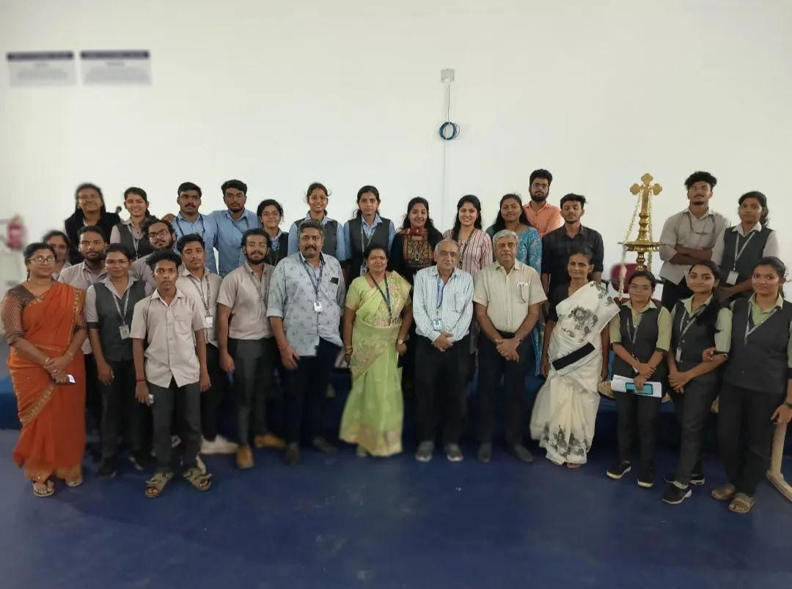

- SESSION ON : COASTAL EROSION , CONTROL MEASURES AND GEOTECHNICAL ASPECTS
The session was delivered by Dr. Sheela Nair , Scientist G and Head , Marine Geoscience Group , National Centre for Earth Science Studies, MOES. The session delved into the multifaceted issue of coastal erosion, exploring its causes, impacts, and the imperative need for effective control measures. The session initiated with an overview of coastal erosion, emphasizing natural processes such as wave action, tides, and human-induced factors like urbanization and climate change. Case studies were presented to illustrate the severity of erosion in various coastal regions. Detailed discussions were held on the primary causes of coastal erosion, including rising sea levels, storm surges, and anthropogenic activities. Participants gained insights into the interconnectedness of these factors and their cumulative impact on coastal stability and also Various strategies for mitigating coastal erosion were explored such as gabions, seawalls, beach nourishment and dune restoration. A substantial part of the session focused on geotechnical aspects related to coastal erosion. This included soil characteristics, slope stability analysis, and the role of geological formations in influencing erosion patterns. Geotechnical investigations were emphasized as fundamental for designing effective erosion control measures. The session concluded with insightful case studies demonstrating successful implementation of erosion control measures and geotechnical interventions. The session served as an invaluable platform for understanding coastal erosion.

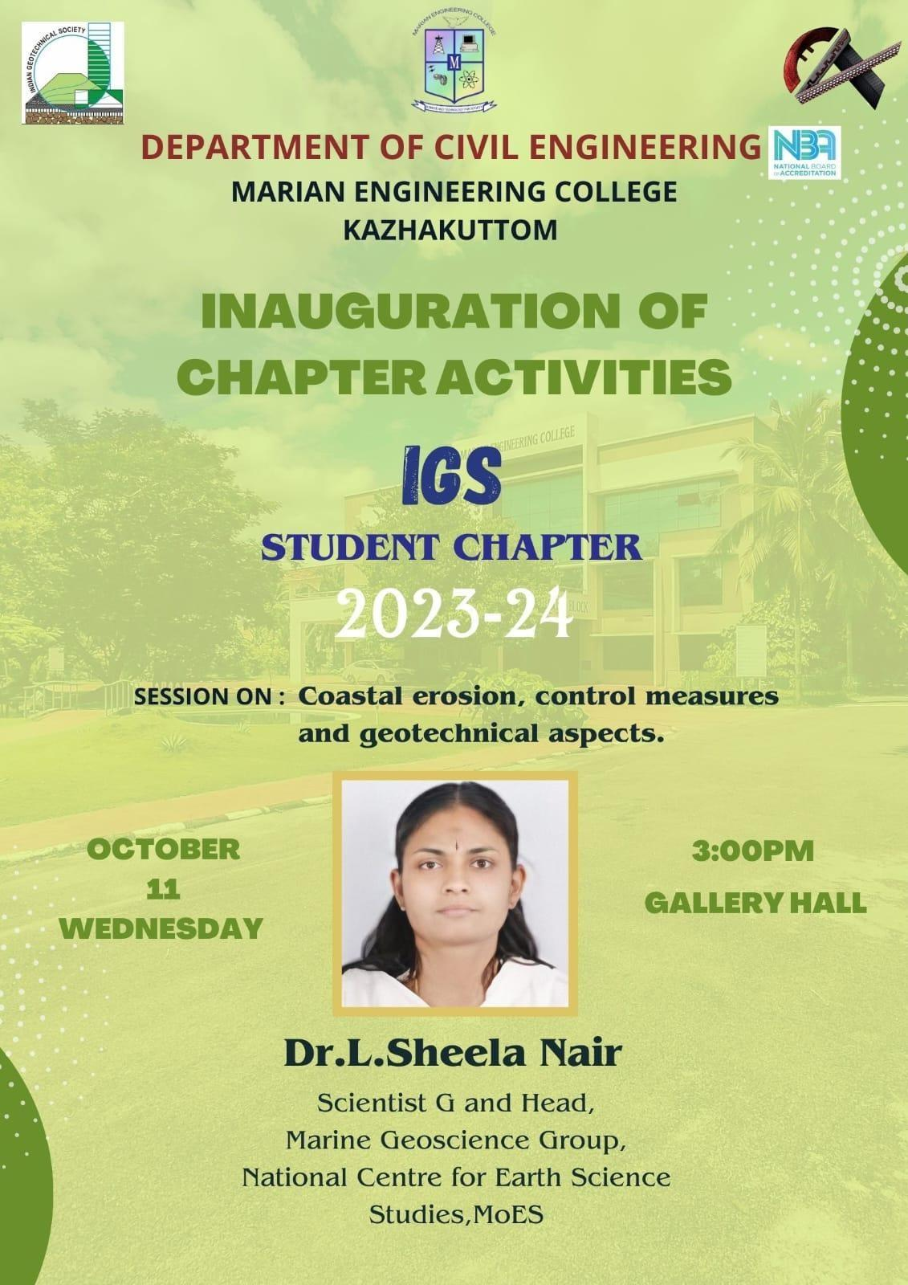
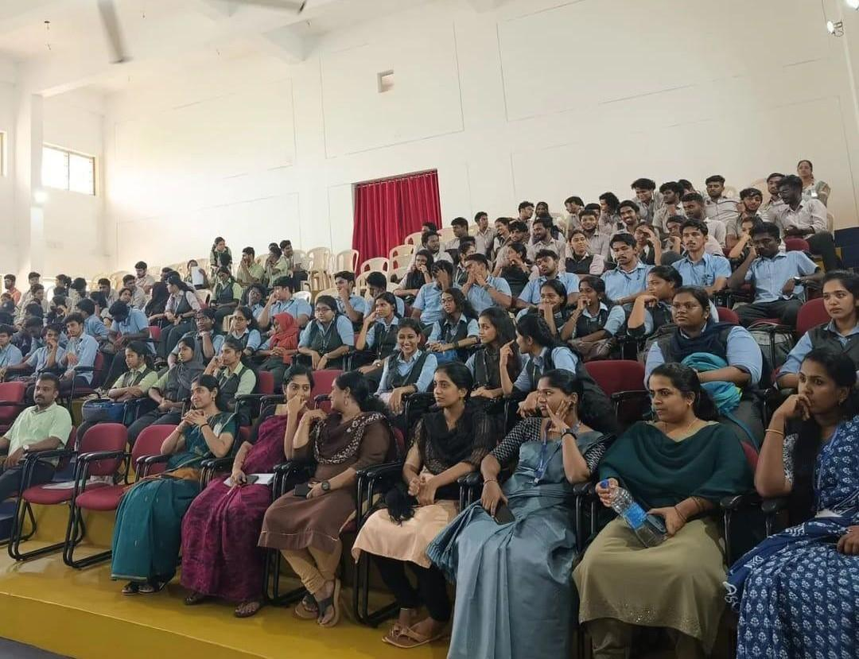
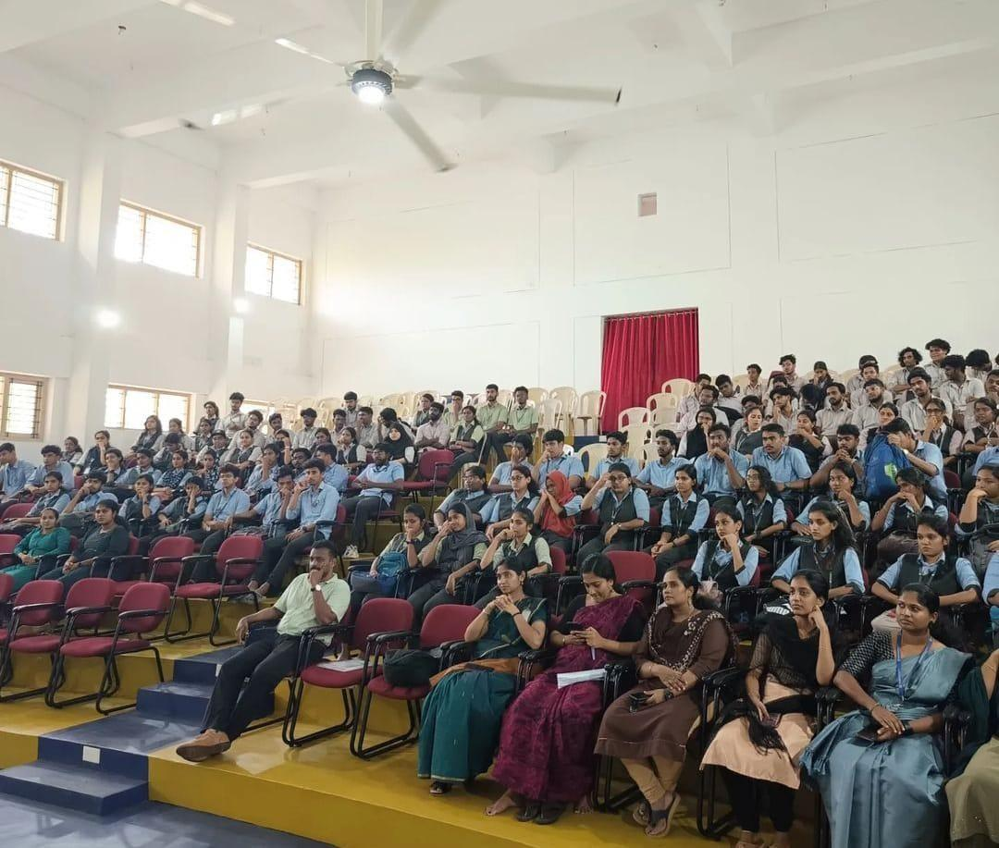
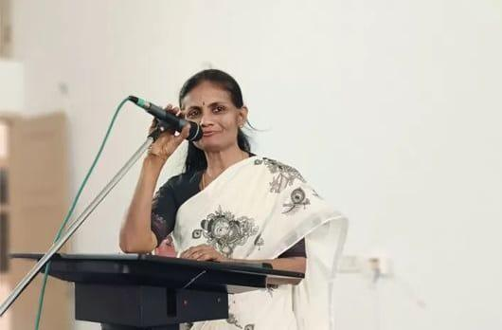

- FIELD VISIT - KERALA FIRST 3D PRINTED BUILDING, KERALA STATE NIRMITHI KENDRA TRIVANDRUM

We have conducted a field visit to Kerala's groundbreaking 3D printed building, a pioneering venture in the construction industry for S3,S5,S7 & Mtech students. S3 and S5 visited on 27th October 2023 and S7 and Mtech students visited on 1st November 2023. 3D printing is an innovative project that marks a significant milestone in sustainable and futuristic architecture. Kerala’s first 3D-printed building is a 380 sq ft, one-room summer house, Kerala State Nirmithi Kendra (Kesnik) campus at PTP Nagar in Thiruvananthapuram. Designed as a demonstration project, AMAZE-28 – as the summer house is named – was completed in 28 days. The project was carried out by Tvasta, a Chennai-based construction tech start-up launched by IIT-Madras alumni, with which Kesnik has inked a memorandum of understanding (MoU). Witnessing the 3D printing process firsthand was awe-inspiring. The efficiency and speed of the 3D printing process were remarkable, significantly reducing construction time compared to traditional methods. During discussions with the project team, it became evident that, despite its success, the 3D printing process faced certain challenges. These included regulatory hurdles and the need for skilled personnel. However, the team demonstrated a proactive approach in addressing these issues, paving the way for smoother integration of 3D printing in future projects. The visit to Kerala's first 3D printed building was an enlightening experience. The project not only signifies a leap forward in construction technology but also serves as a symbol of Kerala's commitment to innovation and sustainability.

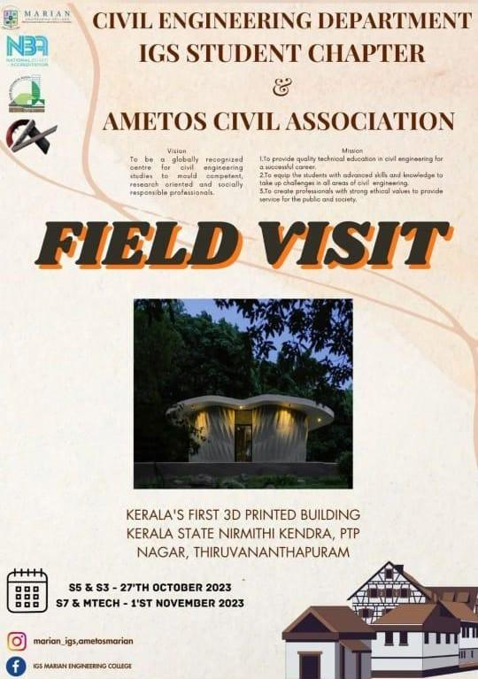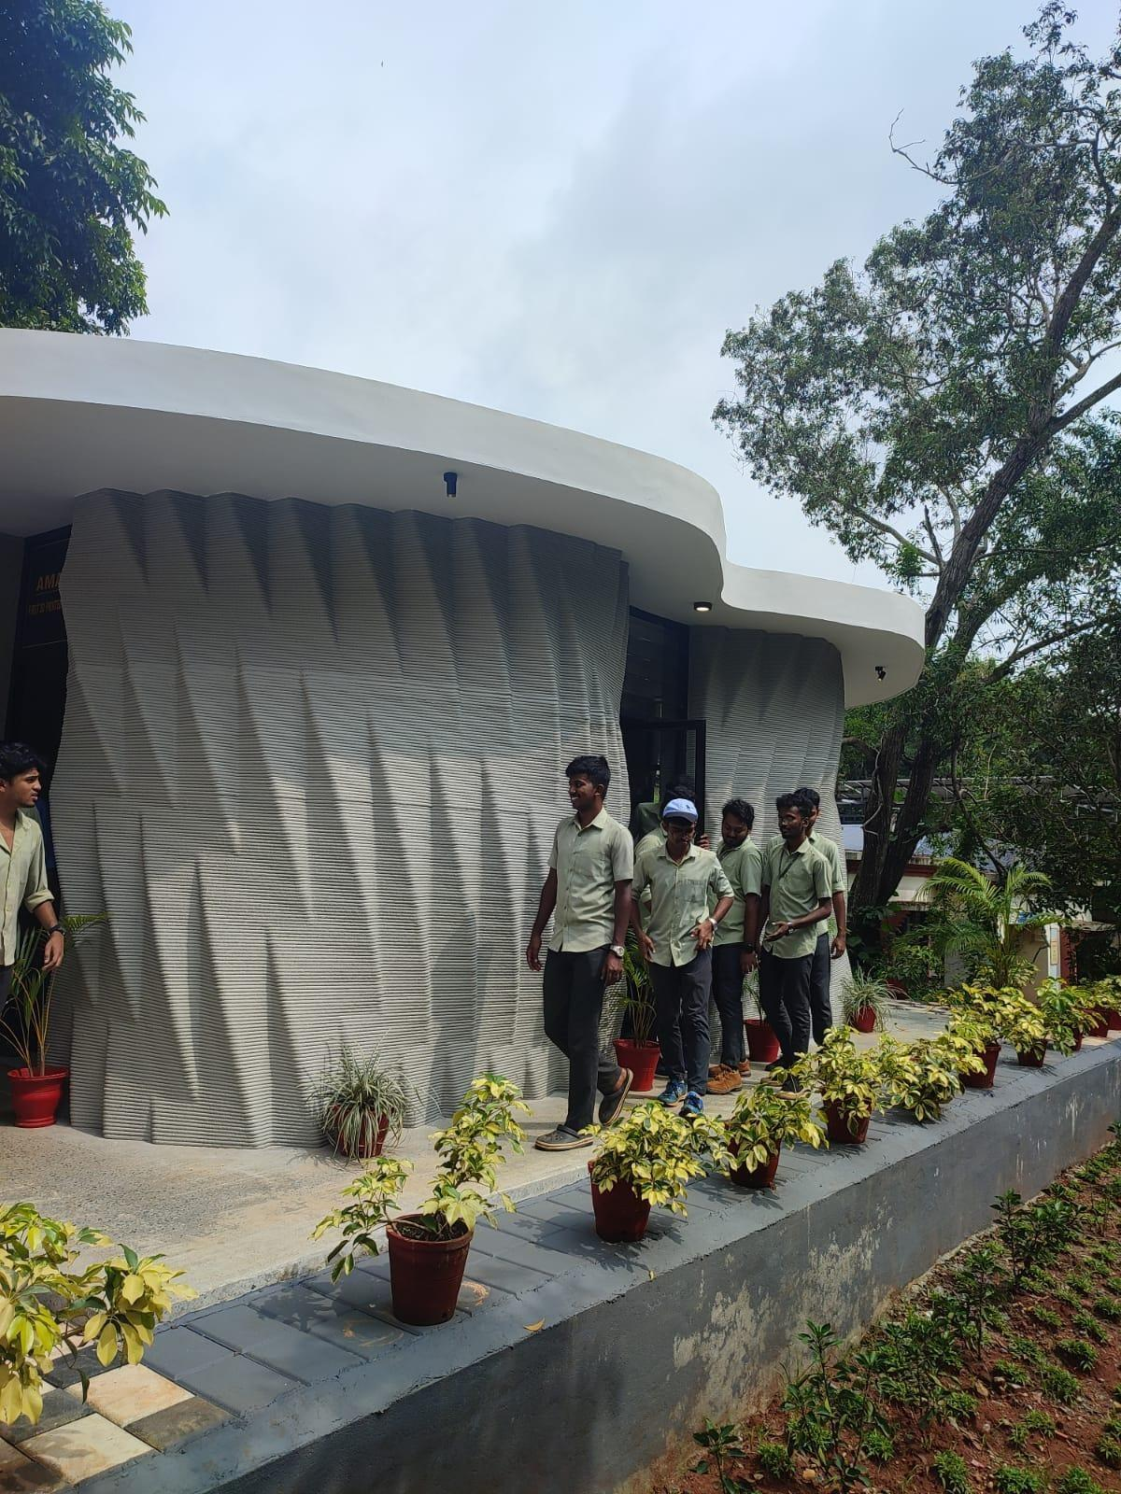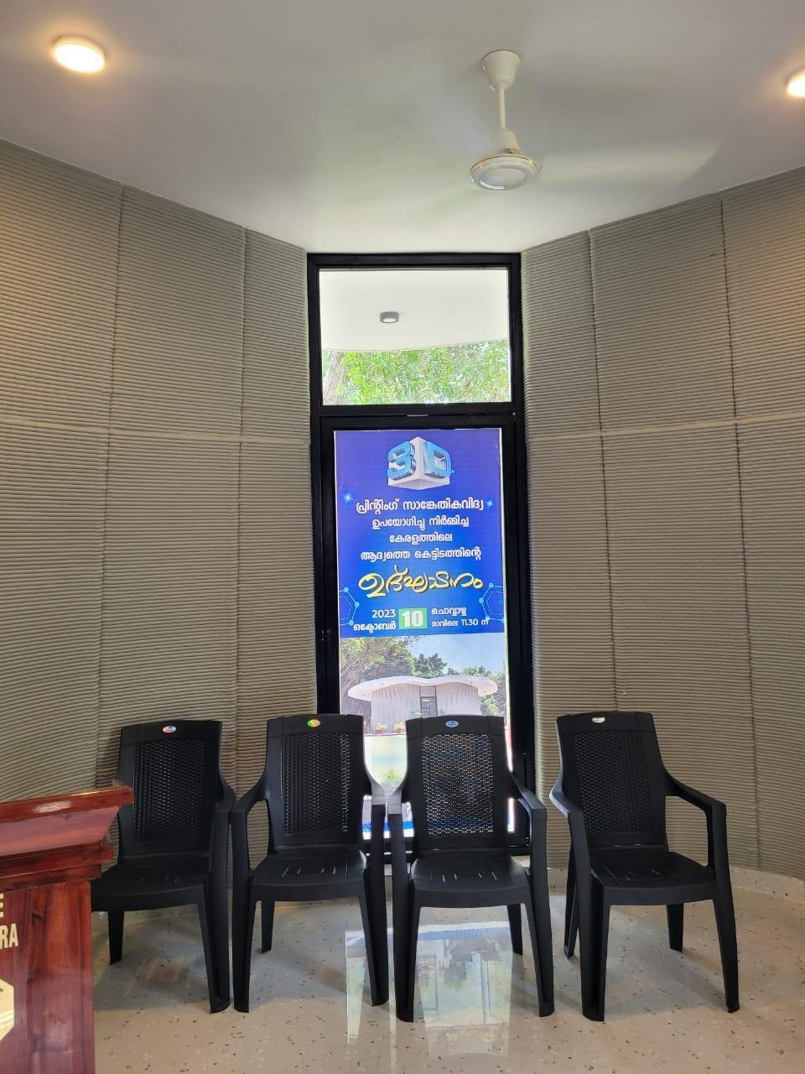
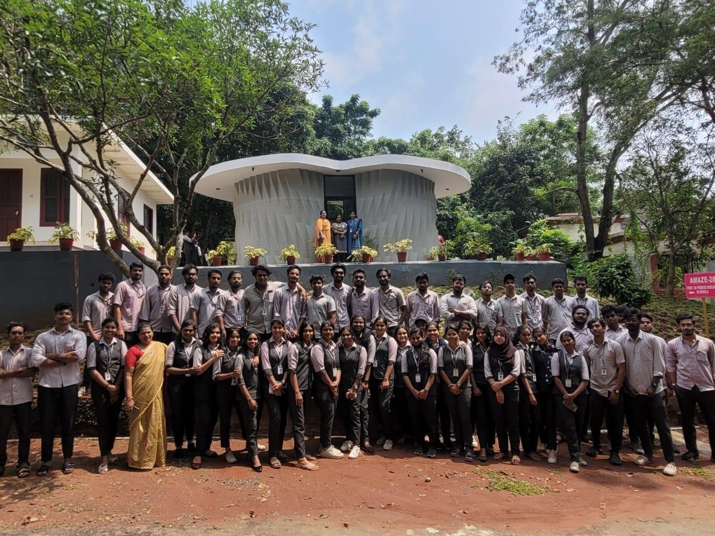
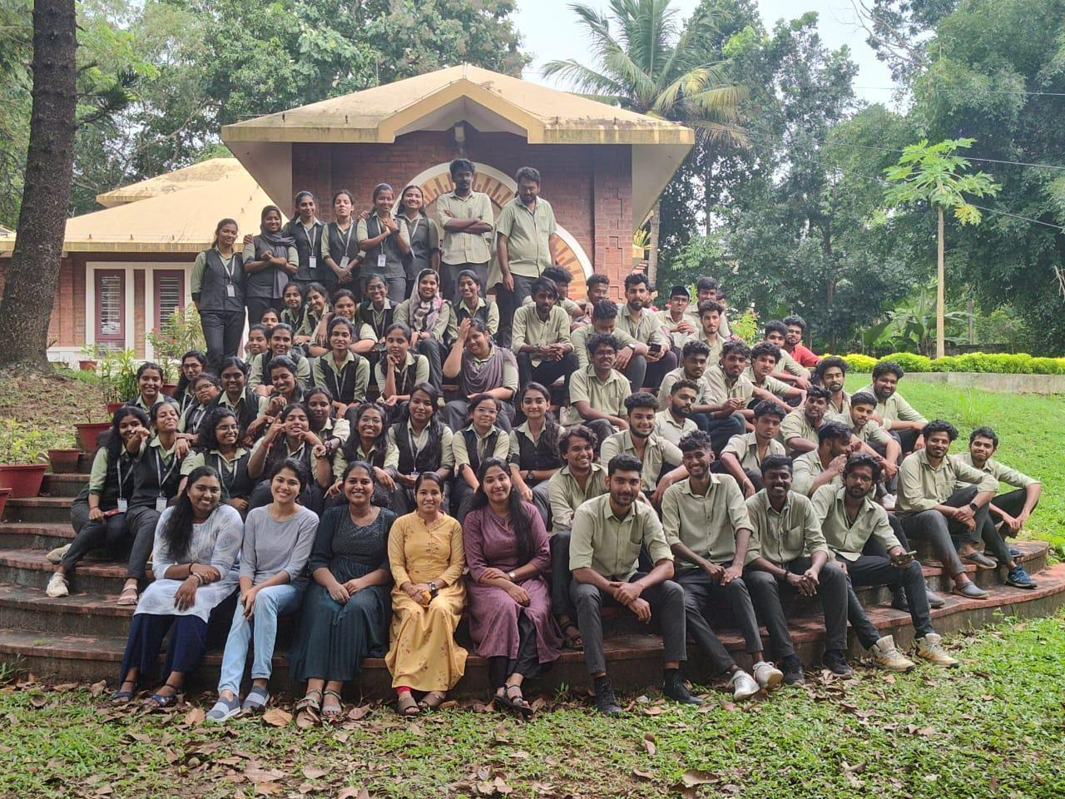
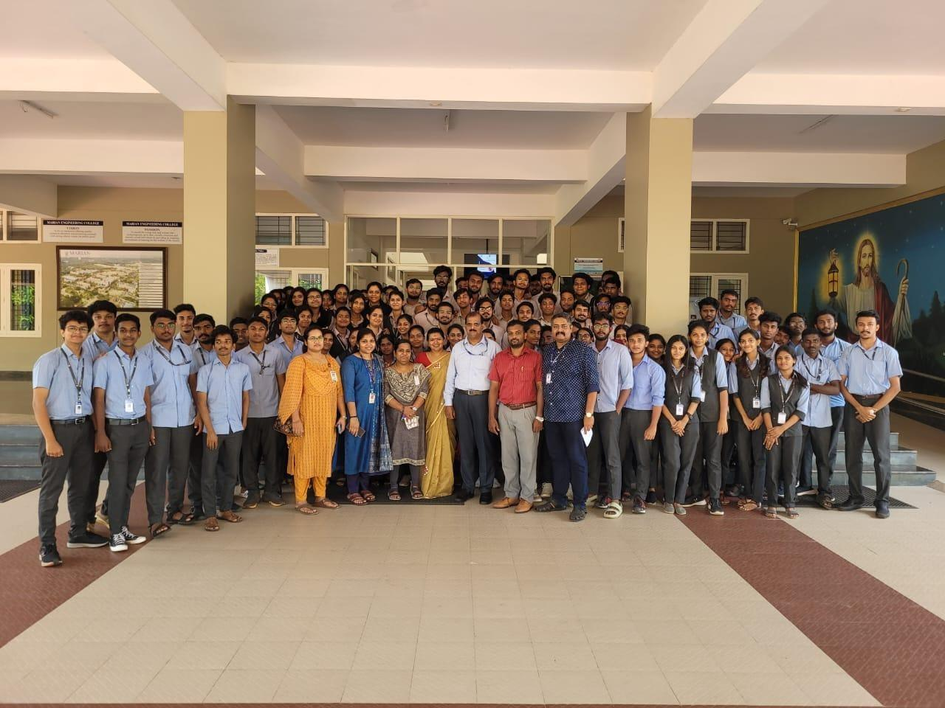
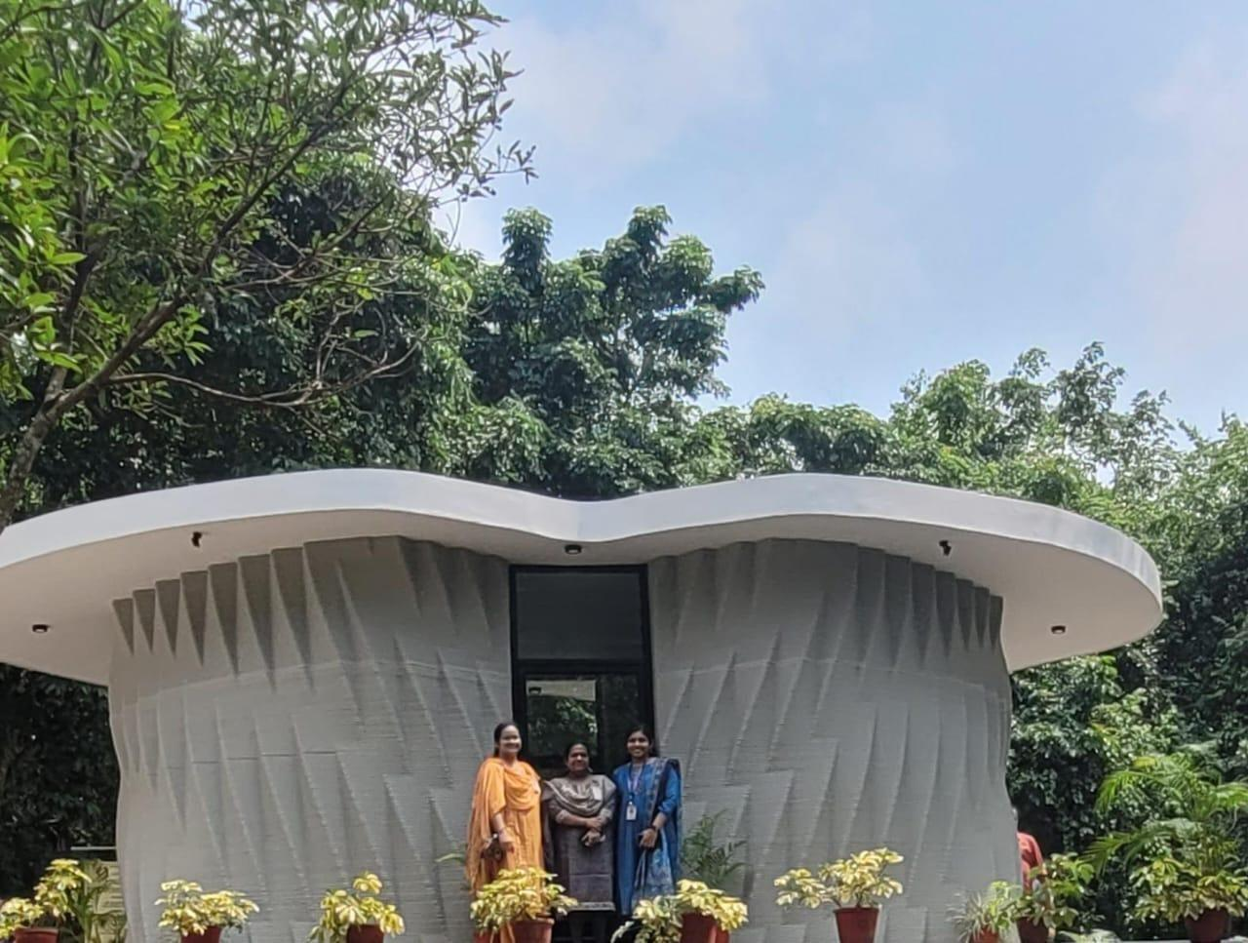

- SITE VISIT - SPT TEST AND PILING
60 students from S5C attended a one-day industrial visit on 27/10/2023. The visit included sessions on standard penetration test (SPT) on a site at Kazhakkoottam, piling test conducted by favorite homes on their site at karikkakom. The visit was dutifully coordinated by faculty members from the department of civil engineering.
Standard Penetration Test : The standard penetration test is an in-situ test that is coming under the category of penetrometer tests. The standard penetration tests were carried out in a borehole. The test is used to measure the resistance of the soil strata to the penetration undergone. The test is extremely useful for determining the relative density and the angle of shearing resistance of cohesionless soils. It can also be used to determine the unconfined compressive strength of cohesive soils.
Piling Test : The key to a steadfast structure is a strong foundation. With large, vertical structures or in situations where the shallow soil is unstable, deep foundations are necessary to anchor the load. These invisible components transfer the load of vertical structures to a deeper soil level with higher bearing capacity and suitable settlement characteristics. However, as they are unseen, piles can potentially hide defects and flaws that threaten structural integrity. Pile tests are essential to determine the bearing capacity and integrity of foundations before building begins and are an effective and reliable method to identify any anomalies within the piles.

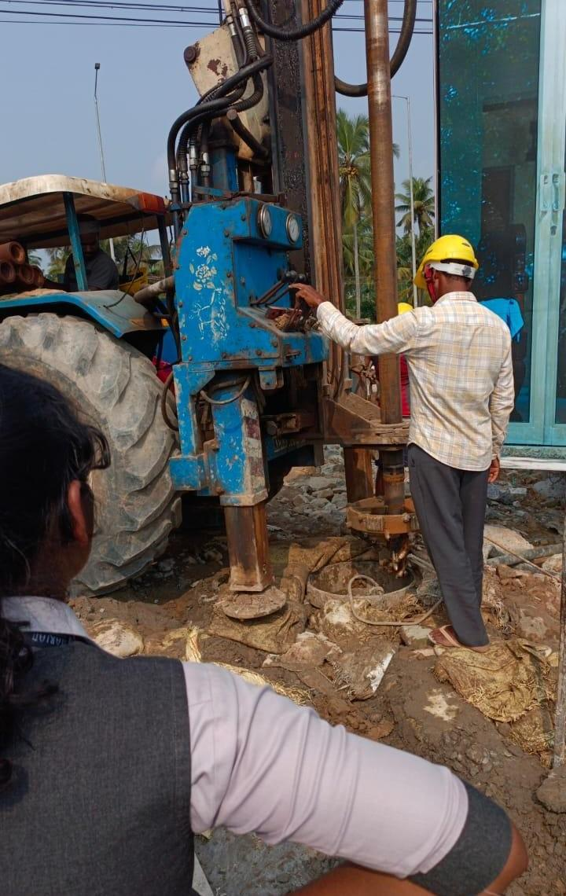
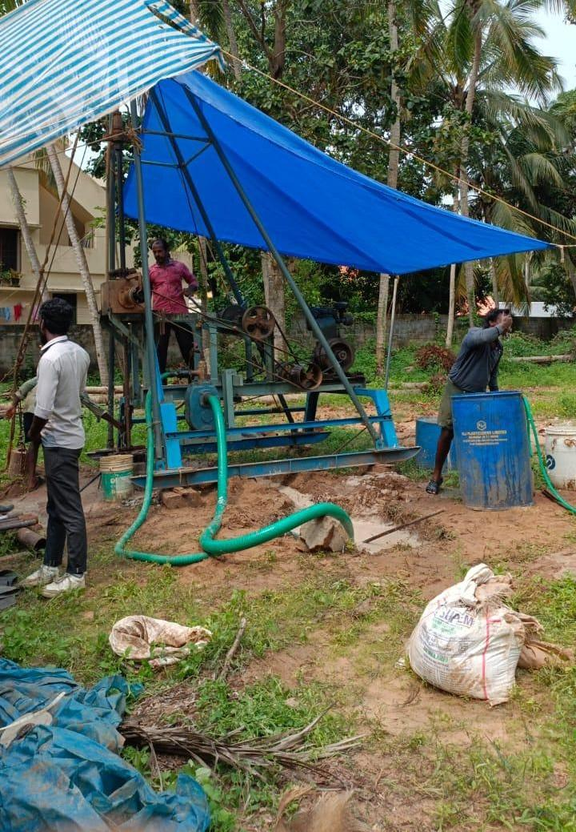
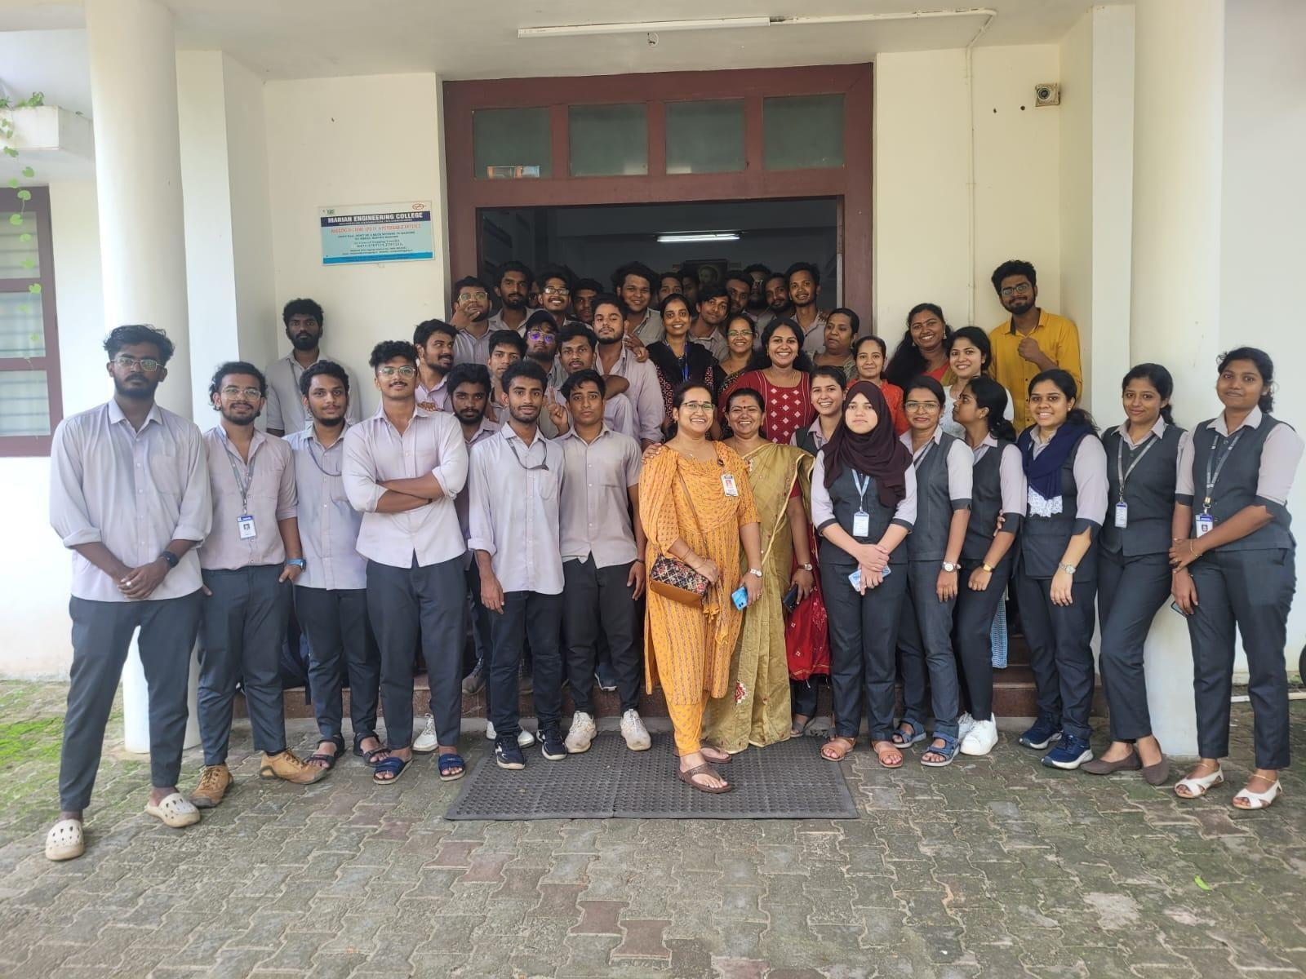
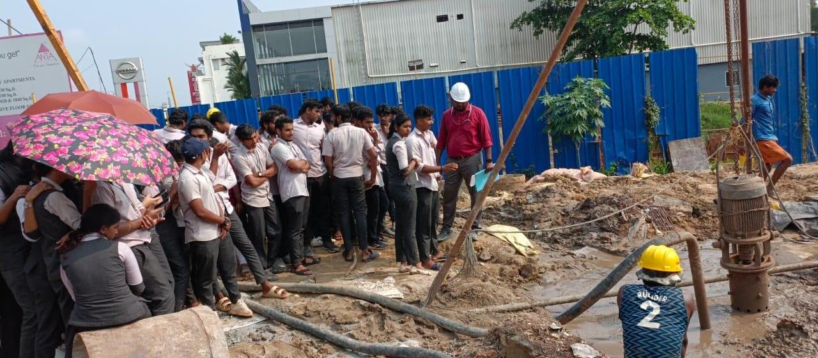
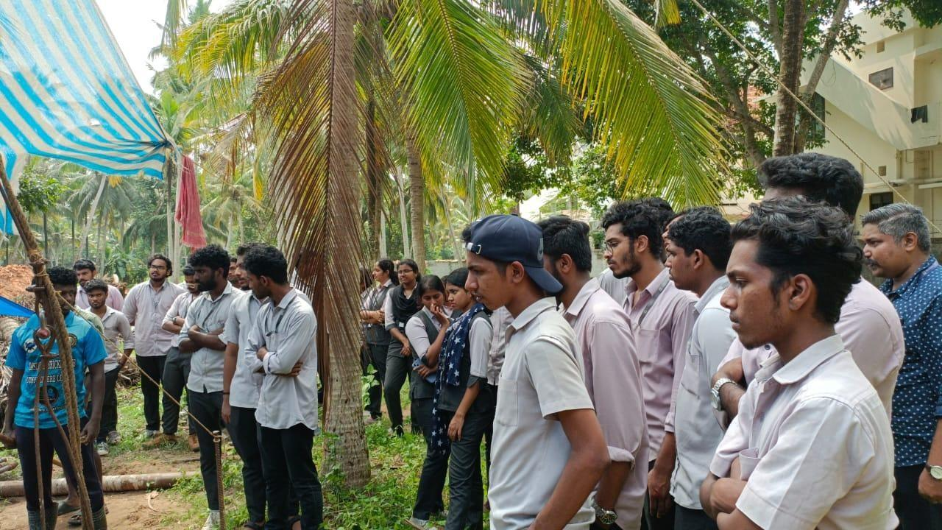

- FIELD VISIT - WATER TREATMENT PLANT ARUVIKKARA, TRIVANDRUM
Field visit to water treatment plant , Aruvikkara was visited on 8th November 2023 by S7 & Mtech students. Kerala Irrigation Infrastructure Development Corporation (KIIDC) took over the 7200LPH Bottled Drinking Water Plant set up at Aruvikkara, Thiruvananthapuram on 5th May 2020. The plant was formally inaugurated on 16th January 2021 by the hon’ble Chief Minister of Kerala. Commercial production of 20 Litre jars was launched on the same day. The plant is situated near the Aruvikkara Dam, 14 km from Trivandrum. The raw water supplied from the Aruvikkara treatment plant of KWA is bottled after all the purification process prescribed by BIS, which includes Sand filter, Activated Carbon filter, Ultrafiltration, UV filtration and also Ozonation process.
The main purpose for this visit was to give practical knowledge about how raw water is treated and how water is distributed in different villages. By this visit students can be familiar with the industrial environment and get knowledge of different units of water treatment plants. Also in 6th semester from environmental engineering we got some knowledge about how components of a filtration plant are constructed, so it is very much convenient to see all the practical components in a real time work environment. They gave the basic knowledge about the treatment process, they explained to students that before arriving at your tap, water is treated at the Water Treatment Plant to remove sediment, bacteria, and other impurities. They explained how the filtration process is working and what are the procedures included in purification of water. Students got an idea about the working of trickling filters, rapid sand filters and also the processes.

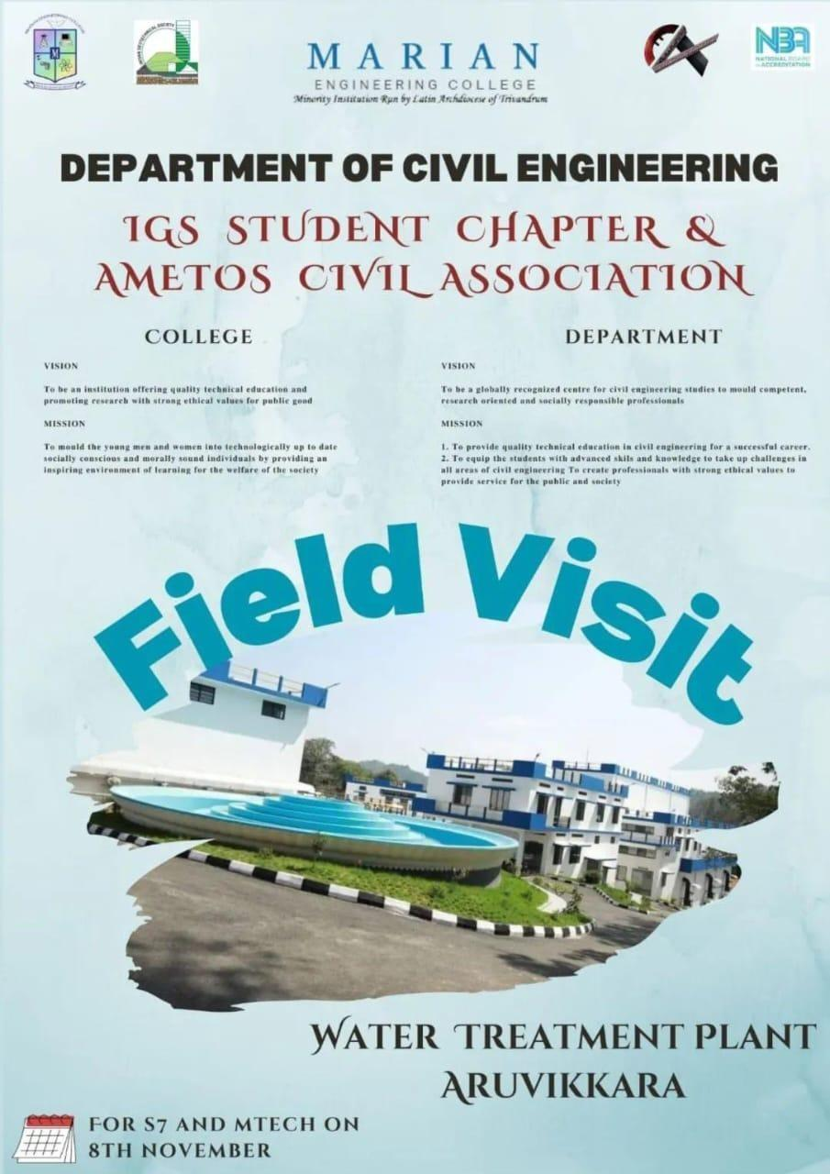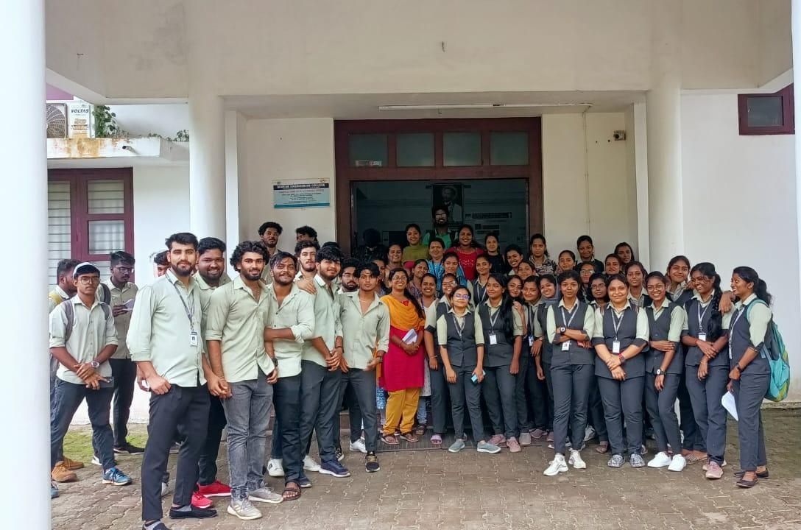
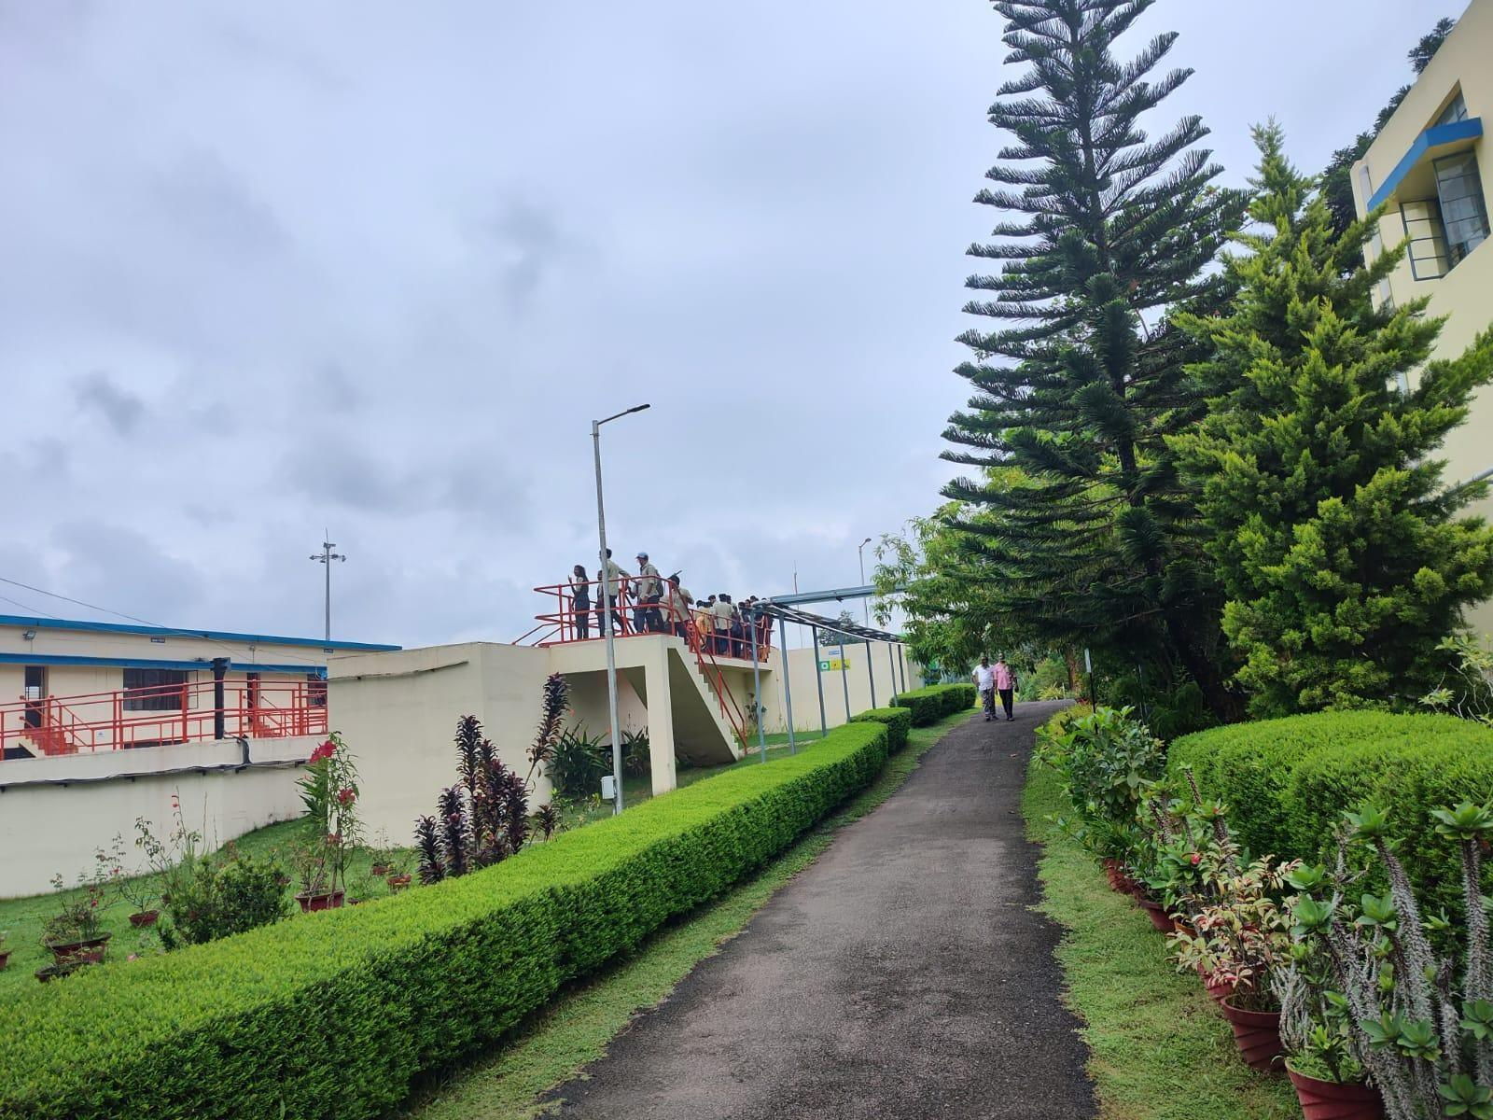
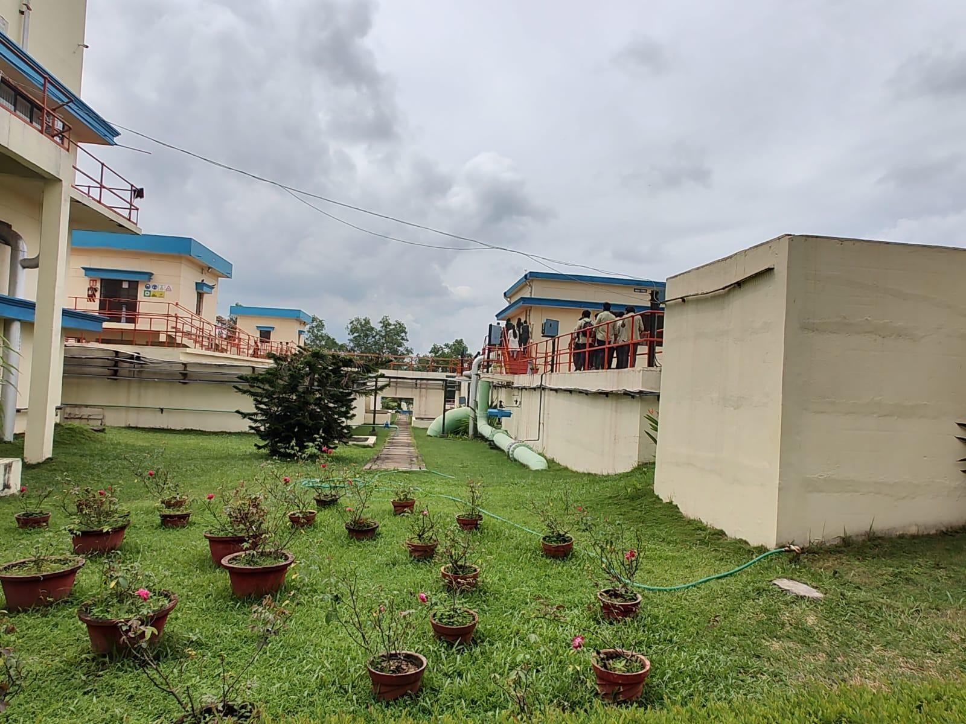
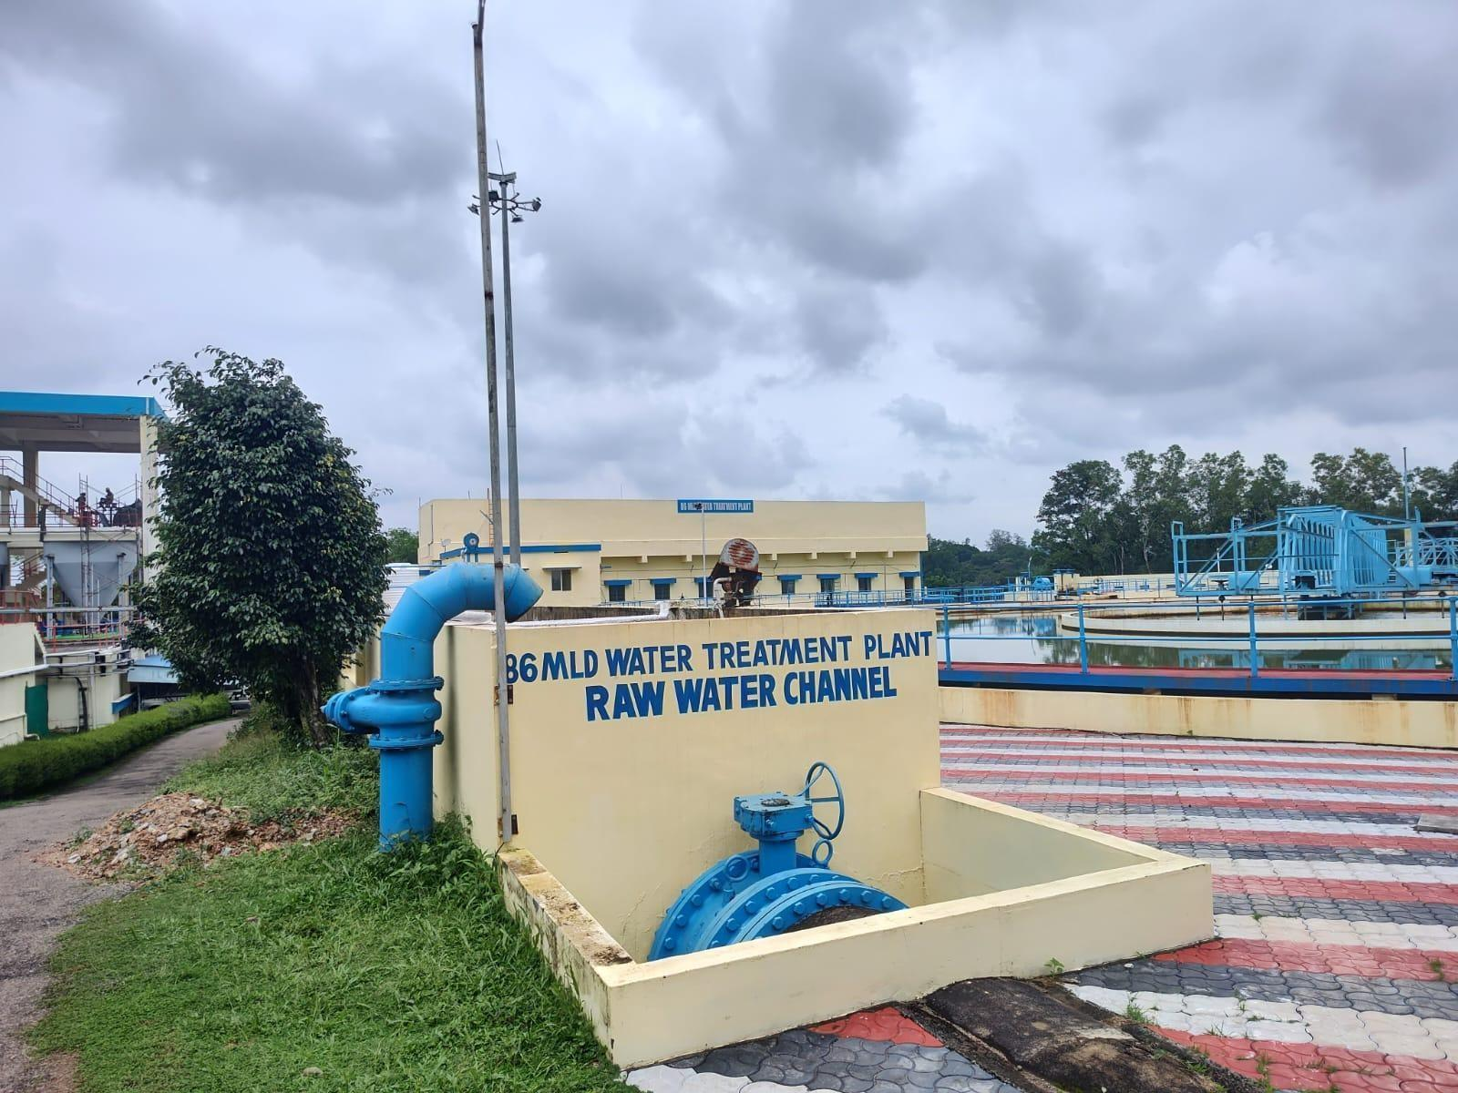
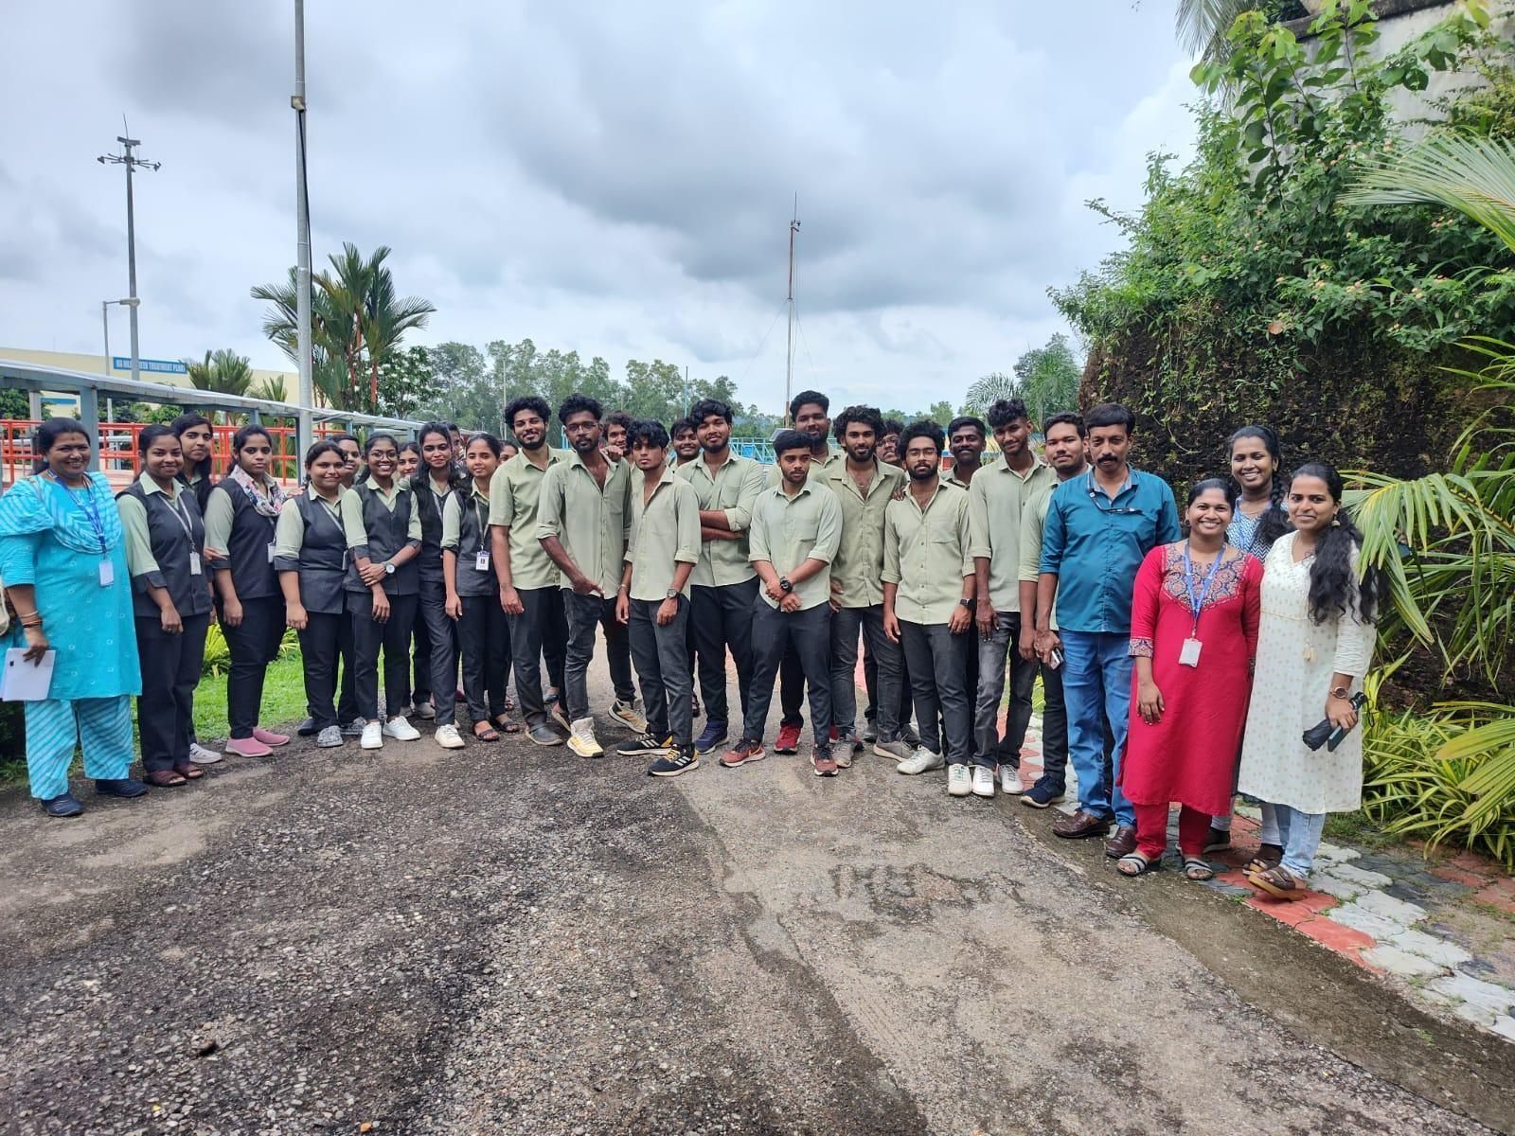

- FIELD VISIT - SOIL MUSEUM, TRIVANDRUM
S3C & Mtech students visited the Kerala Soil Museum on 15/11/2023.Kerala Soil Museum is a museum on the premises of Central Soil Analytical Laboratory at Parottukonam, Thiruvananthapuram District, in the Indian state of Kerala. The museum displays the diverse types of soil in the state. It has been described as the world's largest soil museum and the first soil museum in India established to international standards. The museum showcases a wide array of soil types found in different regions, highlighting their unique characteristics and compositions. Exhibits demonstrate the role of soil in agriculture, emphasizing how soil health impacts crop growth and yield. Students are educated on the geological processes that contribute to the formation of different soil types over time. The museum incorporates interactive displays, allowing visitors to engage with soil samples, understand soil testing methods, and learn about sustainable soil management practices.
During our visit, an expert guide provided a comprehensive tour, explaining the importance of soil conservation and sustainable practices. Additionally, informative presentations were conducted, enhancing our understanding of the critical role soil plays in maintaining ecological balance. The visit deepened our understanding of the vast diversity of soils, each with its own unique properties and significance. We gained awareness of how soil contributes to environmental conservation efforts, emphasizing the need for responsible soil management. The Soil Museum in Trivandrum offers a valuable educational experience, providing a comprehensive understanding of the significance of soil in agriculture, geology, and environmental science. The field visit ended about 3:30 pm, it can be concluded that the field visit was successful and we believed that our objective was achieved. students learned something new and beneficial for them.

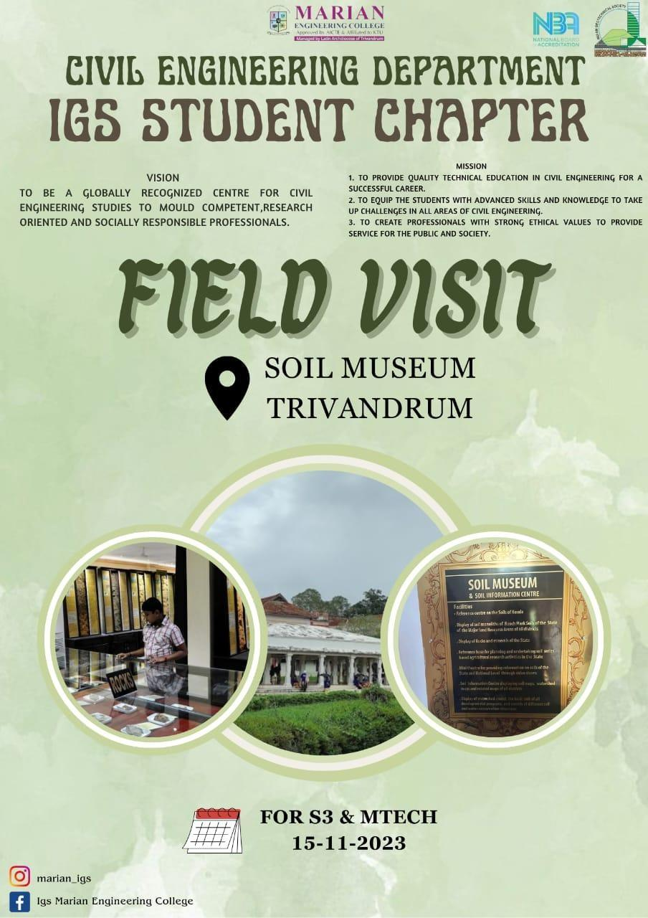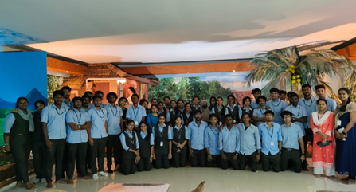

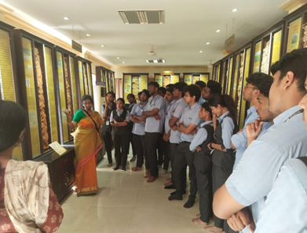
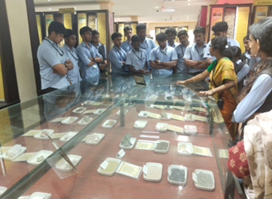
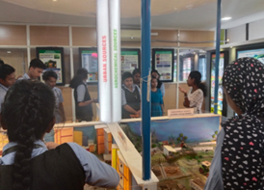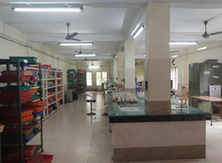

- PHOTOGRAPHY CONTEST - WORLD SOIL DAY
A photography competition was conducted on 5th December 2023 as a part of World Soil Day with the theme ‘SOIL, WATER - A SOURCE OF LIFE’. It aimed to raise awareness about the significance of soil health and its impact on the environment. The theme encouraged participants to capture the beauty, diversity, and importance of soil and water in our daily lives.
There were 11 students who participated. The contest started from 5th December at 12 pm to 7 pm and the judgments were made by faculty members of IGS and the winners were awarded with certificates and e certificates were provided for all participants. Anjanadevi J A of S7C1 got first prize, Anakha Alexander of S7C1 got second prize and Sreerag B Kumar of S7C1 got third prize.
The photography contest not only celebrated the aesthetic appeal of soil but also served as a powerful medium for spreading awareness about soil conservation. The diverse and impactful entries demonstrated the participants commitment to
promoting environmental consciousness through the lens of creativity.

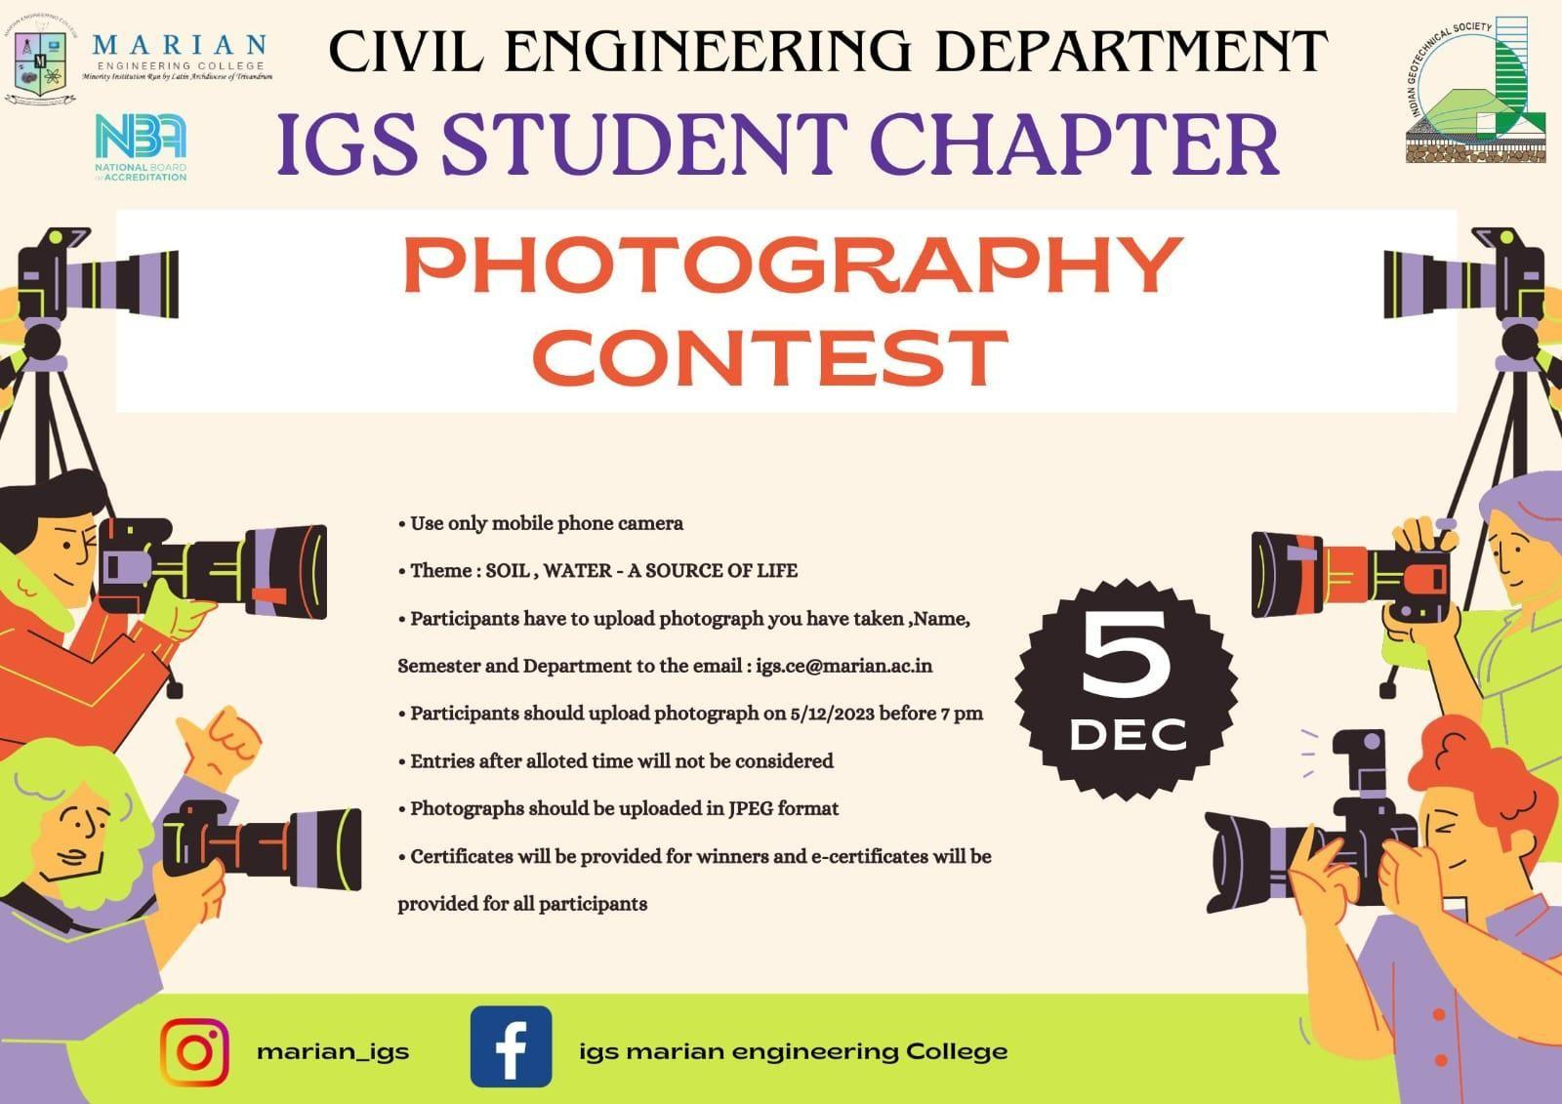

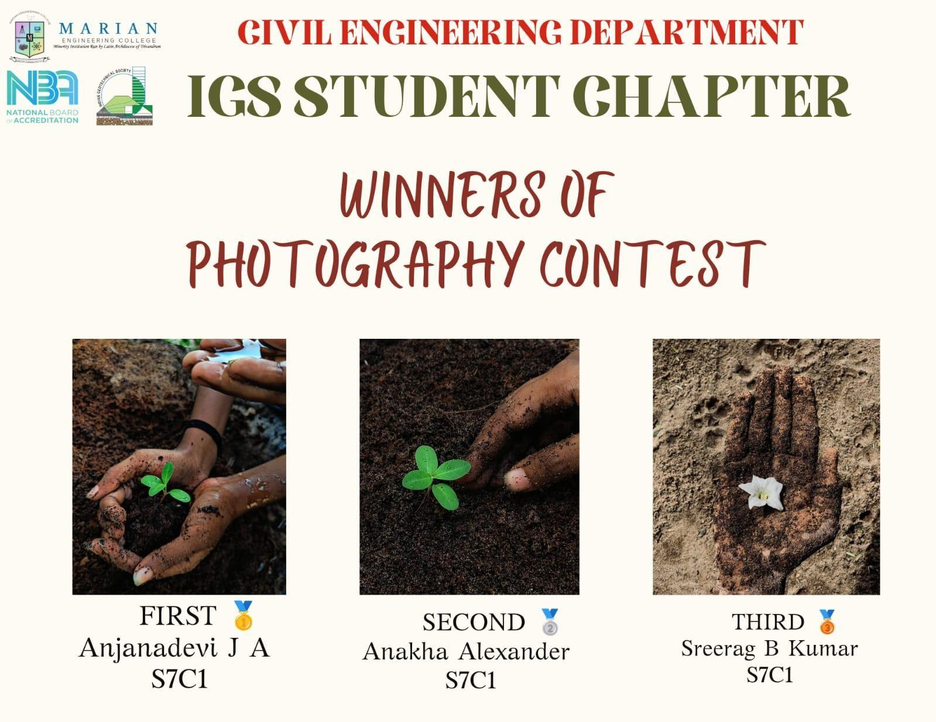

FIRST PRIZE | SECOND PRIZE | THIRD PRIZE
Anjanadevi J A , S7C1 | Anakha Alexander , S7C1 | Sreerag B Kumar, S7C1

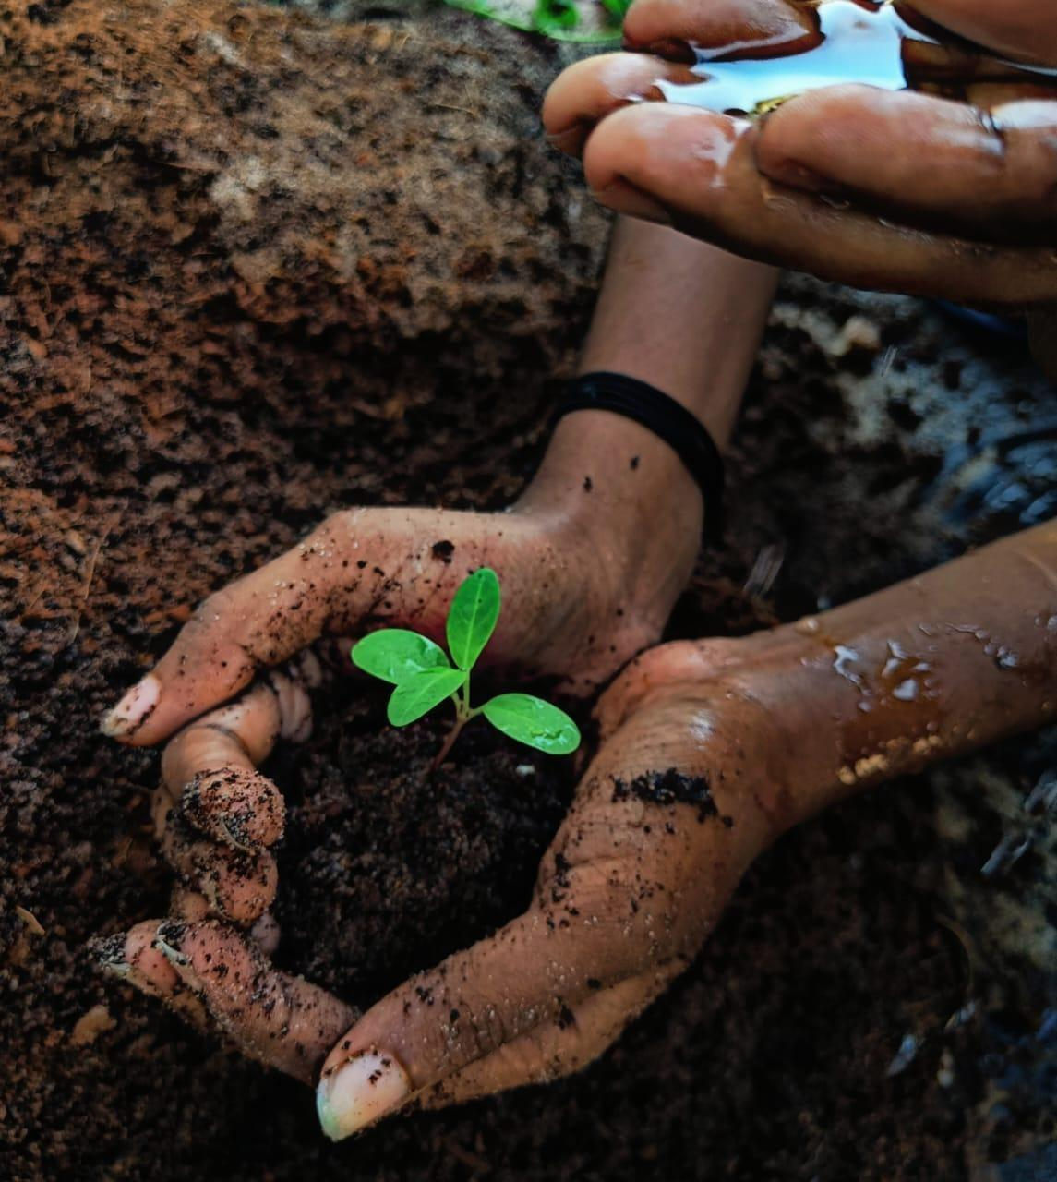
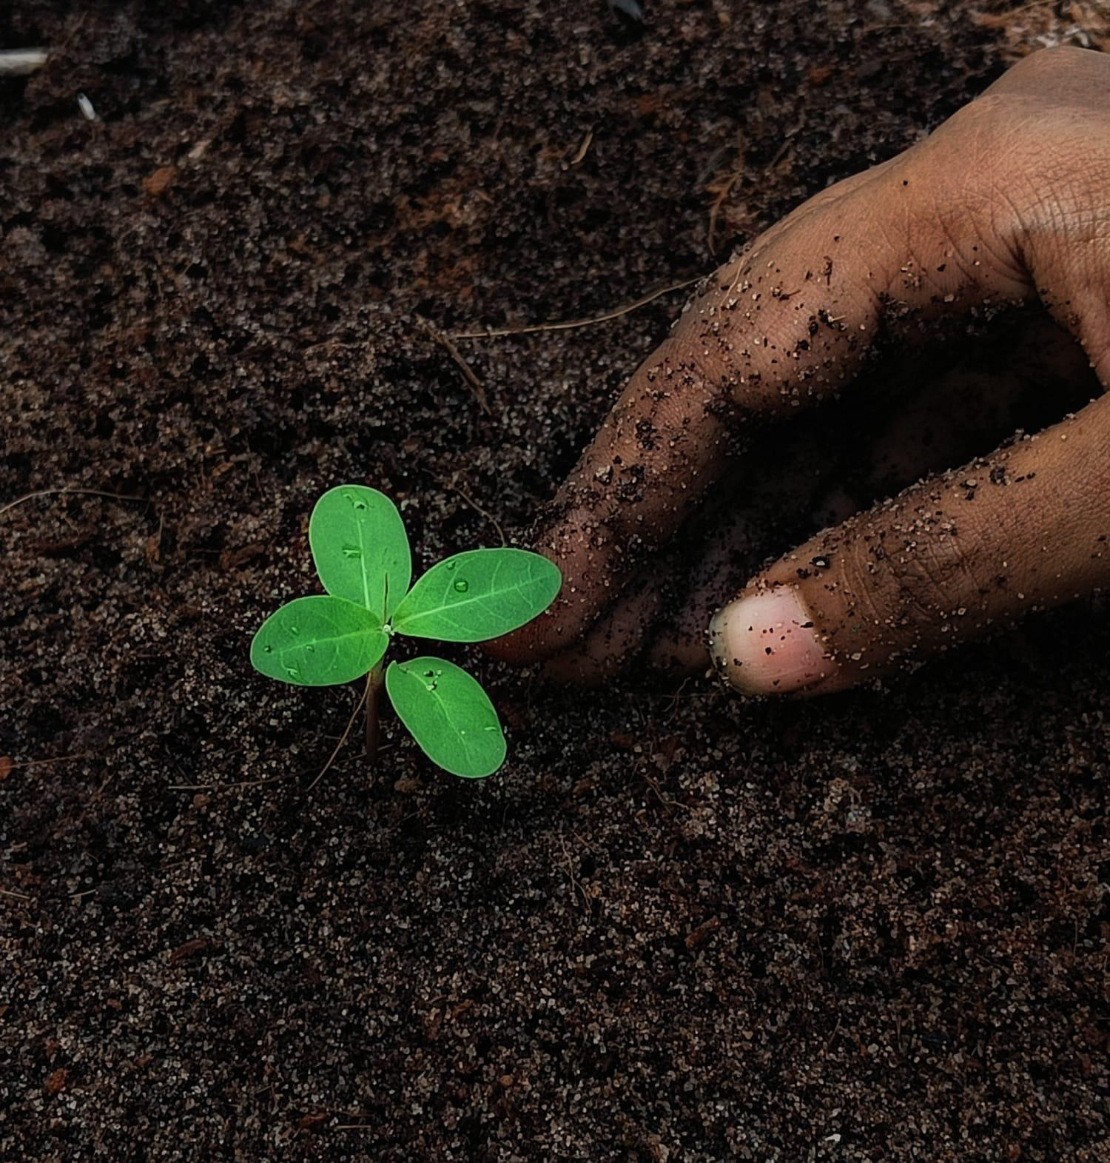
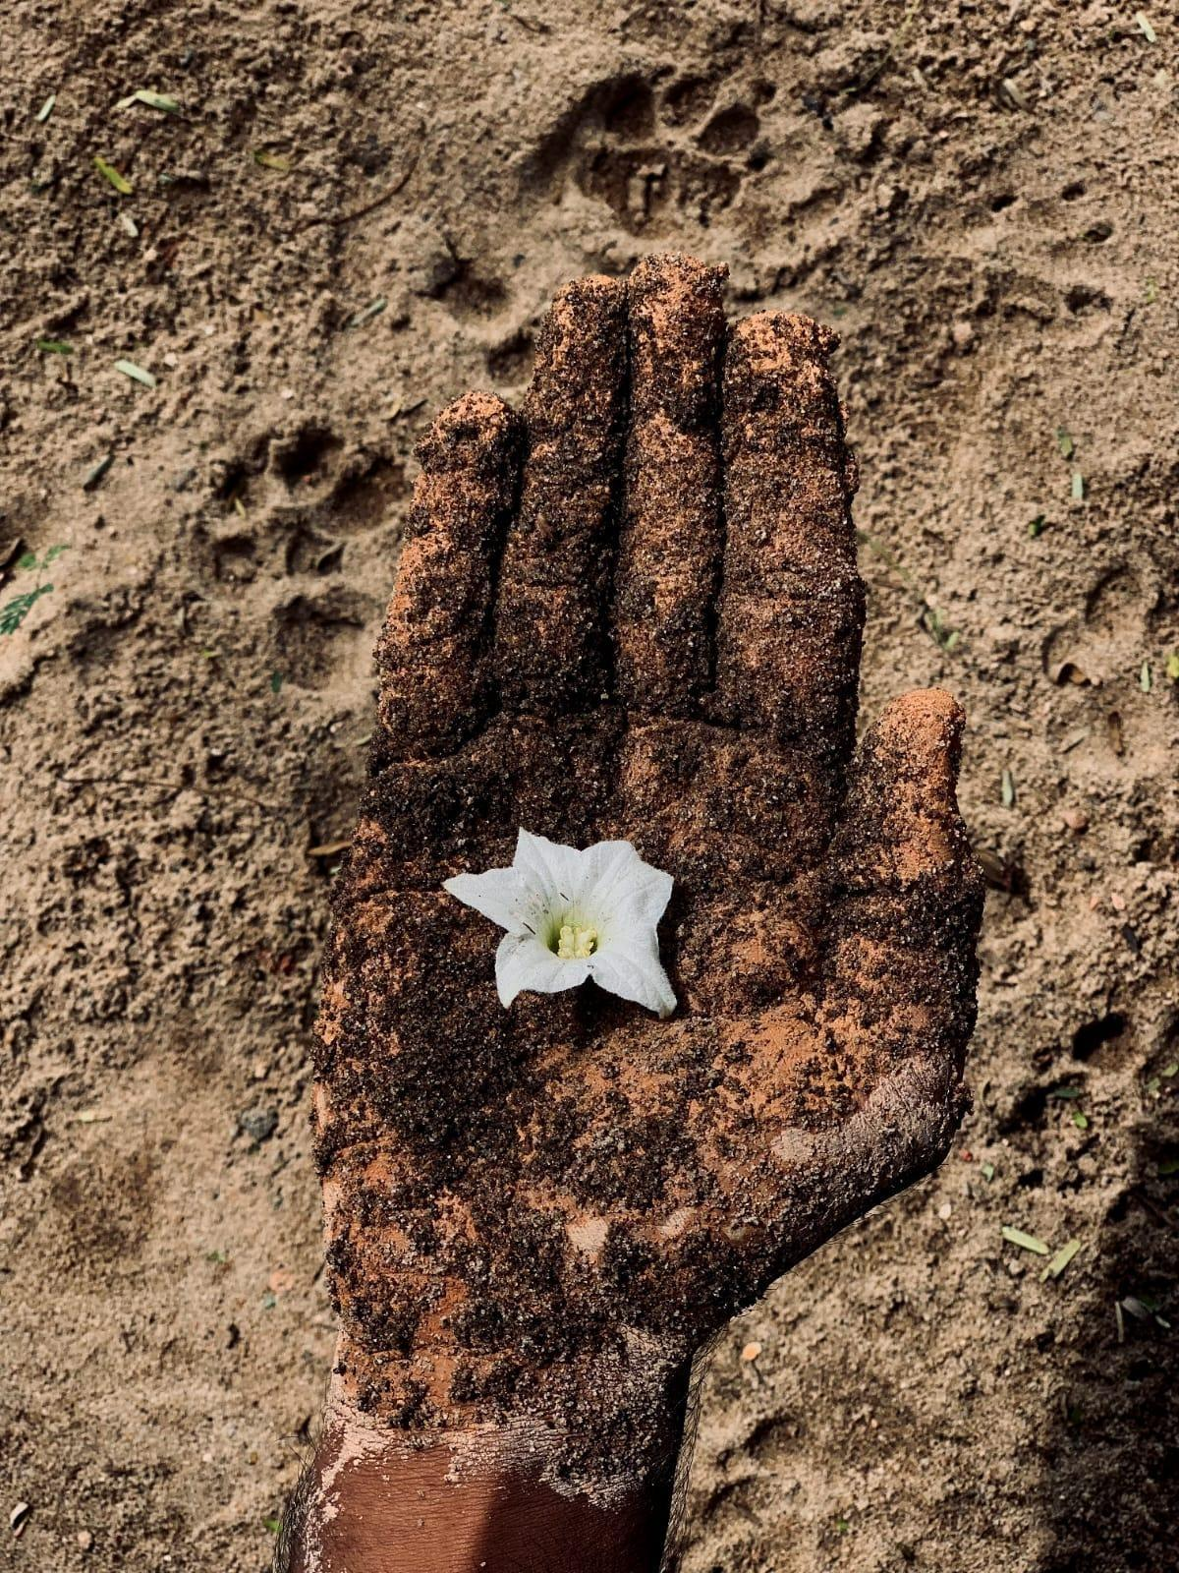

- POSTER MAKING COMPETITION - WORLD SOIL DAY

The poster making competition on the "Importance of Soil Conservation" aimed to raise awareness about the critical role soil plays in our ecosystem and the need to preserve it for future generations. Held on 5/12/2023 - 10/12/2023 , the event drew participation from 14 enthusiastic individuals, each expressing their perspectives through creative artworks. Students outside Marian Engineering College were allowed to participate.
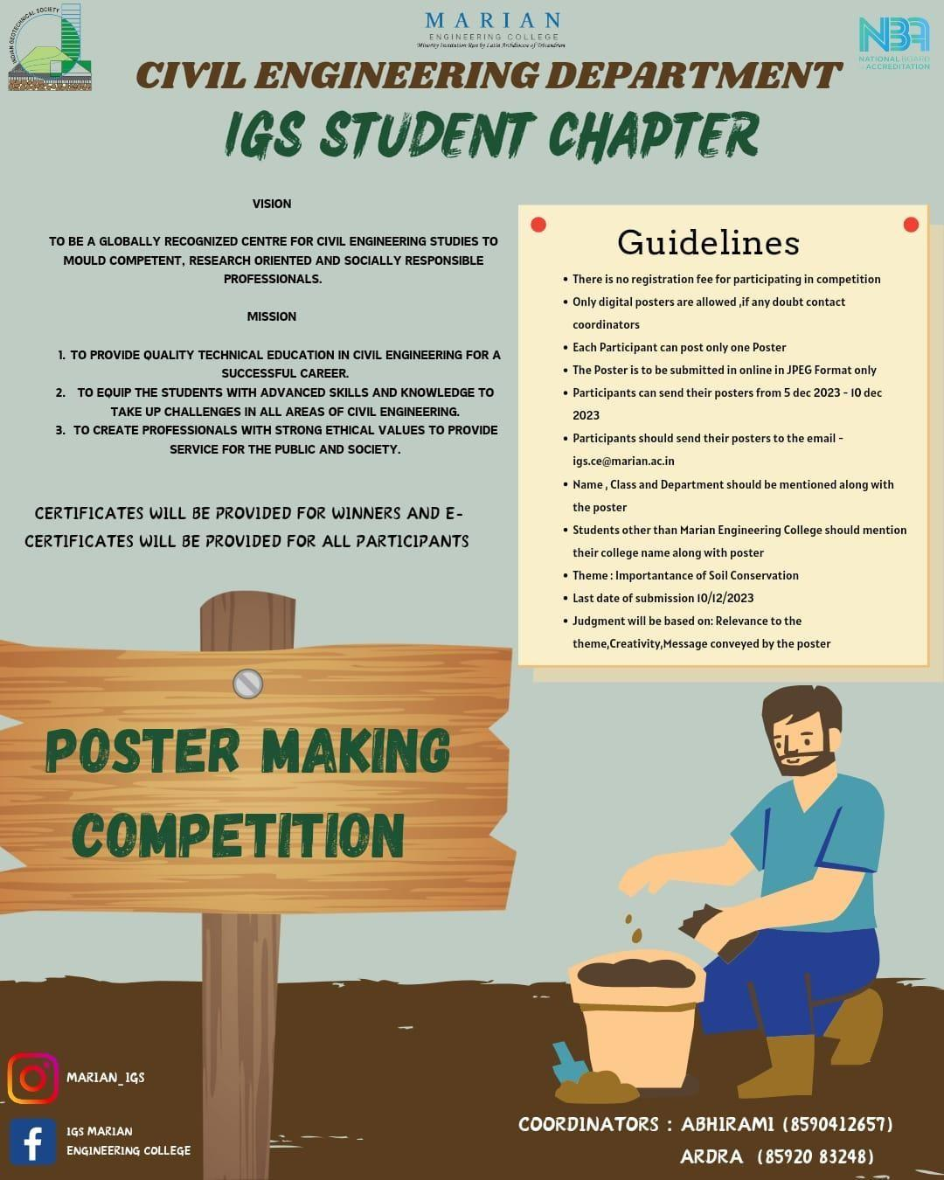
Participants demonstrated a clear understanding of the theme, emphasizing the various aspects of soil conservation, such as preventing erosion, promoting sustainable agriculture, and preserving biodiversity. The posters were visually striking, employing vibrant colors and innovative designs to capture attention. Many artists used compelling imagery to convey the urgency and importance of soil conservation. A
notable feature of the competition was the informative content incorporated into the posters. Participants effectively communicated the consequences of soil degradation and offered practical solutions to promote soil health. The winners are decided by faculty members of IGS, Sweety Thadeous of S7C1 got first prize, Amritha A V of S7C1 got second prize and Bizna S of S7C1 got third prize. The winning entries serve as powerful reminders of the vital role each person plays in safeguarding our planet's soil for current and future generations.

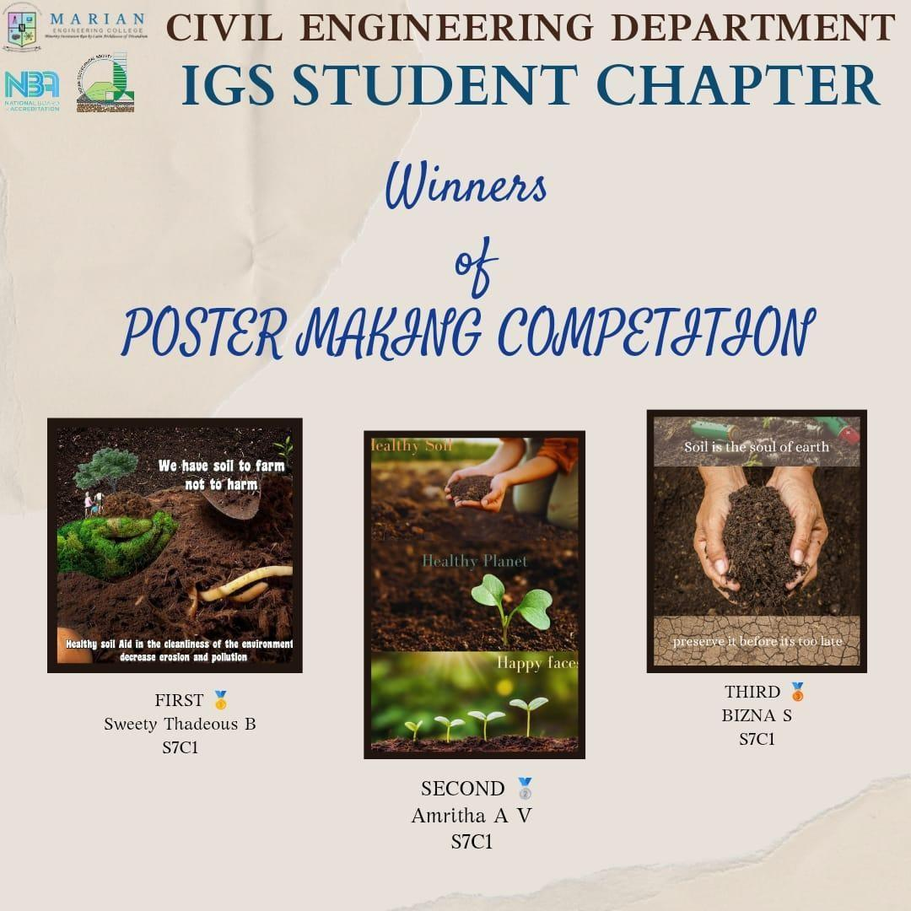

FIRST SECOND THIRD

Sweety Thadeous, S7C1 Amritha A V , S7C1 Bizna S, S7C1
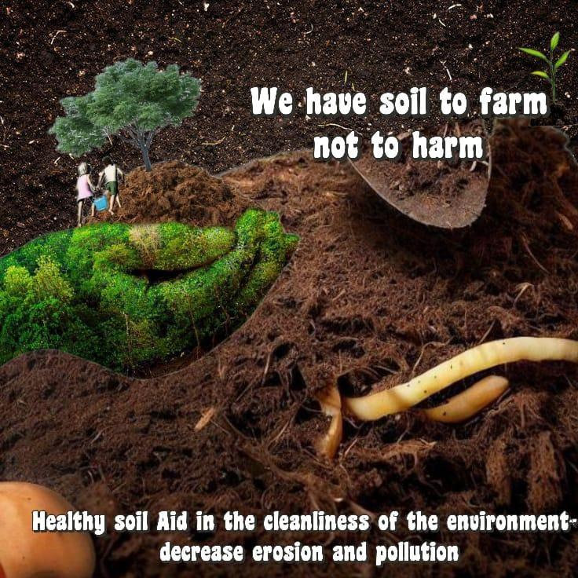

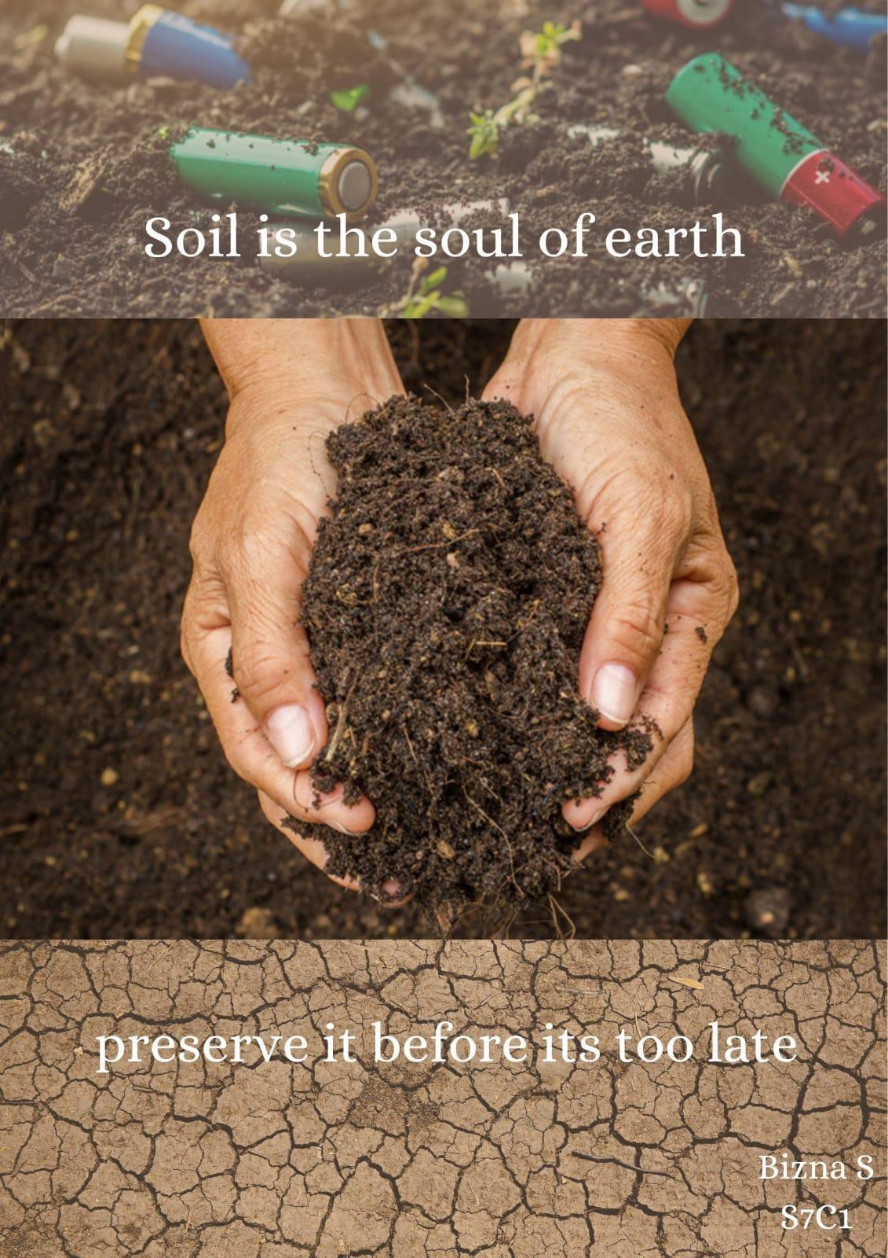

10.WOMEN EMPOWERING FUNCTION

A Women empowering function was organized as a part of World Women’s Day in the Civil Engineering department seminar hall on 6th March 2024 at 1.00 pm for an inspiring and empowering event, marked by the presence of esteemed Chief Guest, Er. Lekshmi A S, IES CWE Air Force, Southern Air Command, Aakulam. The event was hosted by Aparna S Nair of S8C1 then the event was started with a prayer by Anjanadevi J A of S8C1 and Aparna Mugaldas of S8C2 after that Inaugural Address by Dr. Narayanan S, HOD of Civil Engineering Department and then Anamy J B of S8C1 delivered a speech about Women’s Day and Dr Abdul Nizar M, Principal, Mec wished every attendees and shared his thoughts about women’s day.
Chief Guest Lekshmi IES captivated the audience with her remarkable speech and story ‘Fighting spirit in silence – A true story of a young Geotechnical Engineer’, shedding light on the challenges she overcame and the milestones she achieved in her IES training and personal life. Her resilience and determination resonated with everyone present, leaving a lasting impact on the audience. Despite facing challenges with speaking, her journey through IES training and life served as a beacon of inspiration for all attendees
In a heartfelt gesture, we honored the women faculty members of the Civil Engineering department by Dr. Abdul Nizar M, recognizing their invaluable contributions to academia and mentorship. Their dedication and expertise serve as guiding lights for aspiring engineers.
Furthermore, the event highlighted the achievements of women students in the Civil Engineering department, honoring them by Chief Guest for their excellence in academics, cultural activities, sports, and beyond. Their accomplishments underscored the importance of fostering an inclusive environment that nurtures talent and promotes gender equality in all fields.

Women's Day celebration was not only a tribute to the achievements of women but also a call to action for continued support and empowerment. It served as a reminder of the progress made and the work that remains to be done in achieving gender parity and inclusivity in all spheres of life. Overall, the event was a resounding success, leaving attendees inspired and motivated to strive for greater heights in their personal and professional endeavors, irrespective of gender barriers. The event was concluded with a vote of thanks delivered by Helen Thomas of M4GT.
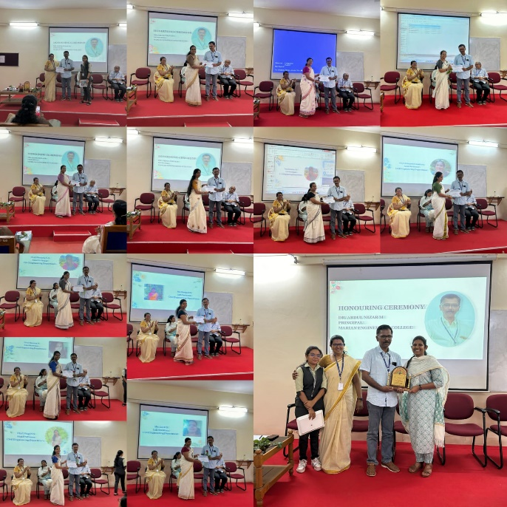
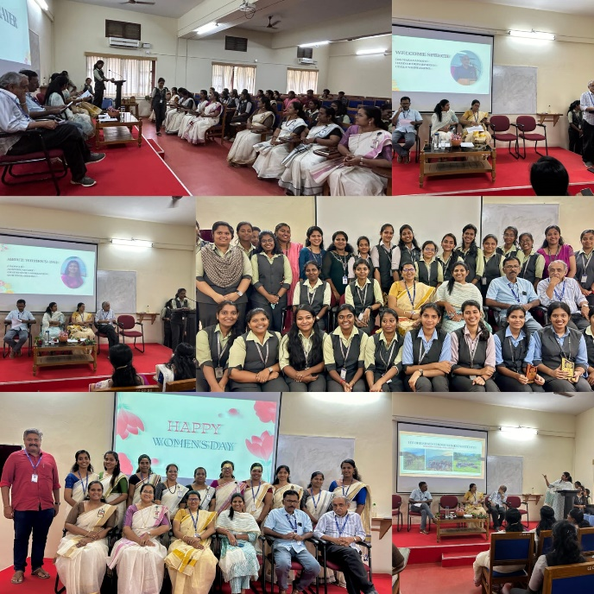

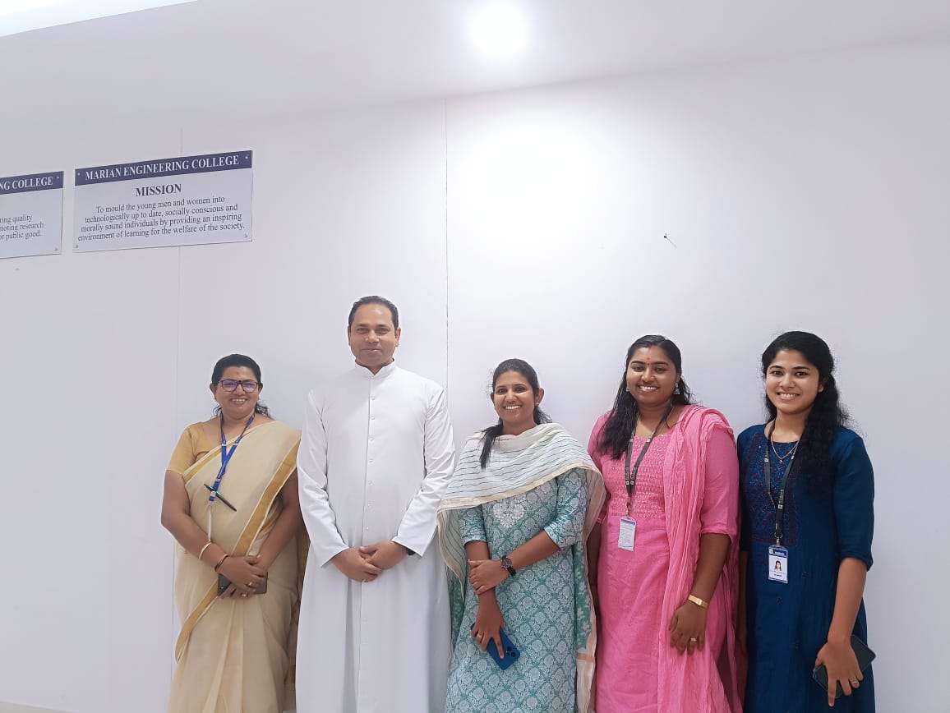
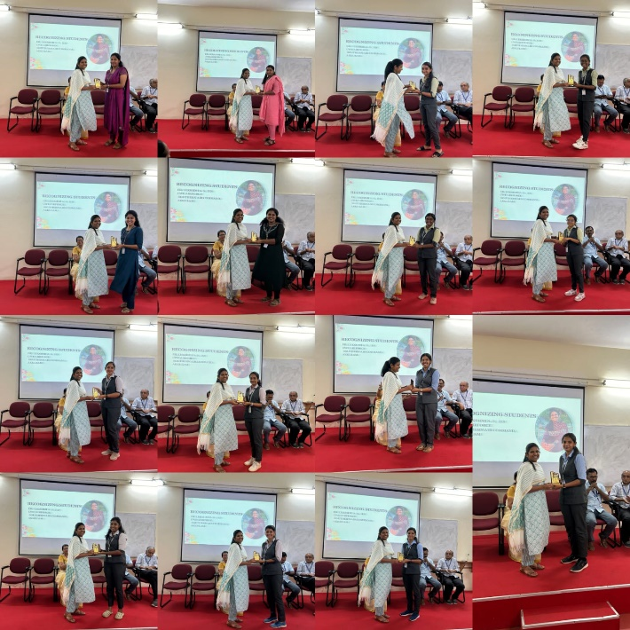

- WORKSHOP ON SPATIAL PREDICTION OF SOIL PARAMETERS USING GEOSPATIAL AI/ML

Indian Geotechnical Society Student Chapter, Civil Engineering department, Marian Engineering College in collaboration with IGS Thiruvananthapuram Chapter was conducted a workshop on the topic ‘Spatial prediction of soil parameters using geospatial AI/ML on 3rd April 2024 at Seminar hall, Civil Engineering department, MEC. The workshop was sponsored by Saju Lal G, Managing Director, Geonyms India Private Limited and the media partner is Construction philosophy magazine.
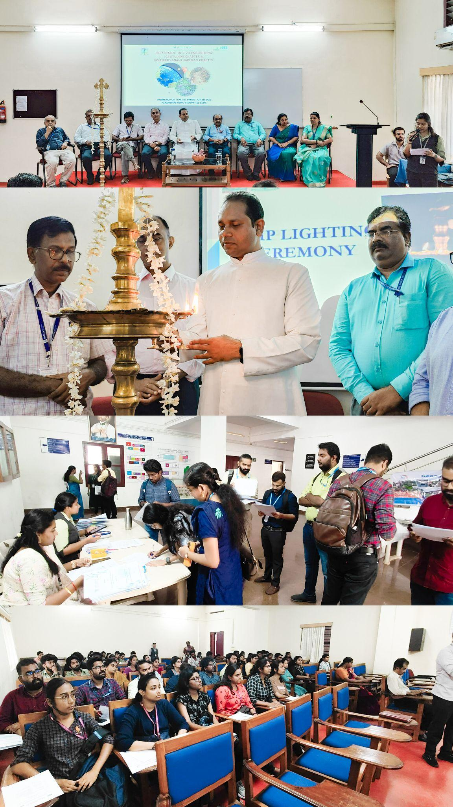
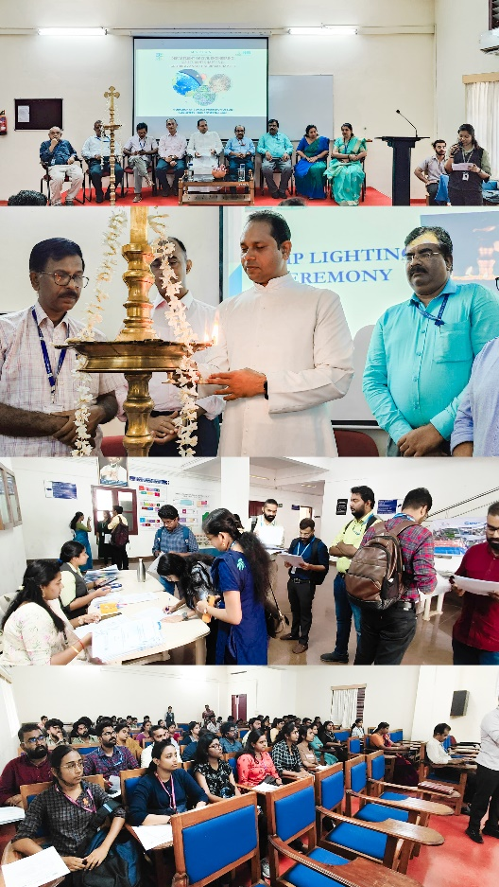
102 participants registered for the workshop and among that 94 participated. Students, Faculty members, Research scholars and several Govt officials participated i.e. students from College of Engineering Trivandrum, Marian Engineering College Trivandrum, CUSAT, Mohandas college of Engineering, Saintgits college of Engineering, LBSITW Poojappura, IIT Madras, TKM college of Engineering Kollam, Rajadhani Institute of Engineering & Technology, UKF, College of Engineering Muttathara and Govt Officials from NATPAC, KIIFB. The program started with an inauguration ceremony in which the program was hosted by Ariya P of S8C1. The welcome speech was delivered by Dr. Narayanan S, Head of department, Civil Engineering department, MEC then presidential address was delivered by Fr. Dr. A R John, Manager, MEC after that inauguration was done by Prof. Radhakrishnan T, Asst Professor, Digital University Kerala by lighting the lamp. Dr. N Unnikrishnan, Retd Professor in Civil Engineering, CET delivered the felicitation after that media partner presentation was carried out by Mr. Nebu Abhraham, Editor, Construction philosophy magazine & Chairman, Confest 2024. Dr. Rani V, Associate Professor of Civil Engineering department, MEC & Joint secretary of IGS Thiruvananthapuram Chapter delivered the vote of thanks.

The workshop focused on the latest developments in spatial predictions and the application of geospatial artificial intelligence/machine learning (AI/ML) techniques for soil parameter estimation. The workshop aimed to bring together researchers, practitioners, and industry professionals to explore innovative approaches and discuss challenges in this rapidly evolving field. The workshop included four sessions

- ‘A focus to AI applications in Civil Engineering’ - Dr Aswathy S U

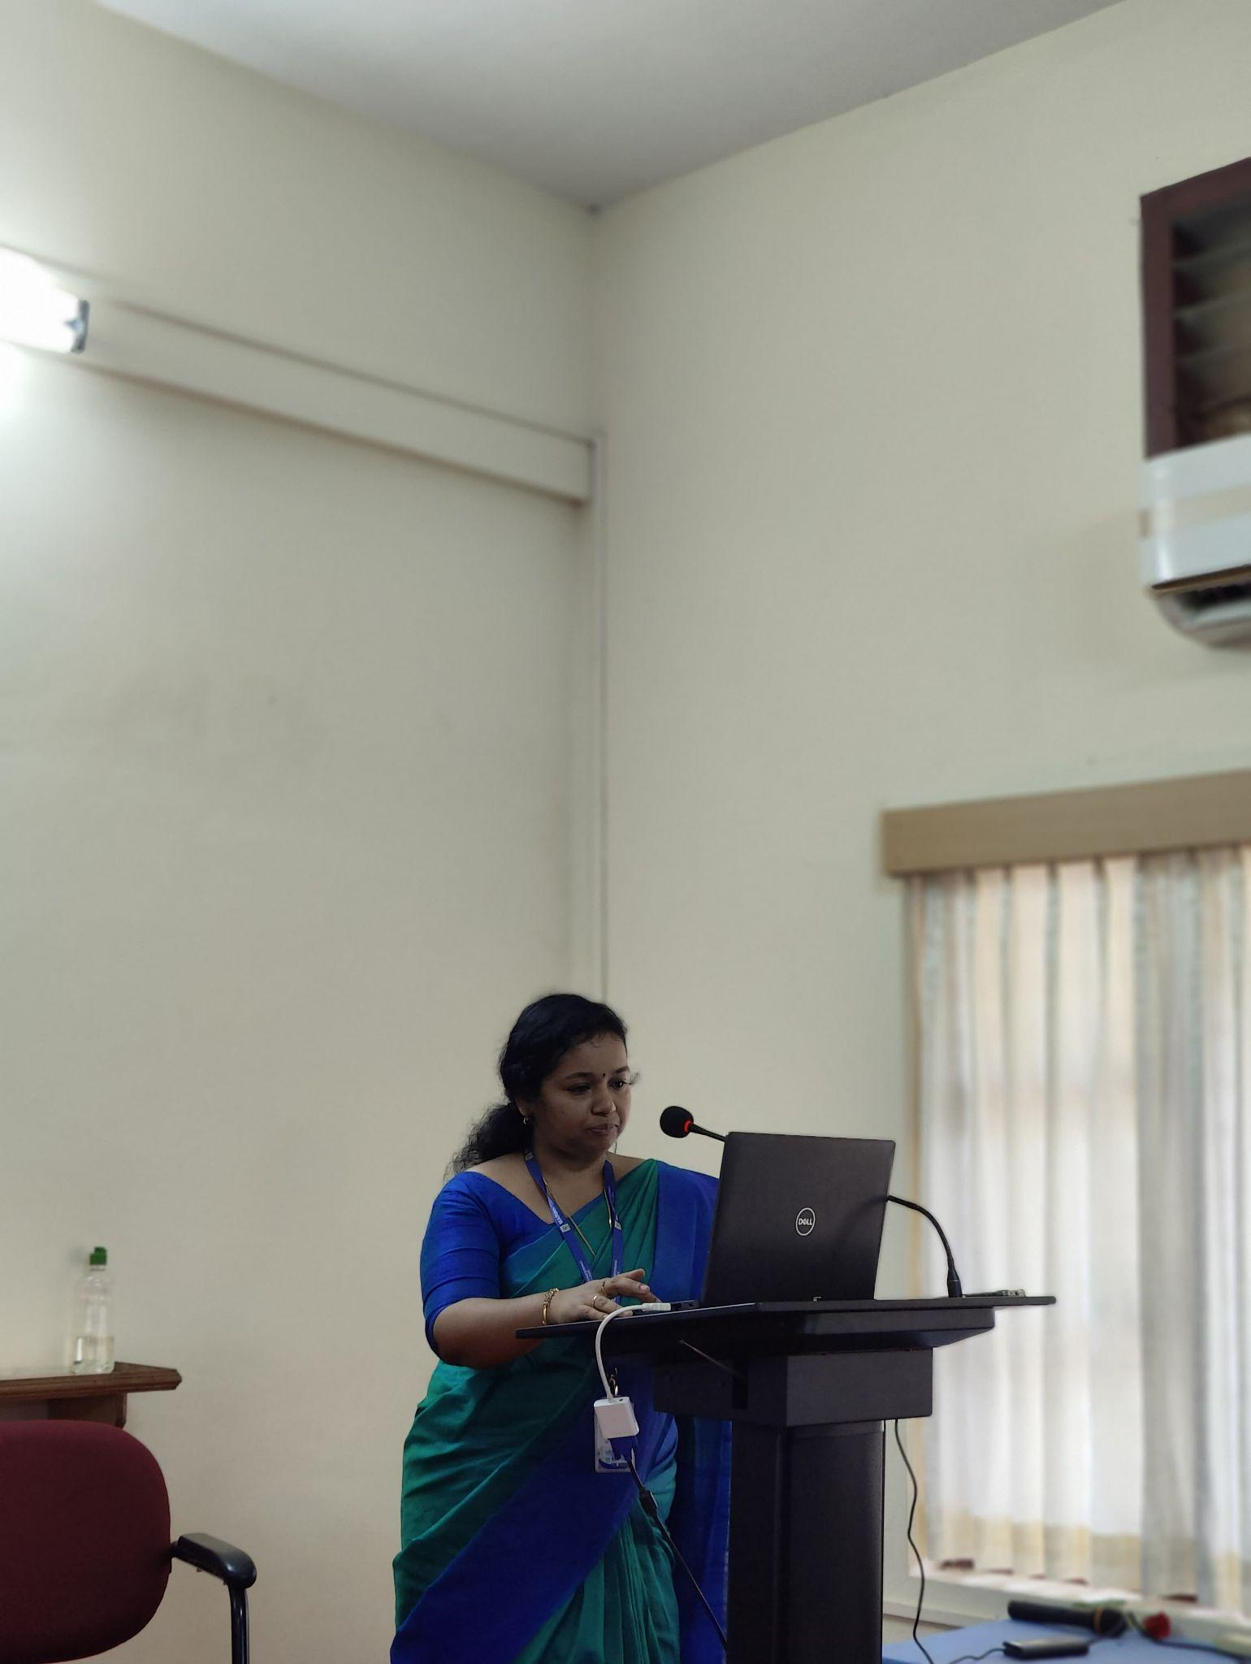
The first session was delivered by Dr. Aswathy S U, Professor in Department of Computer Science & Engineering, MEC. The session aimed to explore the potential of artificial intelligence (AI) in revolutionizing various aspects of civil engineering, from design and construction to maintenance and sustainability. The session brought together experts, researchers, and practitioners to discuss current trends, challenges, and future prospects in integrating AI technologies into civil engineering practices. The session commenced with an overview of AI technologies and their relevance to civil engineering disciplines. Speakers emphasized the role of AI in enhancing efficiency, accuracy, and sustainability across various stages of infrastructure development. The session delved into the role of AI in managing and maintaining infrastructure assets. Topics included predictive maintenance, condition monitoring using IoT sensors, and data-driven decision-making for asset management. Speakers emphasized the importance of AI in extending the lifespan of infrastructure and minimizing lifecycle costs. It showcased the transformative potential of AI technologies in reshaping the future of infrastructure development and management. By harnessing the power of AI-driven analytics, automation, and predictive modeling, civil engineers can create safer, more efficient, and sustainable built environments.

- ‘Spatial prediction of soil parameters using geostatistical and machine learning techniques’ - Prof. Radhakrishnan T

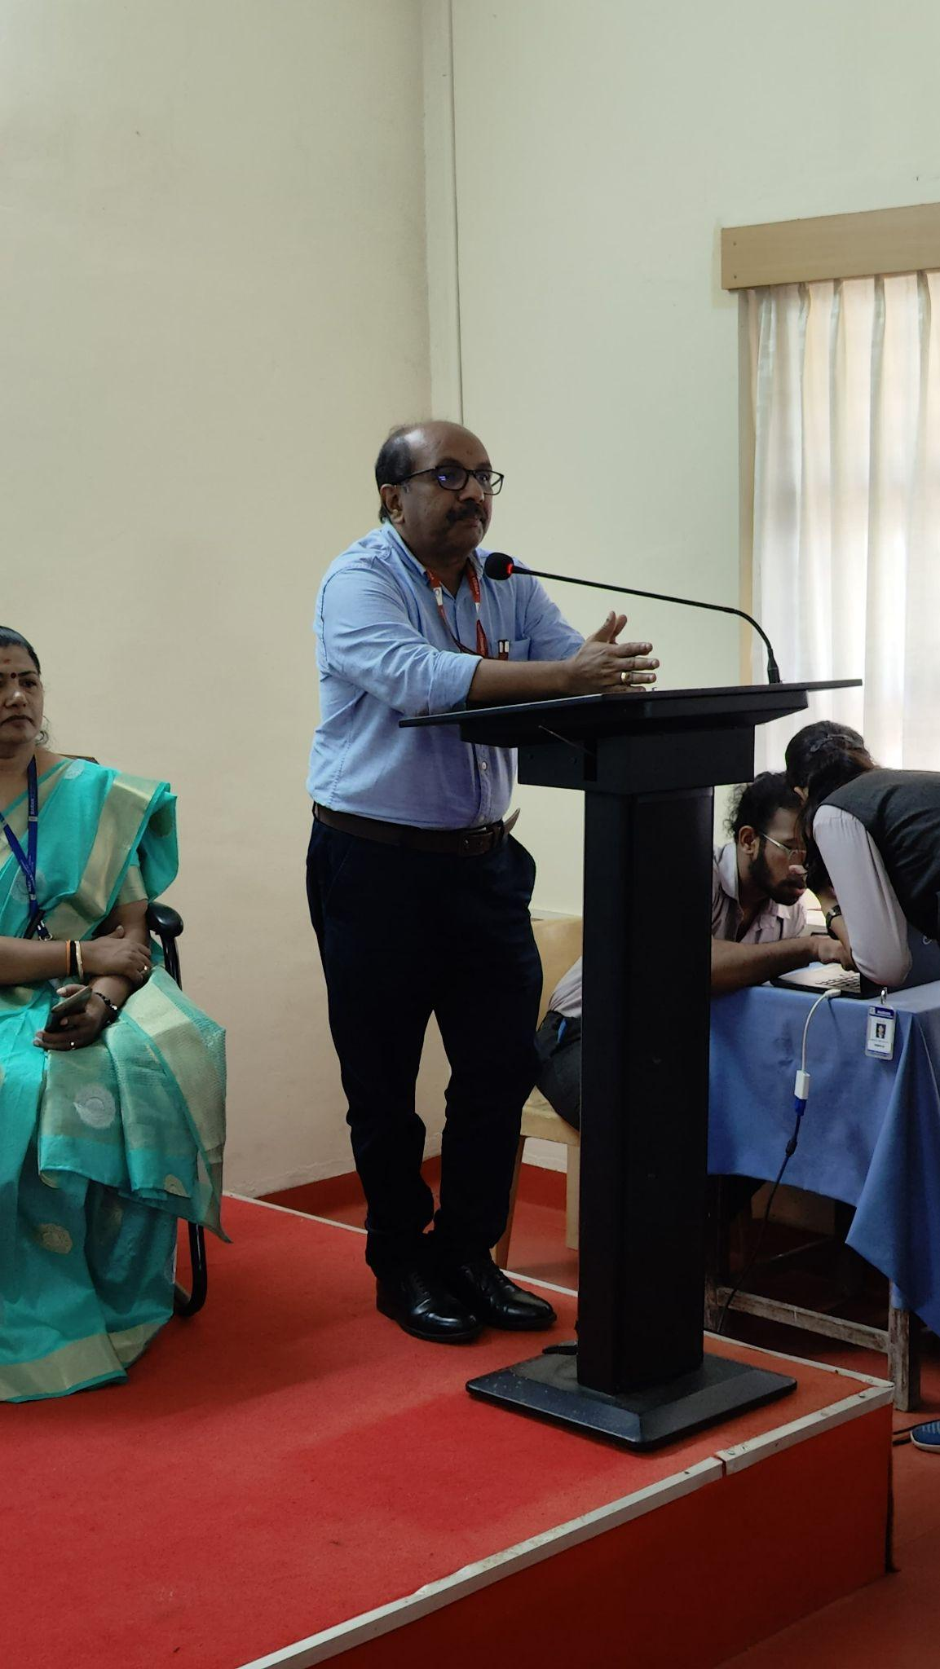
The second session was delivered by Prof. Radhakrishnan T, Asst Professor, Digital University Kerala. The session provided a platform to discuss innovative approaches for mapping and predicting soil properties at various spatial scales. The session aimed to bridge the gap between traditional geostatistical methods and emerging machine learning techniques in soil science and geotechnical engineering. The session began with an overview of classical geostatistical techniques such as kriging, variogram analysis, and spatial interpolation. Presenters highlighted the strengths and limitations of these methods in characterizing spatial variability and predicting soil parameters. Speakers introduced machine learning algorithms and their applications in soil parameter prediction. Topics included supervised learning techniques (e.g., random forests, support vector machines) and unsupervised learning approaches (e.g., clustering algorithms) for analyzing large datasets and capturing complex spatial patterns. The session highlighted real-world applications of spatial prediction techniques in diverse fields such as geotechnical engineering, precision agriculture, and environmental management. Presenters showcased how accurate soil parameter maps can inform land-use planning, site characterization, crop management practices, and natural resource conservation efforts. The session on spatial prediction of soil parameters provided valuable insights into the synergies between geostatistical methods and machine learning techniques. By leveraging the complementary strengths of these approaches, researchers and practitioners can advance our understanding of soil variability and improve the accuracy of soil parameter predictions for informed decision-making in various applications.

- ‘Advances in digital forensics’ - Dr. Sunil S P

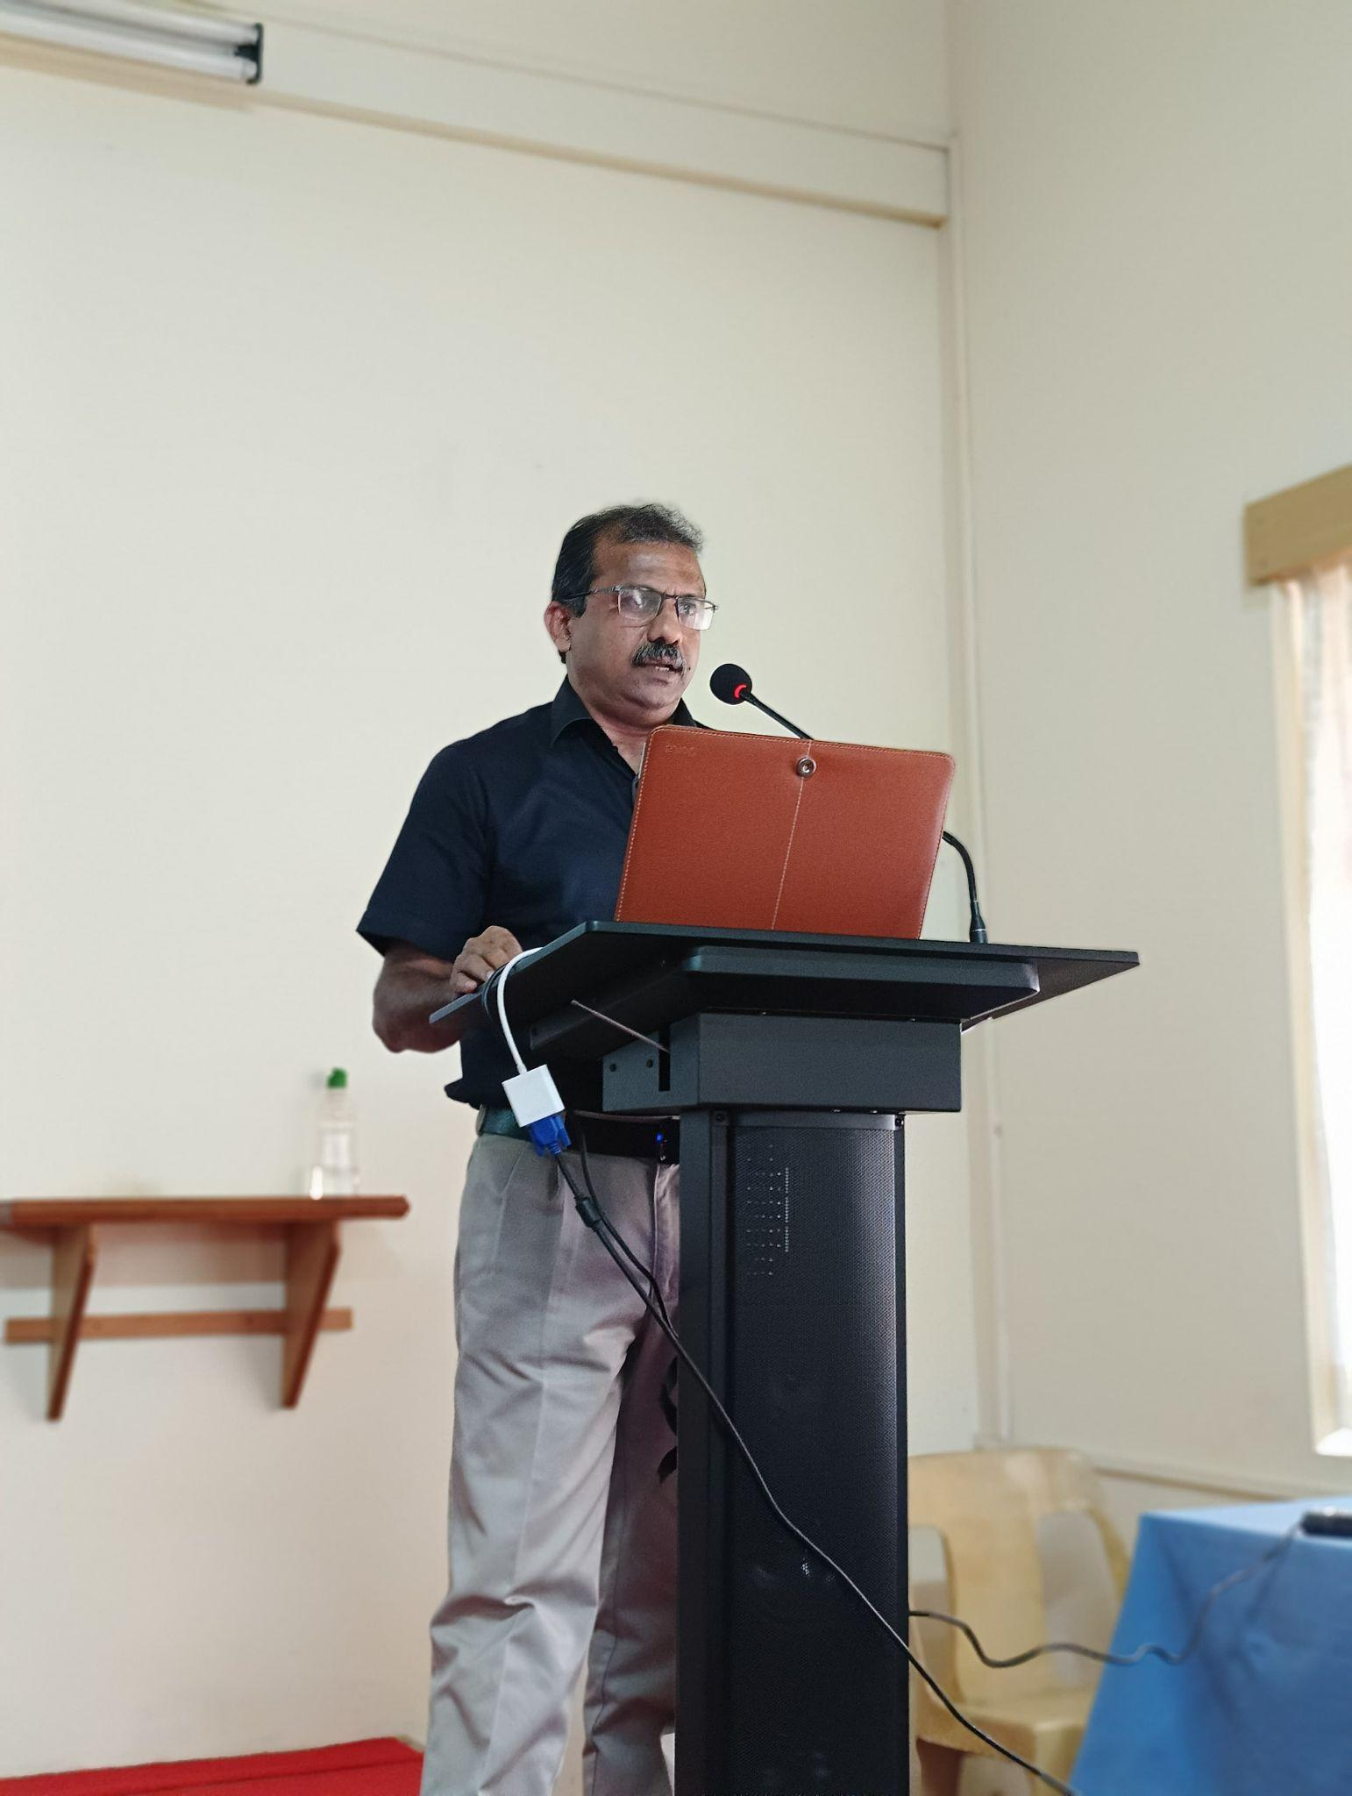
The third session was delivered by Dr. Sunil S P, Director – Operations Alibi Global Pvt. Ltd., and Former Joint Director, State Forensic Science Lab, Trivandrum, Kerala. The session aimed to update professionals, researchers, and students on emerging trends and best practices in investigating cybercrimes, analyzing digital evidence, and securing digital systems. It began with an introduction to digital forensics, emphasizing its importance in investigating cybercrimes, data breaches, and digital fraud incidents. Presenters discussed the scope of digital forensics, forensic methodologies, and the legal framework governing digital evidence collection and analysis. Speakers showcased the latest advancements in forensic tools, software, and techniques for extracting, preserving, and analyzing digital evidence. Topics included disk imaging, memory forensics, network forensics, mobile device forensics, and cloud forensics, with demonstrations of cutting-edge forensic technologies and methodologies. Presentations focused on the role of digital forensics in incident response, cyber incident investigation, and cybersecurity incident management. Experts shared case studies and real-world scenarios to illustrate the application of digital forensics in identifying security breaches, tracing attackers, and mitigating cyber threats.

- ‘AI and deep learning in Geotechnical investigations’ - Dr. N Unnikrishnan

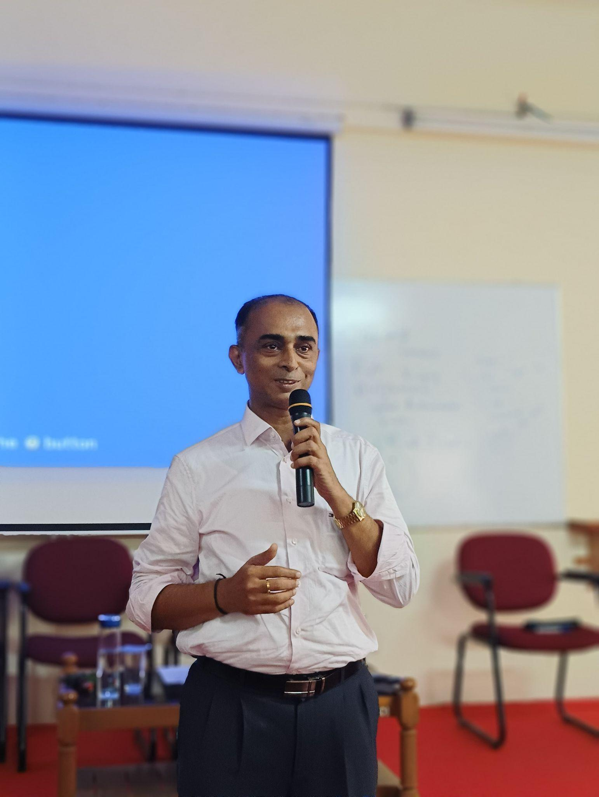
The fourth session was delivered by Dr. N Unnikrishnan, Retd Professor in Civil Engineering, CET. The session showcased the transformative potential of artificial intelligence (AI) and deep learning in revolutionizing traditional geotechnical engineering practices. Speakers highlighted how these technologies are overcoming the limitations of conventional methods by enabling the analysis of large datasets with unprecedented accuracy and efficiency. Attendees learned about various applications of AI in geotechnical investigations, including soil classification, slope stability analysis, and foundation design optimization. By leveraging AI algorithms, engineers can extract valuable insights from geophysical data, such as seismic surveys and ground-penetrating radar, to enhance subsurface characterization and identify potential geohazards. Furthermore, the session discussed the role of AI in risk assessment and decision-making processes for infrastructure projects. Through predictive analytics and real-time monitoring systems, AI-driven models can forecast potential failure scenarios and recommend preventive measures, thus minimizing project risks and ensuring structural integrity. Overall, the session emphasized how AI and deep learning are empowering geotechnical engineers to make informed decisions, optimize design processes, and enhance the safety and sustainability of infrastructure development projects.

Exhibition on soil investigation & testing

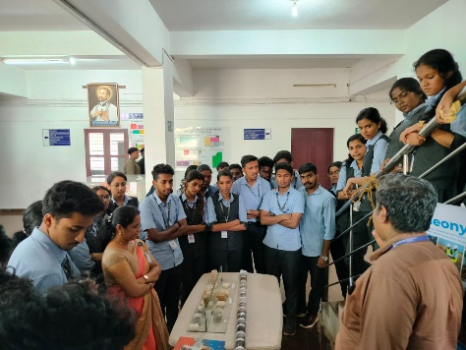
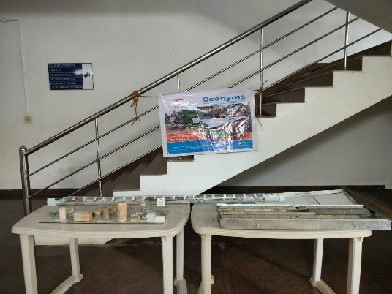
Geonyms India Private Limited organized an insightful exhibition aimed at showcasing the latest advancements and methodologies in the field. The event served as a platform for experts, researchers, and industry professionals to exchange knowledge, share best practices, and explore innovative technologies. The Soil Investigation and Testing Exhibition organized by Geonyms proved to be a valuable platform for knowledge exchange, collaboration, and professional development in the field of geosciences. The event succeeded in highlighting the critical role of soil investigation and testing in ensuring the safety, sustainability, and success of various engineering and environmental projects.

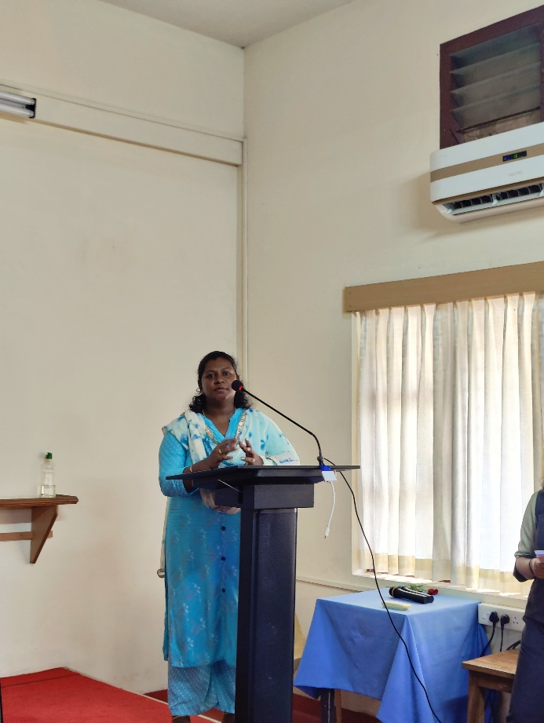
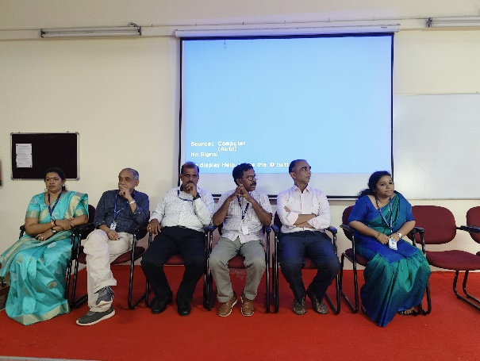
Overall, the workshop provided invaluable insights into the intersection of geospatial analysis, artificial intelligence, and machine learning in soil science. Through presentations, and discussions, participants gained a deeper understanding of the methodologies, challenges, and potential applications of utilizing AI/ML techniques for predicting soil parameters at spatial scales. The workshop highlighted the importance of collaboration between soil scientists, geospatial analysts, and data scientists to address complex environmental challenges and harness the power of technology for sustainable land management. Moving forward, continued research, innovation, and interdisciplinary collaboration will be crucial for advancing our ability to accurately predict soil parameters and inform decision-making for land use planning, agriculture, and environmental conservation. The program coordinators provided lunch for all participants and after the session all participants were provided certificates by organizing a valedictory function. An interactive session and also provided an opportunity for participants to show their feedback and overall experience about the session. Overall the program was well organized by the organizing committee and program coordinators.
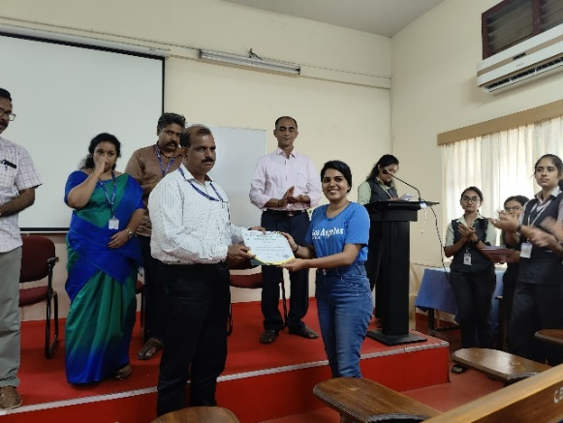
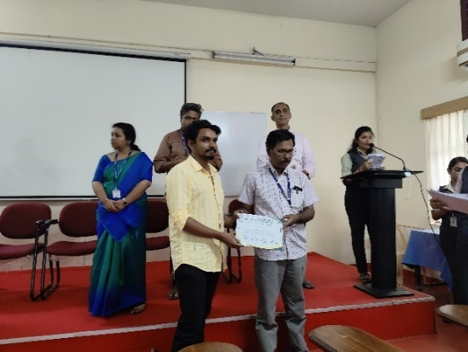

MORE ABOUT THE PROGRAM

