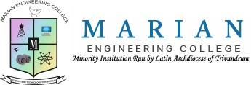 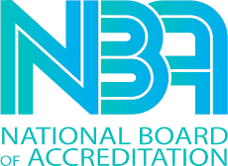 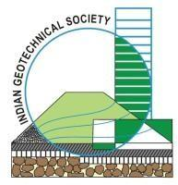

MARIAN ENGINEERING COLLEGE

DEPARTMENT OF CIVIL ENGINEERING

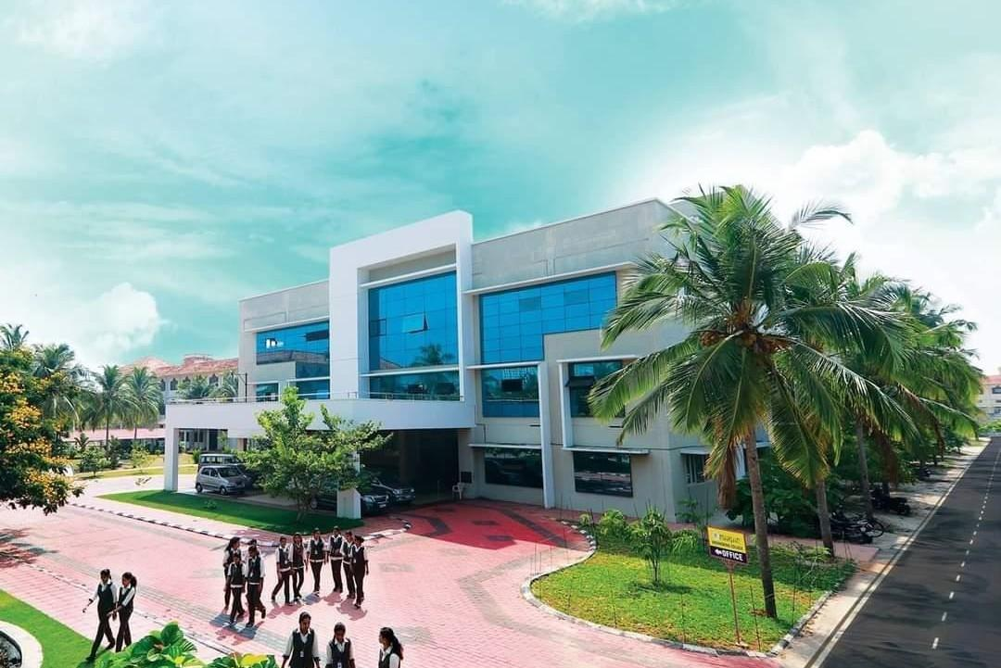

**REPORT OF ACTIVITIES OF INDIAN GEOTECHNICAL SOCIETY STUDENT CHAPTER JAN 2025 - MARCH**

**OFFICE BEARERS**

|  |  |
| --- | --- |
| MENTORS | PROF. KANNAN K, PROF. REVATHY V S |
| IGS JOINT SECRETARY | Dr. RANI V (Trivandrum chapter) |
| PRESIDENT | DEVIKA M S |
| SECRETARY | SARANG SUBHASH |
| TREASURER | DEVIKA SAJI |
| VICE PRESIDENT | ANN MARIAN F |
| JOINT SECRETARY | AISWARYA SUNIL |
| CONTENT HEAD | ABI R S, ANANYA T, MADHAVI PRADEEP |
| EXECUTIVE HEAD | AVIDHAN G NAIR, SANJAI S SUNIL,  VISHNENDRA SOONU |

**EVENTS**

* SITE VISIT – SOIL MUSEUM
* SESSION ON: SUBANSIRI LOWER HYDROELECTRIC PROJECT
* SESSION ON: EXPLORING THE POTENTIALS OF TEKLA STRUCTURES
* INTERNATIONAL SYMPOSIUM ON SUSTAINABLE PRACTICES IN GEOTECHNICAL ENGINEERING

**ABOUT THE EVENTS**

1. **SITE VISIT TO SOIL MUSEUM**

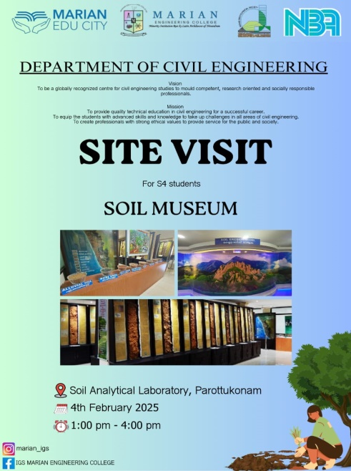S4 students attended an industrial visit on 4th February 2025 in the afternoon. The visit was to Soil Analytical Laboratory, Parottukonam, Thiruvananthapuram. This soil museum is the world's largest soil museum and the first soil museum in India established to international standards. It was setup by the department of Soil Survey and Conservation of Government of Kerala and was inaugurated on 1st January 2014. Nearly, eighty two Bench Mark soils have been identified in the 27 different Major Land Resource Areas of Kerala. A Bench Mark Soil is one that is widely extensive, holds a key position in the soil classification system and is of special significance to farming, engineering or other uses. The museum includes the following features

*Fig.1.1 Site Visit to Soil Museum - Poster*

* 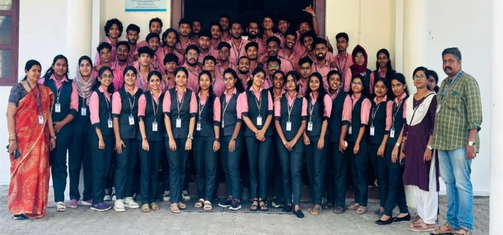 Reference centre on the Soils of Kerala.

*Fig. 1.2 Faculties and S4 Students off to Soil Museum*

* Display of soil monoliths of the Bench Mark Soils of the Major land Resource Areas of all districts across the State.
* Display of rocks and minerals of the State.
* 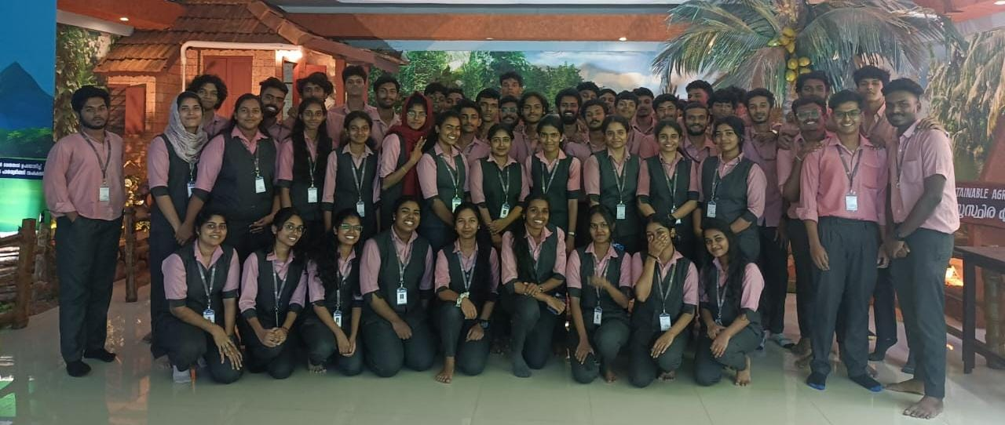Reference base for planning and undertaking soil series based agricultural research activities in the State.

*Fig. 1.3 S4 Students at Soil Museum*

* Mini theatre for providing information on soils and environmental issues at State and National Level through video shows.
* Soil Information Centre displaying soil maps, watershed maps and related maps of all districts.
* 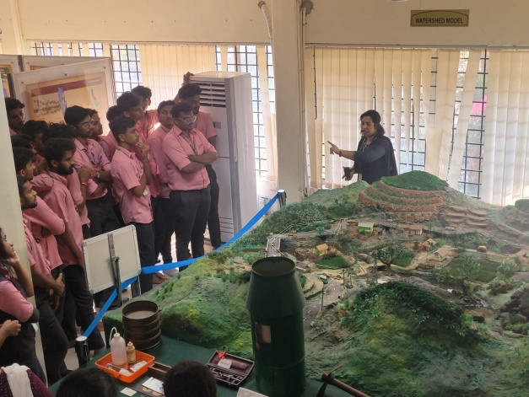Display of watershed model, the basic unit of all developmental programs, and models of different soil and water conservation structures.

All these features were explained monotonously by the concerned authorities to our students. Students greatly enjoyed the visit and had an awesome experience.

*Fig. 1.4 Students listening to an Authority from the Soil Museum*

1. **SESSION ON: SUBANSIRI LOWER HYDROELECTRIC PROJECT**

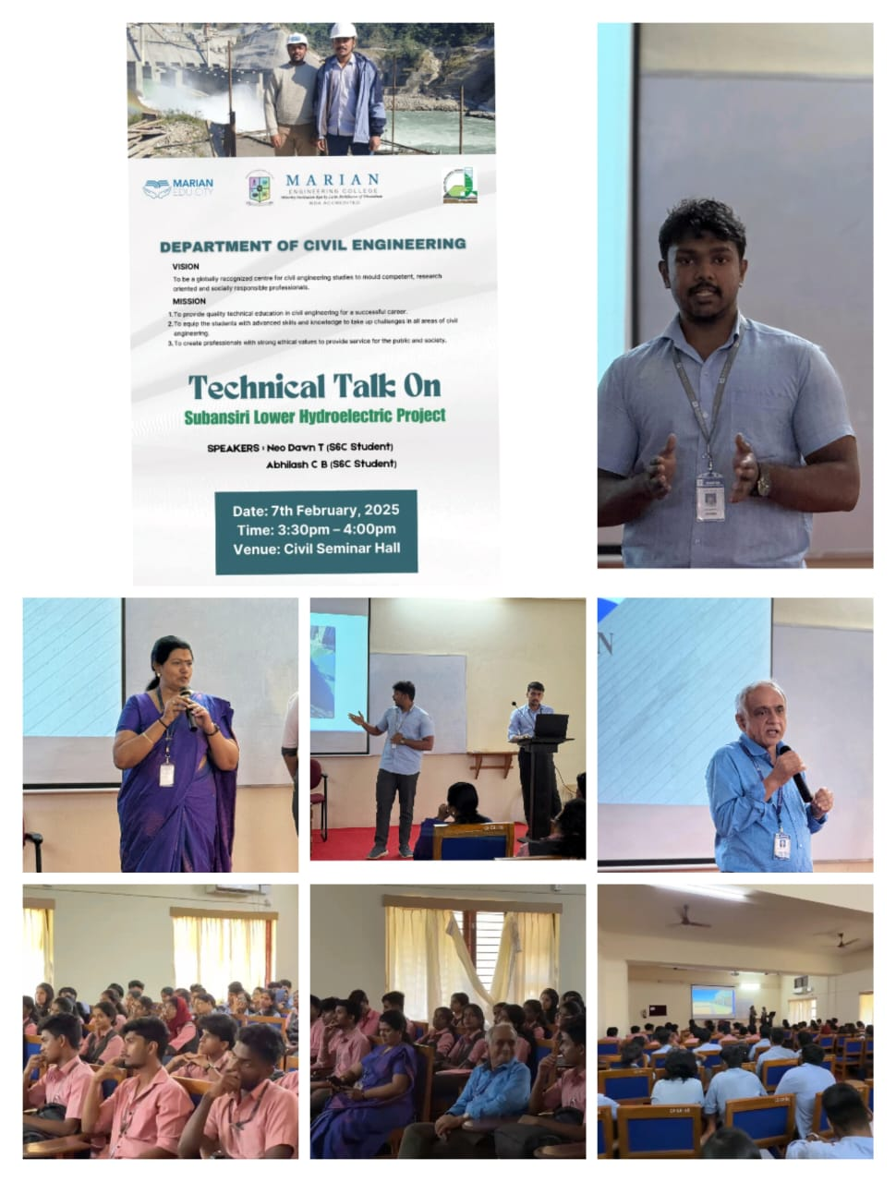A seminar was conducted on the topic “SUBANSIRI, LOWER HYDROELECTRIC PROJECT” on 7th February 2025 by the Civil Engineering department of Marian Engineering college. The session was held at the Seminar Hall of Civil Engineering department. The session was delivered by two students from S6 Civil Engineering – Neo Dawn T and Abhilash C B. They shared their internship experience. The Lower Subansiri Hydroelectric Project (SLHEP), is a 2000 MW run-of-river hydroelectric project on the Subansiri River (a tributary of the Brahmaputra), is being developed by National Hydro Power Corporation (NHPC) and is located on the border of Arunachal Pradesh and Assam. The project is under construction and is expected to be one of the largest hydroelectric plants in India. The project includes a concrete gravity dam, head race tunnels, surge tunnels, pressure shafts, and a surface power house. The project is expected to generate around 7,500 million units of power annually in a 90% dependable year. As of late 2024, the project was nearing completion, with some units expected to start functioning by March 2025. Participants gained insights into the interconnectedness of these factors and the cumulative impact on their projects. The session concluded with a case study demonstrating the students live experience at the site. The session served as an invaluable platform for understanding the importance of B.TECH internships and also gave innovative project ideas for the participants.

*Fig. 2.1 Poster and few photos from the Session*

1. **SESSION ON: EXPLORING THE POTENTIALS OF TEKLA STRUCTURES**

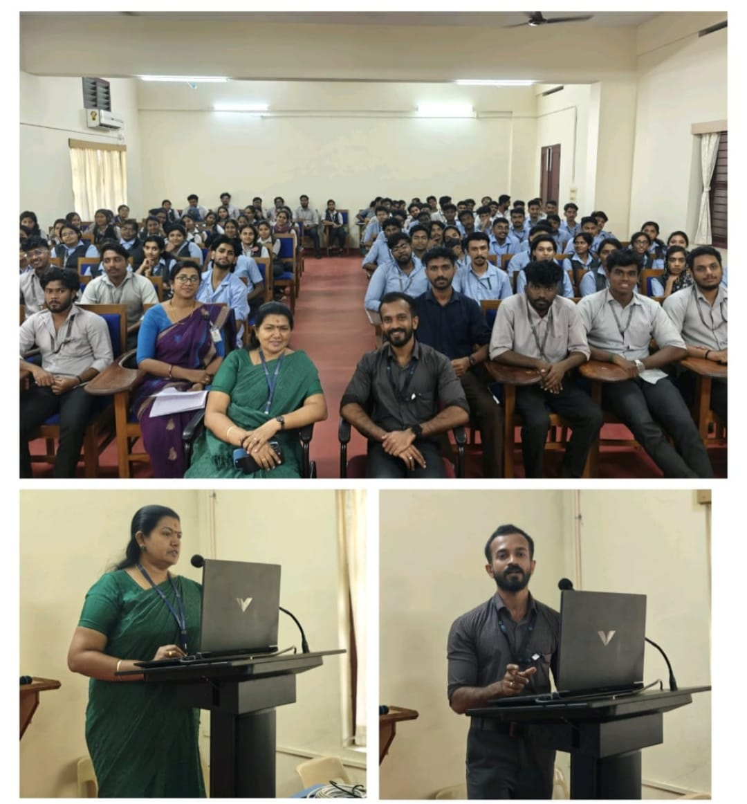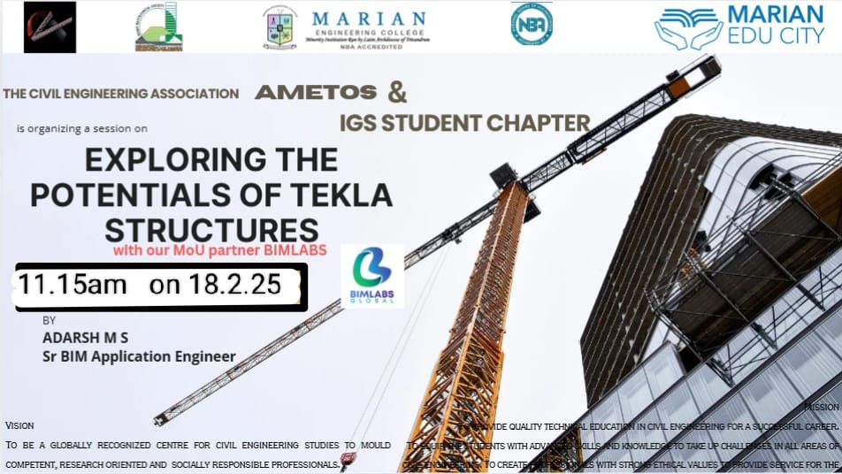A seminar was conducted on the topic "EXPLORING THE POTENTIALS OF TEKLA STRUCTURES" on 18th February 2025 by the Civil Engineering department of Marian Engineering college in association with the Civil Engineering association AMETOS and IGS student chapter. The session was held at the Seminar Hall of Civil Engineering department and was delivered by Adarsh M S, Senior BIM Application Engineer, BIM Labs Global. As an expert in BIM, Adarsh M S shared his knowledge on how modern construction practices were deeply influenced by the use of softwares and the use of Tekla Structures. Tekla Structures is a powerful BIM software that enables detailed 3D modeling for steel, concrete and timber structures, facilitating efficient collaboration and streamlined workflows from design to fabrication. It helps improve project quality, reduce errors and accelerate delivery by offering advanced features for visualization, planning and construction. Participants gained insights into the interconnectedness of these factors and the cumulative impact on their career. The session concluded with insightful case studies demonstrating successful understanding of engineering marvels across the globe. The session served as an invaluable platform and insisted the students to understand the importance of skills required in construction industry in today’s world.

*Fig. 3.2 Few photos from the Session*

*Fig. 3.1 Poster for the Session*

1. **INTERNATIONAL SYMPOSIUM ON SUSTAINABLE PRACTICES IN GEOTECHNICAL ENGINEERING**

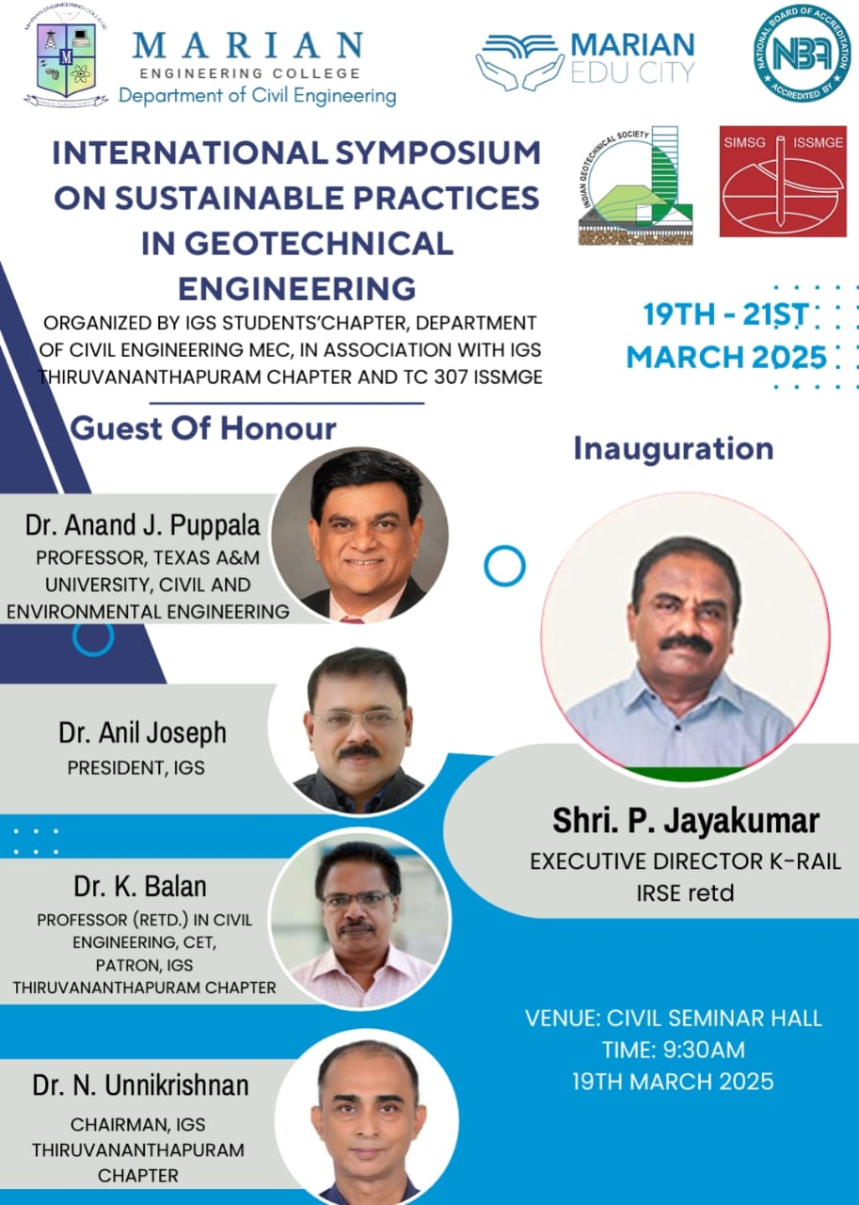An international symposium was conducted on the topic "SUSTAINABLE PRACTICES IN GEOTECHNICAL ENGINEERING" from 19th to 21st March 2025, by the Civil Engineering department of Marian Engineering College. The event, organized in collaboration with prestigious Engineering firms such as GeoEra Infrastructures, Civilianz, Turtle Smart Solutions, BIM Labs Global and Land Coordinates was a momentous occasion. The event marked a significant milestone in fostering academic growth and industry interaction within the institution. The inauguration ceremony was held at the Seminar Hall of Civil Engineering Department and was attended by students, faculty members and distinguished guests from the civil engineering industry.

*Fig. 4.1 Poster for Inaguration of the event*

**INAUGURATION**

The event began at 9:30 AM with a solemn prayer, invoking blessings for the success of the event. This was followed by the welcome address delivered by Prof. Kannan K., Mentor, IGS Student Chapter at Marian Engineering College. Prof. Kannan warmly welcomed the attendees, which included faculty members, students, alumni and the esteemed chief guest, Er. P. Jayakumar, IRSE (Rtd.), Executive Director, Kerala Rail Development Corporation Limited. He emphasized the importance of sustainability in the field of Civil Engineering and its impact in the environment.

Following the welcome speech, Dr. Abdul Nizar M., the Principal of Marian Engineering College, delivered the presidential address. Dr. Abdul Nizar acknowledged the hard work of the faculty and students that had contributed to the success of the event. He outlined the department’s vision of providing quality education towards sustainability. His speech also emphasized the need for students and professionals to stay connected with IGS to remain updated on the latest industry trends and practices. Dr. Abdul Nizar encouraged students to take advantage of the resources available through the IGS Student Chapter, which play a significant role in shaping their 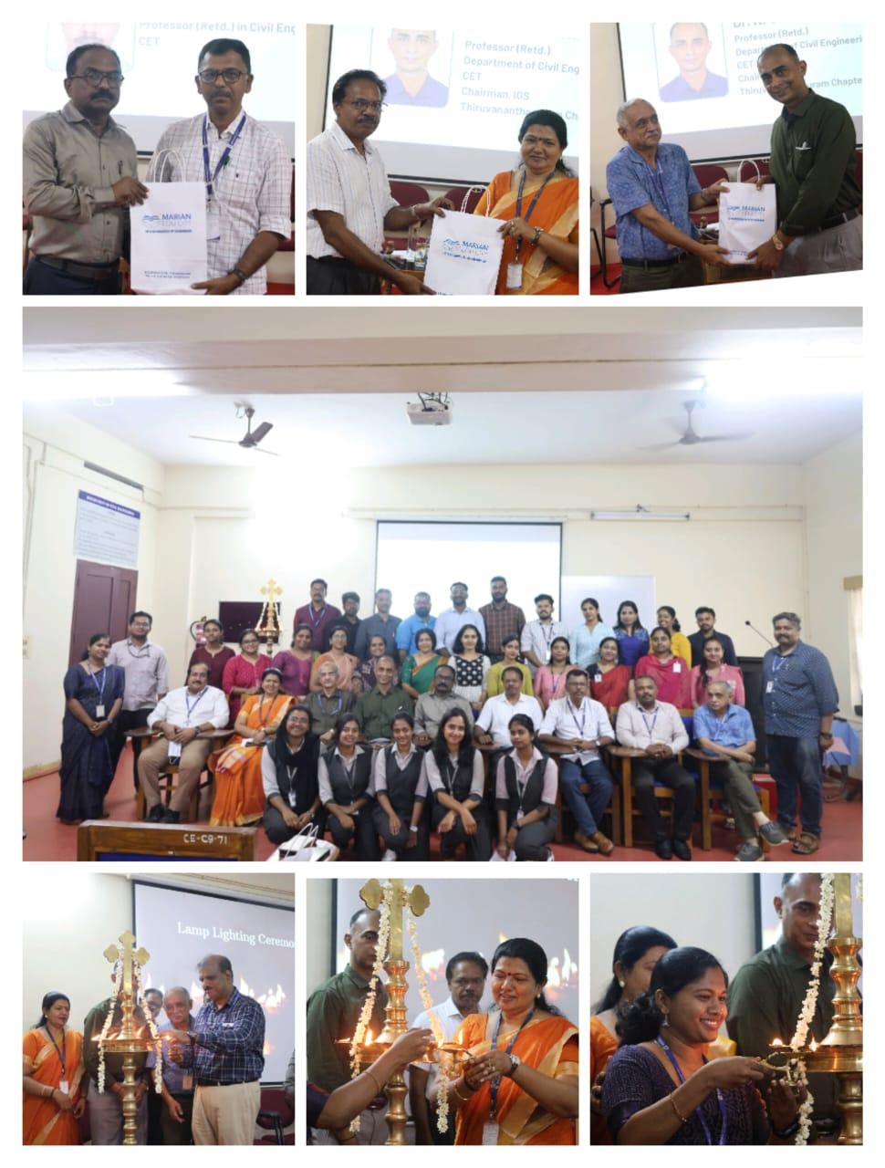engineering careers.

*Fig. 4.2 Few photos from the Inauguration Ceremony*

The next part of the ceremony was the lamp lighting, a symbolic gesture representing the dispelling of darkness and the pursuit of knowledge. Key dignitaries including the principal, the Dean, the HOD, the chief guest and the mentor of IGS Student Chapter, MEC participated in the lamp lighting signifying the formal commencement of the event.

Followed by the lamp lighting, inaugural messages were delivered by the Chairman, TC 307 – ISSMGE Dr. Anand J. Puppala, A.P. &Florence Wiley Chair, Texas A&M University; the President, Indian Geotechnical Society Dr. Anil Joseph, Managing Director, Geostructurals Pvt. Ltd.; the Patron of IGS Thiruvananthapuram Chapter, Dr. K. Balan, Rtd. Professor in Civil Engineering, CET. They congratulated the event for grant success.

The next part of the ceremony was the fecilitations by Dr. Samson, Dean MEC and Dr. N. Unnikrishnan, Rtd. Professor in Civil Engineering, CET & Chairman, IGS Thiruvananthapuram Chapter. They both congratulated the event for a grant success.

The inauguration ceremony concluded with the vote of thanks delivered by Dr. Rani V., Professor & Head, Department of Civil Engineering, MEC & Joint Secretary, IGS Thiruvananthapuram Chapter. Dr. Rani expressed gratitude to all those who made the event a success, including the chief guest, faculty members and students. She extended special thanks to the organizing committee for their hard work and dedication in ensuring the smooth running of the event. She also acknowledged the support of the professionals, collaborators and the participants who contributed to the program.

Overall, the inauguration of the international symposium on sustainable practices in geotechnical engineering was a well-organized and inspiring event. It highlighted the department’s commitment to sustainability and professional excellence.

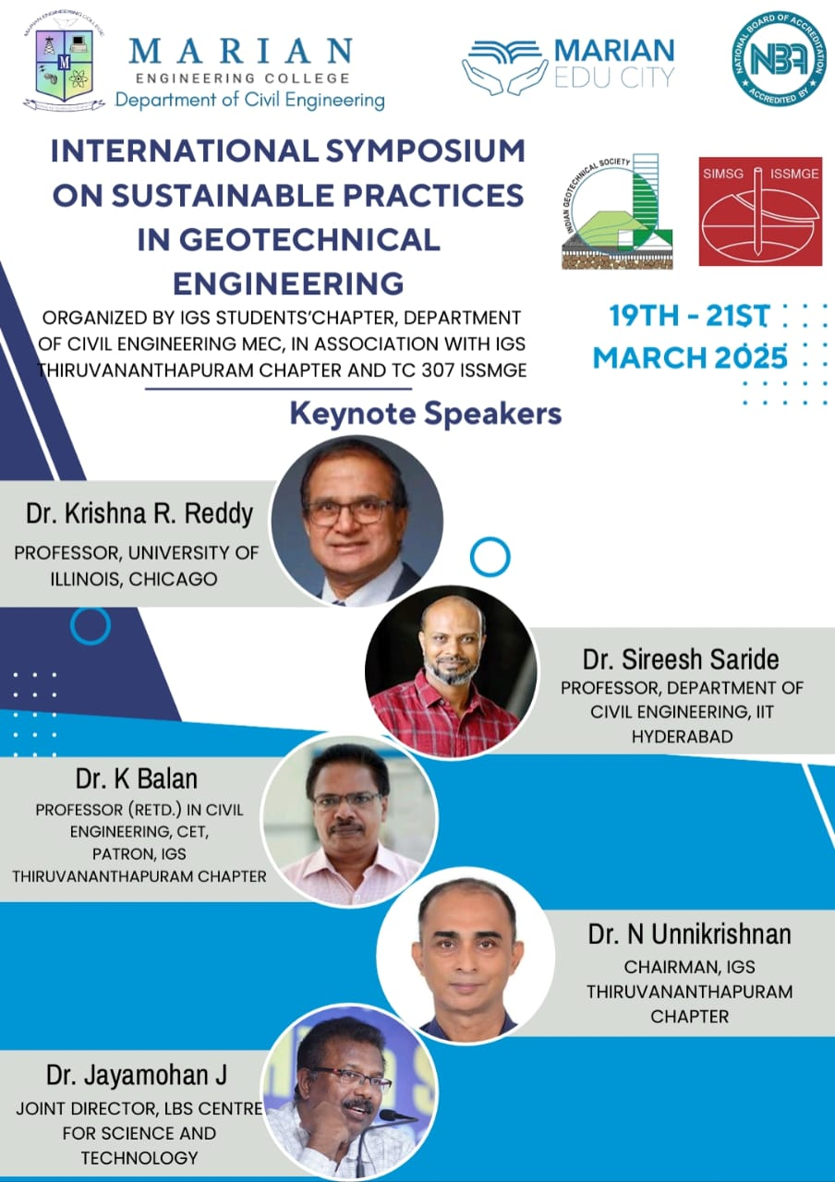 **TECHNICAL SESSIONS**

*Fig. 4.3 Poster for the Technical Sessions of the event*

Followed by the inauguration, about five plenary sessions, a corporate presentation and a panel discussion were conducted at the Seminar Hall of Civil Engineering Department, MEC.

**PLENARY SESSION I**

The session was delivered by Dr. N. Unnikrishnan, Rtd. Professor in Civil Engineering, CET & Chairman, IGS Thiruvananthapuram Chapter. The session began at 11. 00 AM on 19th March 2025. As an expert in Geotechnical Engineering, Dr. N. Unnikrishnan shared his experience with a case study exploring how traditional geotechnical practices in Kerala were closely shaped by the state’s distinctive natural geography, particularly its hilly terrains. It showcased how age-old construction methods such as the use of laterite blocks, natural drainage systems and terraced slopes were inherently sustainable and well-suited to the local environment. The case study emphasized how these practices minimized environmental disruption, made use of locally available materials, and aligned with the contours of the land, offering valuable lessons for modern sustainable geotechnical design. The session gave the participants with valuable insights on how to approach for future construction projects in geotechnical aspect with greater environmental awareness and sustainability.

**PLENARY SESSION II**

The session was delivered by Dr. Sireesh Saride, Professor (HAG), Department of Civil Engineering, IIT Hyderabad. The session began at 1.00 PM on 19th March 2025. The session was held via online mode. The session highlighted the geotechnical aspects of pavement design and construction with a strong emphasis on sustainability. A case study was presented showcasing the use of natural and recycled materials, such as stabilized soil and geosynthetics, to enhance pavement performance while minimizing environmental impact. The study demonstrated how sustainable geotechnical practices can extend pavement life, reduce maintenance needs and lower carbon footprint, offering practical insights into eco-friendly pavement solutions. The session created an informative experience and awareness among the participants.

**PLENARY SESSION III**

The session was delivered by Dr. Krishna R. Reddy, Professor, University Scholar & Distinguished Researcher, University of Illinois, Chicago. The session began at 9.00 AM on 20th March 2025. The session was held via online mode. The session emphasized the importance of integrating sustainability into the design framework of waste containment systems. It highlighted how incorporating sustainable practices in waste containment can not only reduce environmental impact but also improve long-term performance and resilience. The discussion covered innovative materials, design strategies, and technologies that enhance the sustainability of waste containment systems, ensuring they effectively manage waste while minimizing resource consumption and environmental degradation. Case studies were presented to showcase successful applications of these sustainable design principles. The session created a provoking experience and awareness among the participants.

**PLENARY SESSION IV**

The session was delivered by Dr. K. Balan, Rtd. Professor in Civil Engineering, CET. The session began at 10.00 AM on 20th March 2025. Dr. K. Balan shared his experience with a series of case studies demonstrating practical approaches to solving real-world geotechnical engineering challenges with a focus on sustainability. Each case highlights the use of innovative and eco-friendly solutions such as natural geosynthetics, ground improvement techniques and sustainable foundation systems to address issues like soil instability, settlement and bearing capacity. The objective is to showcase how sustainable engineering practices can be effectively integrated into geotechnical projects without compromising performance or safety. The session created a positive impact on participants by enhancing their understanding of sustainable geotechnical solutions and inspiring them to apply environmentally responsible practices in their future projects.

**PLENARY SESSION V**

The session was delivered by Dr. Jayamohan J, Joint Director, LBS Centre for Science and Technology. The session began at 1.00 PM on 20th March 2025. Dr. Jayamohan shared his experience with a series of insightful case studies demonstrating practical solutions to real-time geotechnical engineering challenges with a focus on sustainability. It explored innovative techniques such as the use of natural fiber reinforcements, recycled materials, and bioengineering methods to improve soil stability and reduce environmental impact. Each case study highlighted how site-specific solutions were developed by integrating local resources, traditional knowledge and modern engineering approaches, promoting long-term sustainability in infrastructure development. The session had a positive impact on participants by broadening their understanding of sustainable geotechnical solutions and inspiring them to apply environmentally responsible practices in real-world engineering projects.

**CORPORATE PRESENTATION**

The presentation was delivered by Adarsh M S, Senior BIM Application Engineer, BIM Labs Global. The session began at 2.30 PM on 19th March 2025. The session provided valuable insights into the crucial role geotechnical engineering plays in the design and stability of massive structures around the world. It highlighted how advanced software tools are used for accurate analysis, modeling, and simulation of complex soil-structure interactions. The discussion emphasized how these technologies not only enhance safety and efficiency but also support sustainable development by minimizing material usage, optimizing foundation designs and reducing environmental impacts during construction. The session positively impacted participants by enhancing their awareness on modern software applications in geotechnical engineering and their potential to drive sustainable and environmentally conscious structural designs.

**PANEL DISCUSSION**

Panel discussion was done by a five member panel - Dr. N. Unnikrishnan, Rtd. Professor in Civil Engineering, CET & Chairman, IGS Thiruvananthapuram Chapter; Dr. K. Balan, Rtd. Professor in Civil Engineering, CET; Dr. Rani V., Professor & Head, Department of Civil Engineering, MEC & Joint Secretary, IGS Thiruvananthapuram Chapter; Dr. Narayanan S, Professor in Civil Engineering, MEC; Er. Greeshma, Chief Executive Officer, Geoera Infrastructures, Kollam. The discussion began at 11.30 AM on 20th March 2025. The interactive discussion fostered engaging conversations on sustainable practices in geotechnical engineering, bringing together experts from academia, industry and research. Panelists shared their experiences and perspectives on utilizing eco-friendly materials, innovative ground improvement techniques, and the integration of traditional knowledge with modern engineering solutions. Participants actively contributed through questions and discussions, creating a collaborative environment focused on addressing current challenges and promoting sustainable development in geotechnical practices.

**VALEDICTORY CEREMONY**

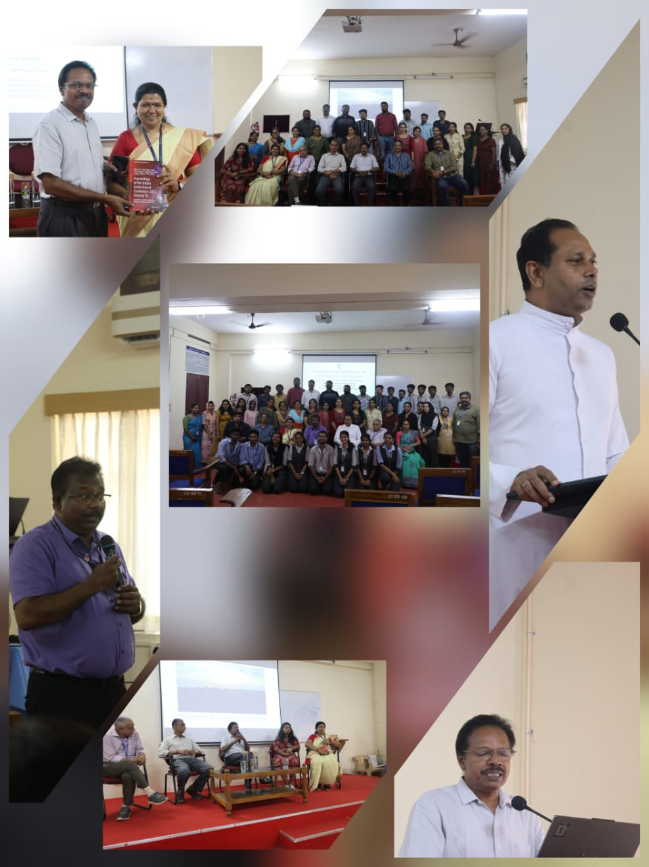The valedictory ceremony was held on 20th March 2025 at the Seminar Hall of Civil Engineering Department, MEC. The ceremony began at 2.00 PM with a solemn prayer, invoking blessings for the success of the event. This was followed by the welcome address delivered by Prof. Revathy V S, Mentor, IGS Student Chapter at Marian Engineering College. Prof. Revathy warmly welcomed the attendees, which included faculty members, students, alumni, Dr. A. R. John, Manager, MEC and the chief guest of the ceremony.

*Fig. 4.4 Few photos from the Panel Discussion and Valedictory Ceremony*

Following the welcome speech, Dr. A. R. John, the Manager of Marian Engineering College, delivered the presidential address. Dr. A. R. John commended the dedication and efforts of both the faculty and students that led to the success of the event. He highlighted the department's commitment to delivering high-quality education with a focus on sustainability. In his speech, he stressed the importance of staying engaged with IGS to stay informed about the latest industry developments and practices. Dr. A. R. John also encouraged students to make the most of the resources offered by the IGS Student Chapter, which play a crucial role in advancing their engineering careers.

The next part of the ceremony was the valedictory address delivered by Dr. Jayamohan J, Joint Director, LBS Centre for Science and Technology & Secretary, IGS Thiruvananthapuram Chapter. Dr. Jayamohan wholeheartedly congratulated the event for grant success.

Followed by the valedictory address, summary of the symposium was read by Dr. Rani V., Professor & Head, Department of Civil Engineering, MEC & Joint Secretary, IGS Thiruvananthapuram Chapter. In the next part of the ceremony, the chief guest was honoured and certificates were distributed to the participants.

The valedictory ceremony concluded with the vote of thanks delivered by Prof. Kannan K., Mentor, IGS Student Chapter at Marian Engineering College. Prof. Kannan extended gratitude on behalf of the organizing committee, to all who have made the "Sustainable Practices in Geotechnical Engineering" event a success. He also thanked esteemed speakers, panelists and experts for sharing their invaluable knowledge and experiences. He expressed his appreciation to Dr. A. R. John for his continuous support and motivating words. He expressed his heartfelt thanks to colleague Prof. Revathy V S, students and volunteers for their hard work and dedication in organizing this event. Finally, he thanked all the participants for their active engagement and contributions and hoped that the insights gained here will inspire everyone to incorporate sustainability in their future endeavors.

**INDUSTRIAL VISIT TO SUSTAINABLE CONSTRUCTION SITES**

Participants and volunteers of the symposium attended a one-day industrial visit on 21st March 2025. The visit included sessions on sustainable construction practices at Vizhinjam International Seaport, Vizhinjam and Poonthura Groynes Site, Poonthura. The visit was dutifully coordinated by faculty members from the department of civil engineering.

**VIZHINJAM INTERNATIONAL SEAPORT**

The Vizhinjam International Seaport, located in Thiruvananthapuram, Kerala, is India's first deep-water transshipment port. Strategically positioned near major international shipping routes, it enhances India's maritime capabilities, positioning the nation to compete with global ports in Dubai, Singapore and Sri Lanka. This multipurpose seaport is an ambitious project taken up by Government of Kerala. It is designed primarily to cater container transhipment besides multi-purpose and break bulk cargo. The port is being currently developed in landlord model with a Public Private Partnership component on a design, build, finance, operate and transfer (“DBFOT”) basis. The private partner, the Concessionaire M/s Adani Vizhinjam Port Private Ltd has commenced the construction on 5th December 2015.

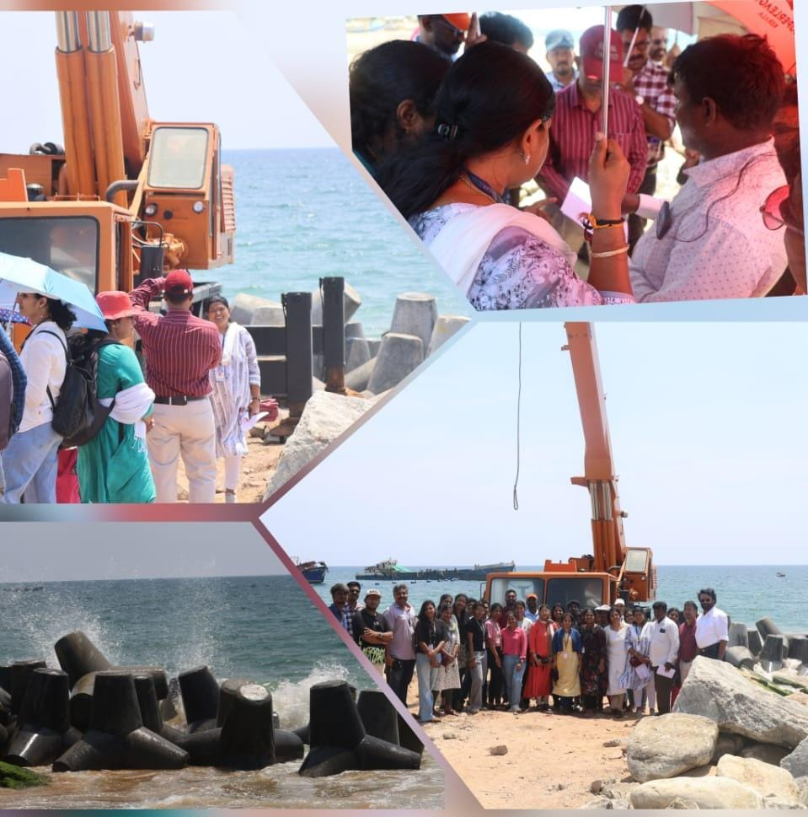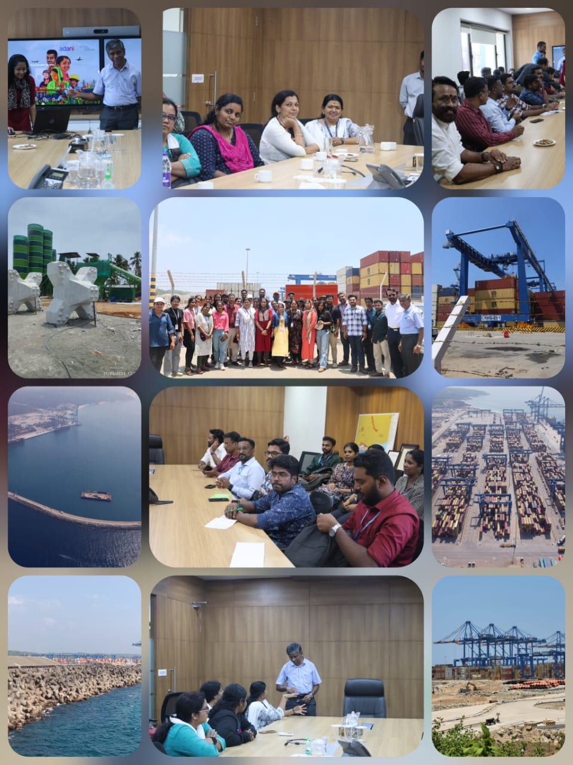Vizhinjam site is gifted by nature with a deep draft of 18m close to shore that requires no capital dredging, can leverage its natural depth to host even ultra-large next-gen container ships requiring 20m+ drafts. Its curvilinear coast mitigates tsunami impact while the port’s positioning results in only mild erosion, minimizing maintenance costs. With capacity for 18,000+ TEU ships, scalable infrastructure to match cargo growth and minimal siltation, Vizhinjam is ready for future. Being the southern tip of India, Vizhinjam is strategically poised to emerge as a transshipment hub that can consolidate and transfer Indian and regional origin cargo to mainline vessels at lower costs than routing them via Colombo. By locating a world-class Indian transshipment port right on top of a core international shipping lane, Vizhinjam can unlock lasting maritime and economic advantages for the country.

*Fig. 4.6 Few photos from the Industrial Visit - Poonthura Groynes Site*

*Fig. 4.5 Few photos from the Industrial Visit - Vizhinjam International Seaport*

**POONTHURA GROYNES SITE**

Poonthura, a fishing village, in Thiruvananthapuram, Kerala has been experiencing significant coastal erosion, which has led to the loss of beach area used by fishermen for landing vessels. To combat this, the irrigation department plans to construct eight groynes to address coastal erosion, with the groynes varying in length and spaced 150 to 200 meters apart. A groyne is a long narrow structure built out into the sea from the beach to limit the movement and loss of beach material (sand and shingle). The area already has a sea wall for about 400 meters, but beyond that, there are 8 groynes with lengths less than 50 meters, some of which have been damaged. The details of the groynes are lengths of 60, 40, and 20 meters, spaced 150 to 200 meters apart. There's also a geotube coastal protection project underway, with the Kerala government extending it to another 700 meters from Poonthura Church to Cheriya Muttam.