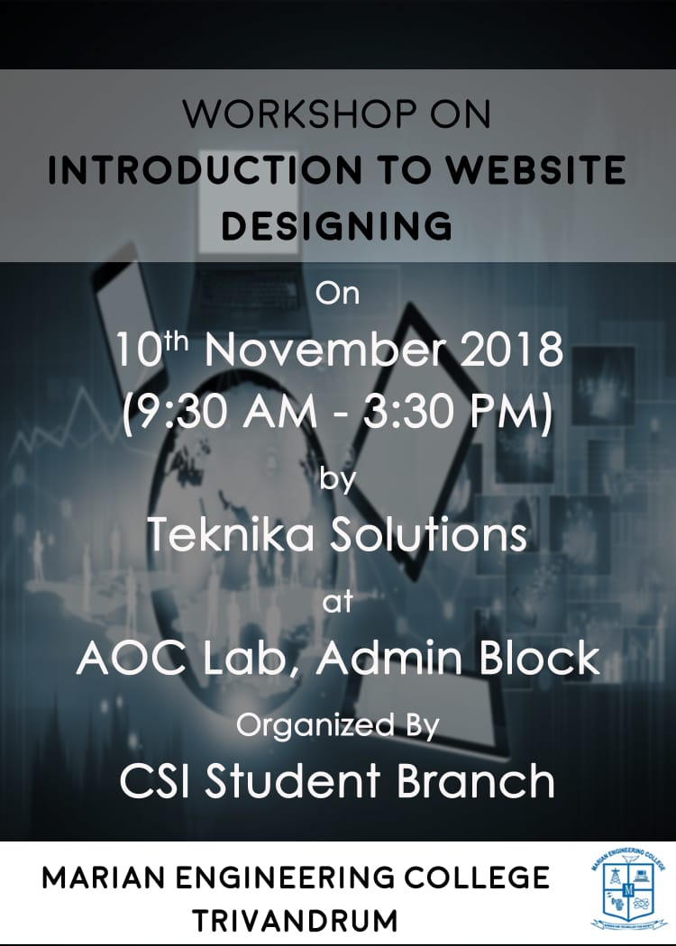

Document Purpose

The purpose of the document is to list the CSI activities carried by CSI student chapter for the period from August 1, 2018 to Dec 2018

Trainings Conducted
A one day software training workshop on ‘Introduction to Website Designing’ on 10th November 2018 was conducted.

The session started at 9.30 am with the talk on Internet of things by Ms.Aarcha Mohan from Mechatronics Club of MEC.She started with History of IOT,moved to protocols and finally the applications. The session was very interesting.Duration was 1 ½ hours.
The 2nd session was on Basics of Website designing which includes HTML and CSS hands on session. Duration of the session was from 11.00 am to 3.30 pm.The workshop was concluded with certificate distribution.The students were able to generate forms successfully.The session was handled by Mr.Bethov from Teknika Solutions.
Total 76 students attended the training,21 from S5 R2, and 55 from S1 R2&R1.

Photographs

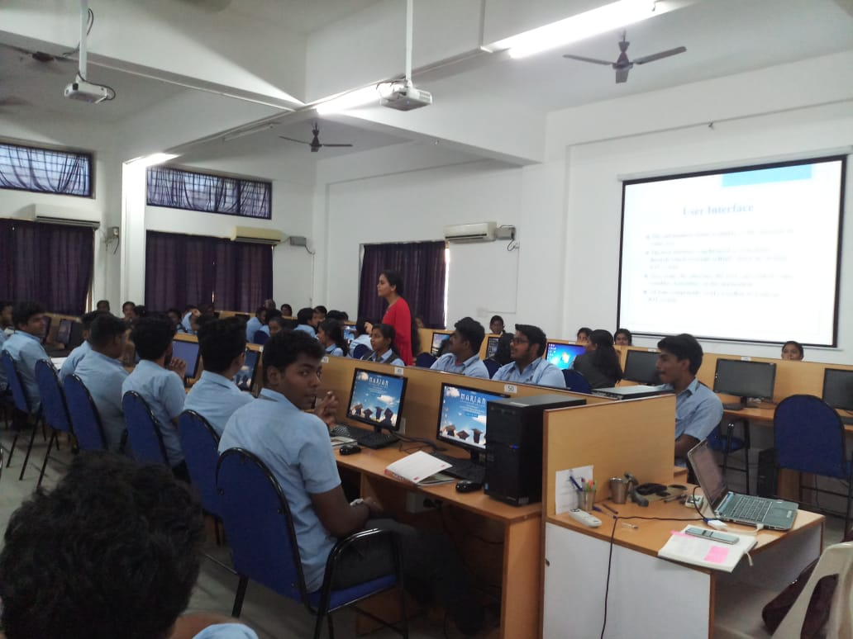
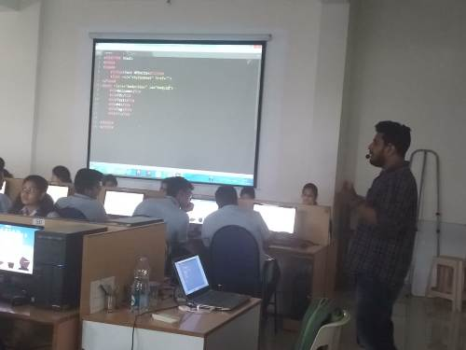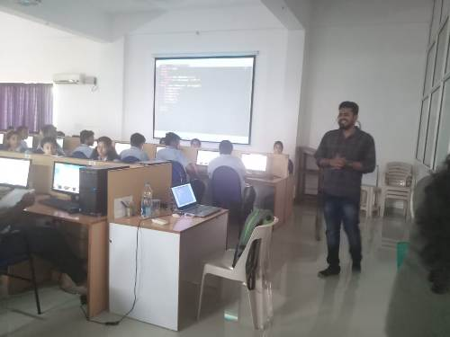

Trainings Planned for 2019
A 3-day intensive training on ‘Internet of Things’, ‘Robotics ,

