COMPUTER SOCIETY OF INDIA

PRESENTATION ON ETHICAL HACKING AND CYBER SECURITY
REPORT

Date : 01st Feb 2019
Venue : Seminar Hall ,CS Dept
Time : 12:45pm-01:45 pm
No. Of Participants : 62
The Computer Society of India of Marian Engineering college has organised a presentation on 01st Feb 2019 for the members of CSI students of semesters S2 and S5.62 students from 2nd semester attended the presentation.

The presentation were divided into 2 sections. 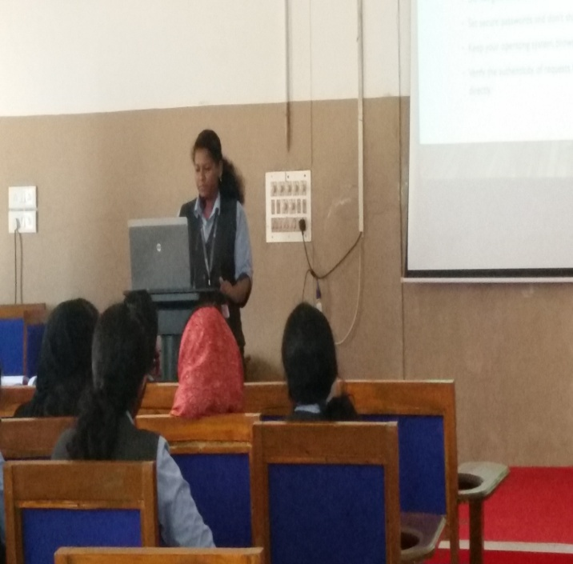
The first was an introductory session where Ms.Natasha of S2 R2 delivered a presentation on Cyber Security.

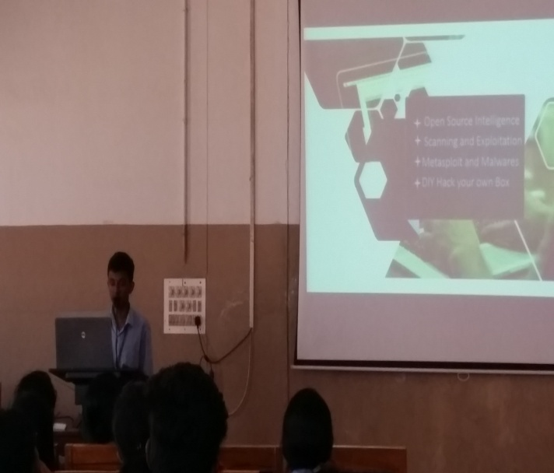
The next session was lead by Mr.Manoj of S2 R2 who dealt with Ethical Hacking
The presentation adjourned by 01:45 pm

