**Report of Overcraft**

**OVERVIEW**

Overcraft is a workshop event conducted by IEEE SB MCE on 27-04-2024 in Marian Engineering College. It was an acknowledged event where participants were taught to create editorials, writings and documents much more quickly and easily with the help of tool.

**EXECUTION**

Arranged a meeting with IEEE Execom members to discuss the event.

After the discussion, we decided on the resource person, date, time, and mode of conduct.

**IMPORTANT DATES**

10th April 2024- 09.00 pm: The idea was brought forward.

14th April 2024- 12.30 pm: An online meeting with members was held.

19th April 2024: First Poster Release.

21st April 2024: Second Poster released.

**DETAILS**

**Event Objective:**

* Introduce participants to the fundamentals of overleaf and its applications .
* Provide practical, hands-on experience in using tools for good document formation.
* Encourage participants to unleash their creativity by giving a task.

**Expected Outcome:**

* Make the thesis writing process easier for students.
* Decrease the amount of time and work required by the Graduate to review thesis.
* Streamline the thesis review process
* Participants will build excellent thesis

**Demographics:**

Participants: 80

**Organizers:**

IEEE SB MCE

1.Chair: Nandana S Chandran (S6 EC)

2.Link Rep: Johann Jose Issac (S4 EC)

3.Treasurer: Rithik Kannan (S8 Cse)

4. Tech Lead/ Media Team: K H Arjun (S4 AH)

5. Vice secretary: Benoy D'Costa (S4 EC)

**Posters & Images:**

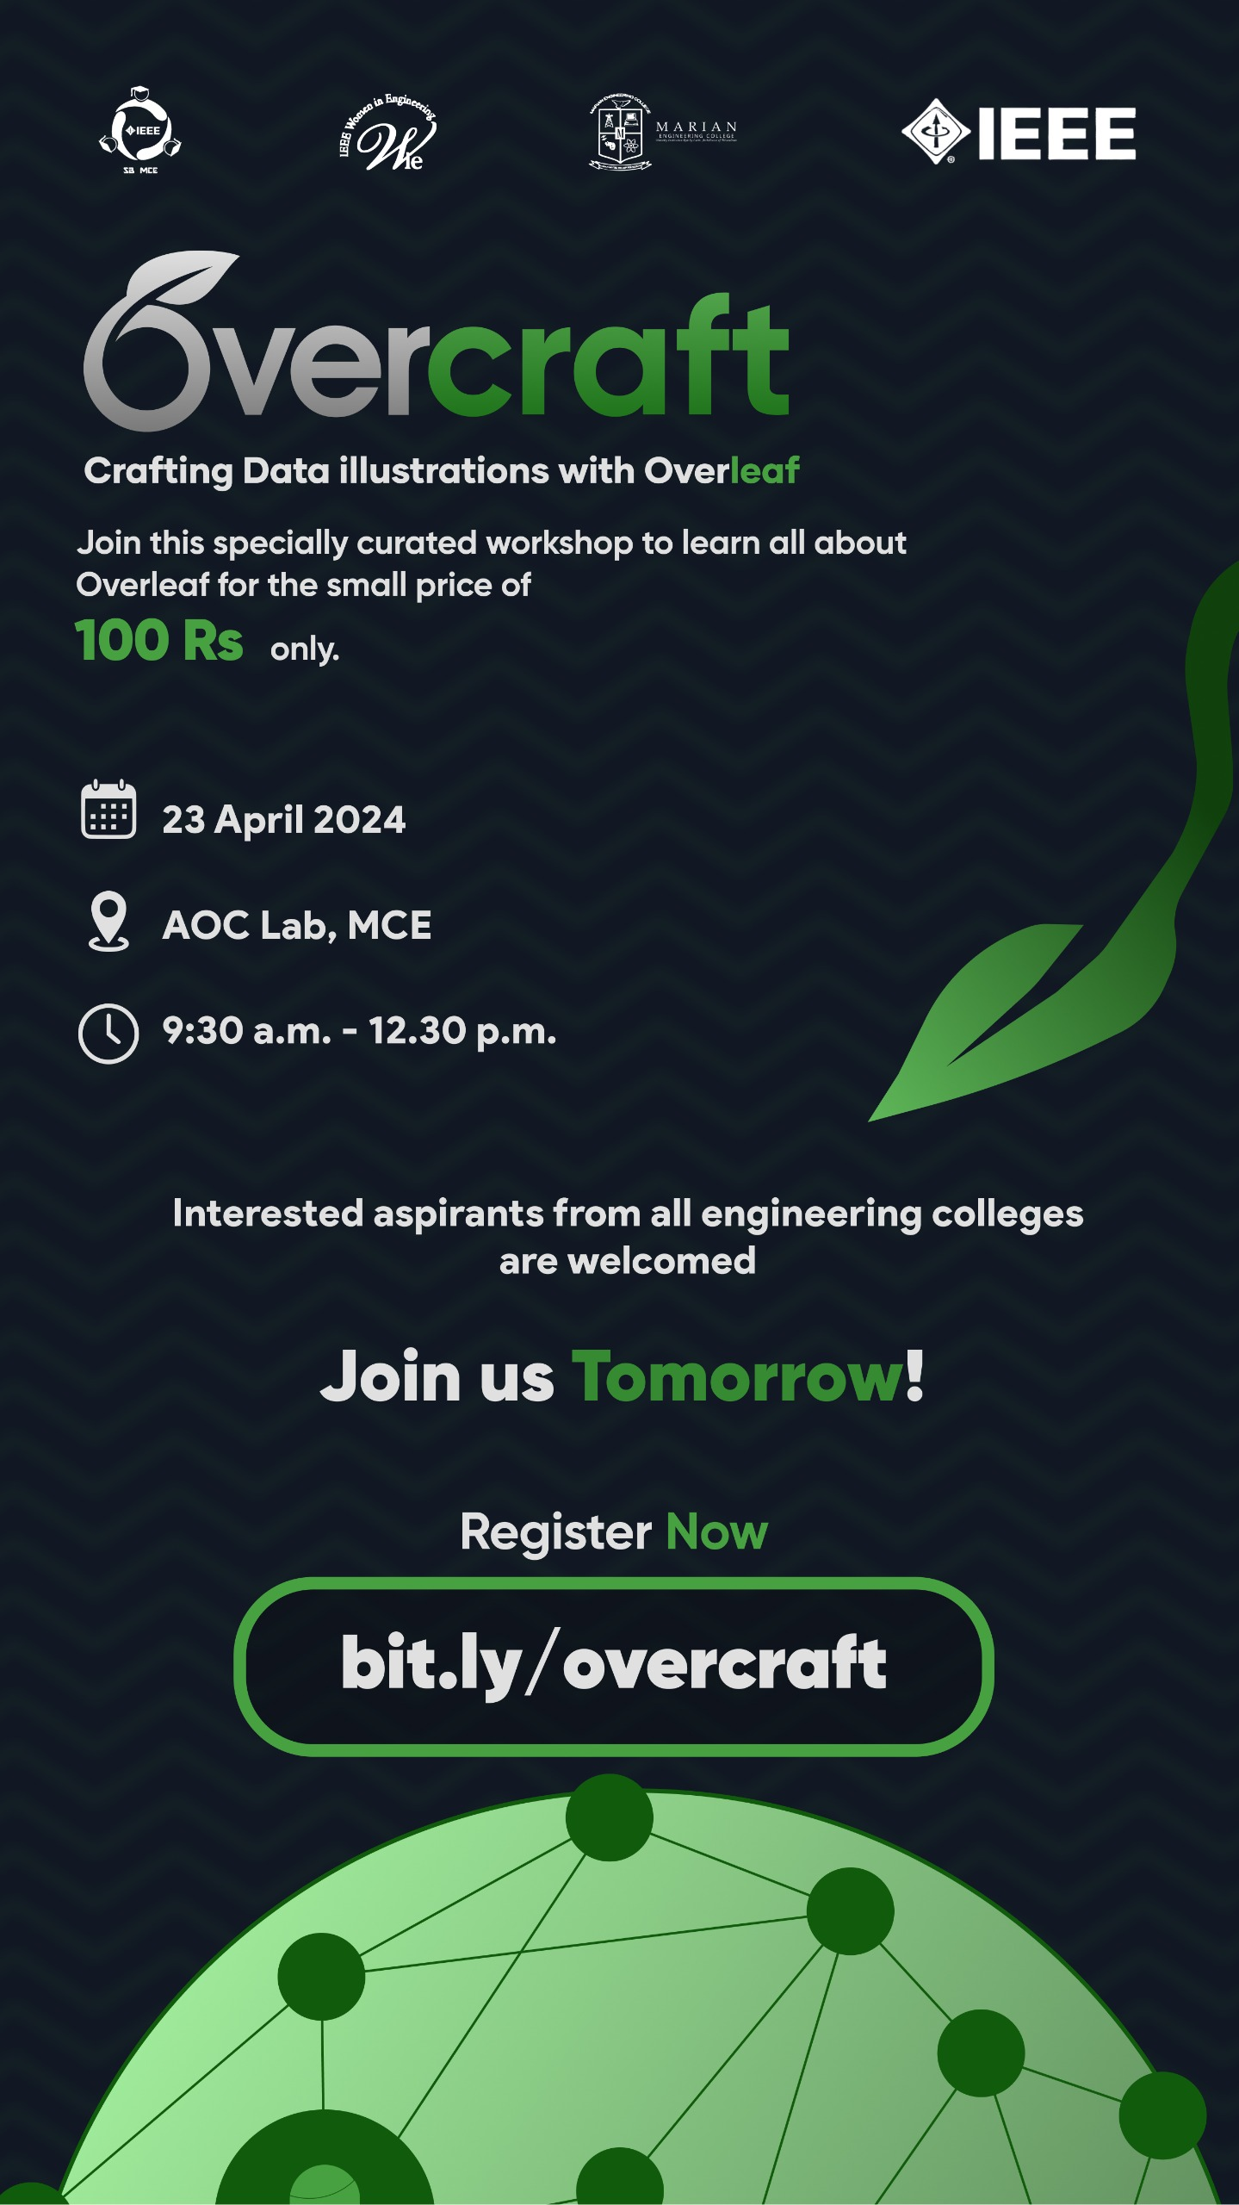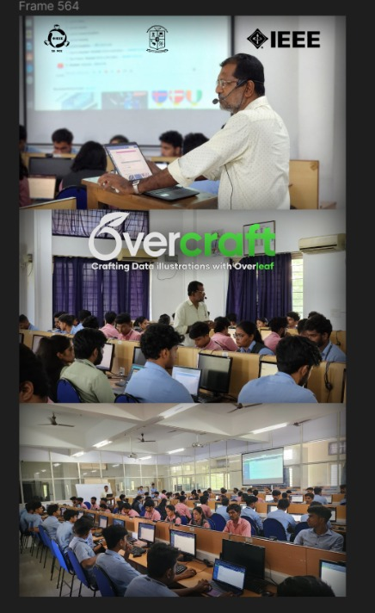

**CONCLUSION**

The event was a success with active participants.